Machine Learning in Healthcare
SAS Case Study

Abstract
Ever wonder where Machine Learning can fit into the healthcare industry to make medical procedures safer and more effective? In this case study, we cover the application of advanced analytics and machine learning in a healthcare application using Visual Data Mining and Machine Learning on the SAS Viya platform. The goal is to understand the key drivers of what causes a stent failure and to be able to predict such a failure. Accurate predictions of stent failures could subsequently trigger preventative measures to ensure a patent’s safety and prevent a negative outcome.

SAS Software
This case study targets the use of SAS Visual Analytics, SAS Visual Statistics, and Visual Data Mining and Machine Learning using SAS Viya. Specifically, we will use these solutions on SAS Viya for Learners – an online resource, free for academics, that requires no set up or infrastructure.

Industry Alignment
This case study aligns with the healthcare industry. Although the focus is on the healthcare and life sciences sectors, the skills learned are easily transferrable to other industries.

Table of Contents
Machine Learning in Healthcare 1
Abstract 1
SAS Software 1
Industry Alignment 1
Table of Contents 2
Notes and Requirements 4
Learning Objectives 4
Estimated Completion Time 4
Experience Level 4
Prerequisite Knowledge 5
Software 5
Content Knowledge 5
Additional Notes 5
Required Setup 6
Data Source 6
Introduction 6
Description of Variables 6
Machine Learning in Healthcare Case Study: Intermediate Level 8
Part 1: Exploration 8
Part 2: Transform and Modify 14
Part 3: Model 17
Model 1: Decision Tree Model 17
Model 2: Logistic Regression Model 20
Model 3: Gradient Boosting Model 21
Model 4: Neural Network Model 22
Model 5: Forest Model 24
Model Comparison 25
Machine Learning in Healthcare Case Study: Advanced Level 27
Part 1: Exploration 27
Part 2: Transform and Modify 27
Handling Missingness 27
Partitioning for Honest Assessment 28
Part 3: Model 28
Model 1: Decision Tree Model 28
Model 2: Logistic Regression Model 29
Model 3: Gradient Boosting Model 31
Model 4: Neural Network Model 31
Model 5: Forrest Model 32
Model Comparison 32
Appendix 34
Appendix A: Access Software 34
Appendix B: Helpful Documentation 34
Appendix C: Recommended Learning 34
Appendix D: Solutions 34
Intermediate Level - Part 1: Solutions 35
Intermediate Level - Part 2: Solutions 35
Intermediate Level - Part 3: Solutions 37
Advanced Level - Part 3: Solutions 47
Authors and Contributors 50

Notes and Requirements

Learning Objectives
In addition to the Learning Outcomes, the student/participant should acquire the following essential business skills/ abilities, e.g., teamwork, presentation skills, etc.
- An understanding of Machine Learning in the healthcare industry.
- An appreciation that Machine Learning requires data preparation and visualization, besides just the algorithms to succeed.
- If done within teams, it could be an exercise in the way of different ideas coming together and presenting the results.
- An understanding of explainable Machine Learning, which helps understand the real-work business requirement to explain what’s going on beyond the algorithms.
- Ensure an ethical and explainable use of Machine Learning algorithms to be understood by medical expertise with minimal Data Science knowledge.
Students will be able to use SAS Visual Analytics and SAS Visual Statistics to:
- Explore Data to examine key variables and potential issues in the data.
- Model using machine learning and predictive modeling to gather information.
- Compare and present results in an interactive report using a structured and meaningful design.

Estimated Completion Time
This case study can be completed as an individual or as a team-based assignment.
Class work: An assignment based on studying the data set, from data preparation and exploration to visualization and machine learning practices.
Class team challenges: Use the dataset, and focus on dashboarding, machine learning or both.
Short-term tasks, e.g., datathons, or a single-afternoon lab session: Focus on either the dashboarding or the machine learning templates to get a result and present it back to the class.
Dissertations: Not suitable.
The estimated amount of time to complete this case study is: 2-3 hours.

Experience Level
The audience for this case study is intermediate to advanced students. The target audience does not just include students with a background in statistics or mathematics. If adequate exposure to SAS Visual Analytics and Visual Statistics can be provided before the case study, undergraduate or graduate students from a wide range of subjects can finish it. (See more details in Additional Notes)

Prerequisite Knowledge

Software
Intermediate Level:
Students should be familiar with the basic features and foundational skills for SAS Visual Analytics, like those taught in the SAS Visual Analytics 1 for SAS Viya: Basics course.
Advanced Level:
Students should be familiar with the basic features and foundational skills for SAS Visual Analytics, as well as skills learned using SAS Visual Statistics.

Content Knowledge
For the best success, students should have a solid understanding of:
- Data visualization and dashboard design theory.
- Basic statistics and predictive modeling, particularly with supervised models such as decision trees, forests, logistic regression, and neural networks and unsupervised models such as clustering.

Additional Notes
While these are not necessarily discussed in the case study, here are ways to enhance content knowledge through adjacent topics.
Undergraduate focus
- Where students already have a math/stats/computing/data science background:
  - Greater focus on analytical processing and exactly which algorithms to use and increase accuracy with different techniques and hyperparameter tuning/optimization.
- Where students do NOT have a math/stats/computing/data science background:
  - Greater focus on visualization, and if scientific background, more focus on medical trends.
  - Leverage SAS Viya’s template or AutoML feature for Machine Learning.
Postgraduate focus
- Where students have a math/stats/computing/data science background:
  - Pay close attention to the rationale behind the selection of these algorithms, how it would perform with additional real data, the implications of missing data, the limitations of the dataset, and how it might be enhanced in a new system.
  - Study the algorithms in-depth to determine the Machine Learning system's explainability and transparency and use SAS Viya's method to “explain” the decisions the algorithms make.
  - Investigate LIME/SHAP plots to learn more about the choices made.
- Where graduates/students do NOT have a math/stats/computing/data science background:
  - Focus on healthcare specifics, how to work together with a data scientist to create a better working system by leveraging both analytical techniques, and medical knowledge.
  - Understand the dataset's shortfalls and explain how it can be improved in a new system.
  - Explain the importance of the ethical use of Machine Learning, using SAS Viya’s technique to “explain” how the algorithm makes decisions.

Required Setup
Student should get access to SAS Viya for Learners.

Data Source

Introduction
The case study has been developed using the SAS Stent_failure.sasbdat dataset available on SAS Viya for Learners.
The path to the dataset location is as follows: Cas-v4e***-default > ACADEMIC > Stent_Failure

Description of Variables
The variables used for this exercise are:
Variable | Description | Type
Age | Patient Age | Numeric
Cell_Design | Stent Cell Design | Character
Cell_type | Stent Cell Type | Character
Coronary_Stream | Upsteam or Downstream disease in coronary | Character
Device_age | Device age (days) | Numeric
Diabetic | Diabetic | Character
Ethnic_group | Patient Ethnicity | Character
Gender | Patient Gender | Character
Geographic_Miss | Geographic Miss | Character
Hospital | Hospital | Character
Hours_Active | Hours active per week | Numeric
Multiple_Stent | Multiple Stent | Character
Patient_id | Patient ID | Numeric
Plaque_Prolapse | Plaque Prolapse through cells of the stent | Numeric
Smoker_flag | Smoker flag | Numeric
Stent_Failure | Stent Failure | Character
Stent_Failure_flag | Stent Failure flag | Numeric
Stent_Length | Stent_Length(mm) | Numeric
Stent_Material | Stent Material | Character
Stent_Thickness | Stent Thickness (mm) | Numeric
Stent_Width | Stent Width (mm) | Numeric

Machine Learning in Healthcare Case Study: Intermediate Level
A stent procedure has a low margin for error, and each type, shape, or material, has a different effect per demographic group. The idea is to apply machine learning to predict the most suitable stent for each individual patient and receive a probability score on its potential for failure. This ensures that all patients will receive regular check-up prior to the stent failure. We can use state-of-the-art Machine Learning algorithms to predict an appropriate medical procedure before it’s even started.

This procedure could become more automated, so that as soon as a doctor writes down the patient’s information, the ideal combination of material, type etc. could be ordered and installed, thus reducing times and improving accuracy. The idea is that this process can be further applied to other medical procedures as well, as Machine Learning in Healthcare is an increasingly invested topic. Additionally, each decision needs to be understood by the doctor. Thus machine learning needs to be transparent to ensure ethical and explainable use of Machine Learning.

Part 1: Exploration
To begin, gain an understanding of the available data.
- Go to Explore and Visualize.
- Find the STENT_FAILURE dataset by clicking Start with Data.
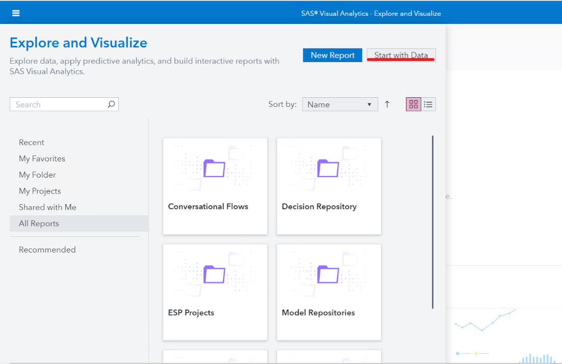
- Review the profile data to get high level information about each variable. Be on the lookout for variables with high cardinality, missingness, outliers, etc..
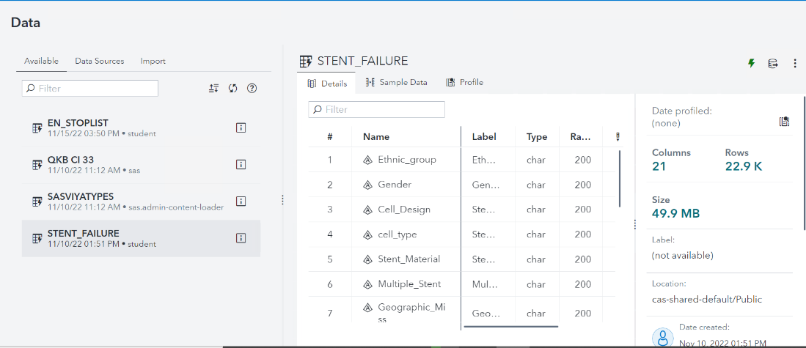
- Click OK to load the dataset into your report. Examine the distribution of Stent Failure and Ethnicity using the auto-chart feature.
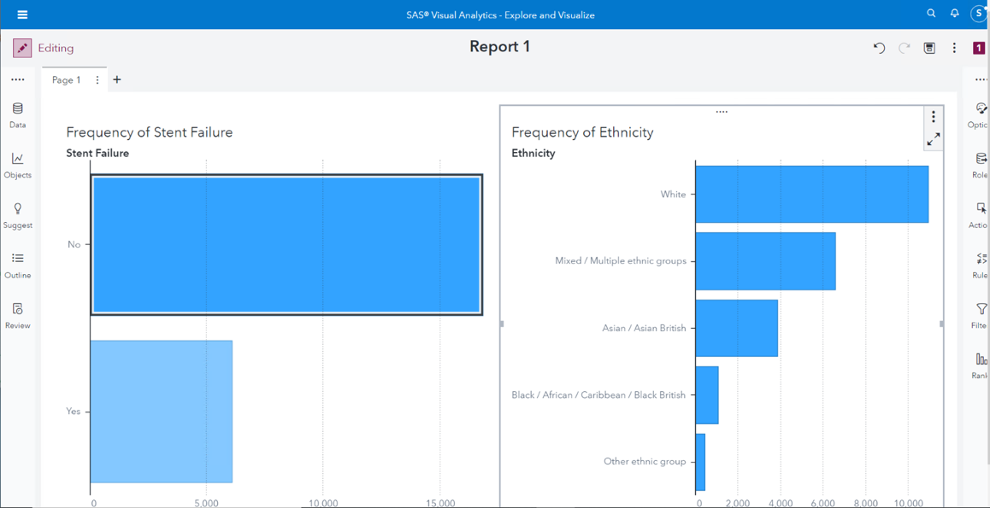

- Drag and drop the Gender variable onto the “Frequency of Ethnicity” chart and select the GROUP role.
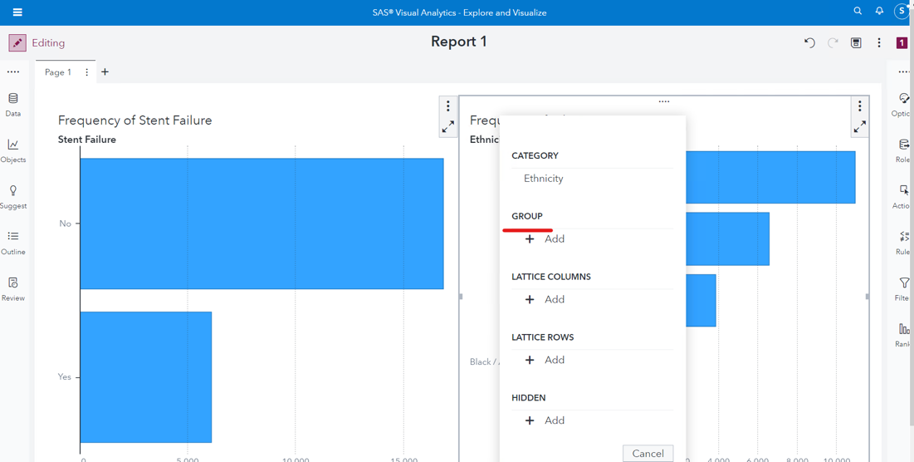
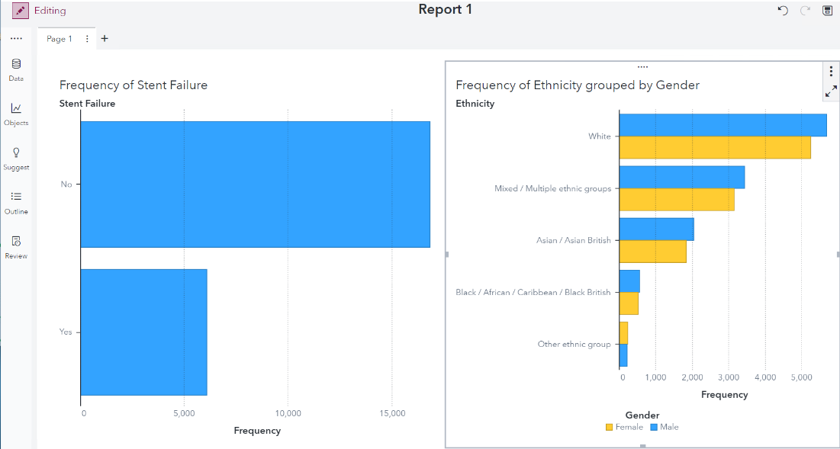
- Through the Roles pane, replace Gender with Hospital.
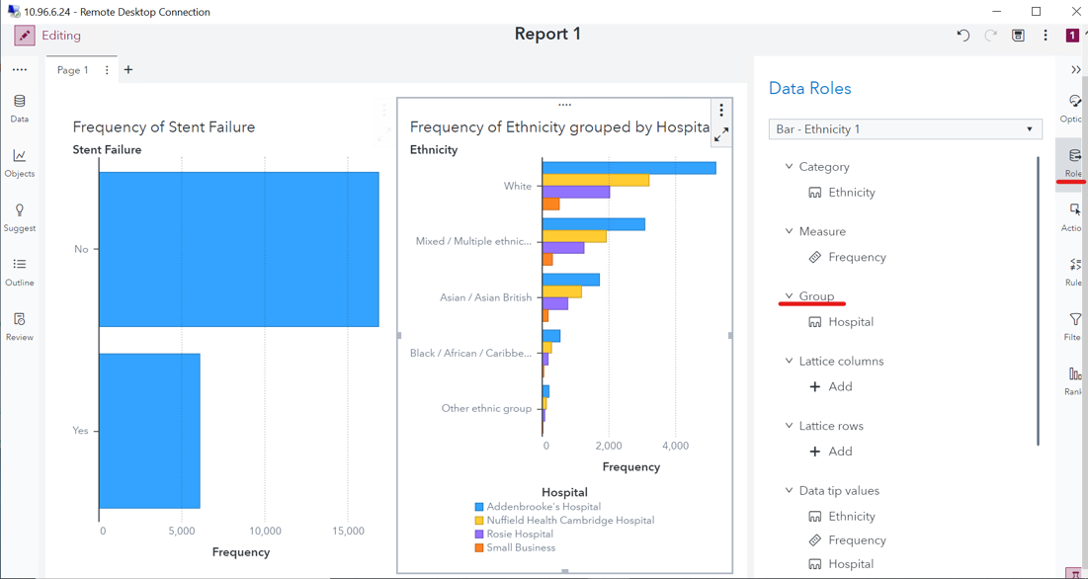
- Select the “Frequency of Stent Failure” bar chart, then click Actions and create an object link filter to the “Frequency of Ethnicity grouped by Hospital” chart.
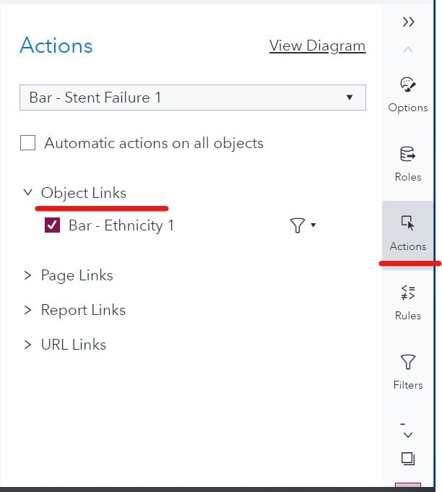
- Build a Correlation Matrix at the bottom of the page to see how the different numerical variables within the dataset correlate. In particular, look at the correlations Between two sets of measures and set Y axis to Stent Failure Flag. All numeric variables other than Patient ID should be added to the X axis.
Note: Patient ID is not included in the correlation matrix because its values are not intended to be used as measurements.
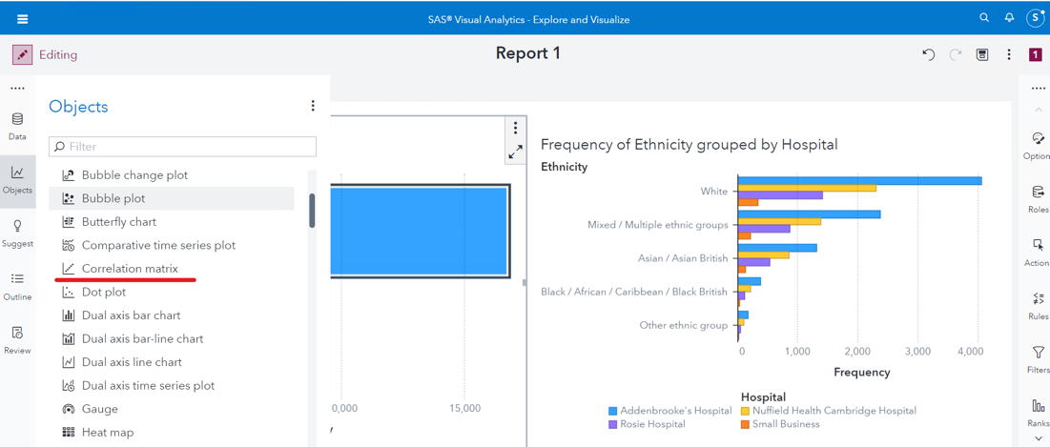
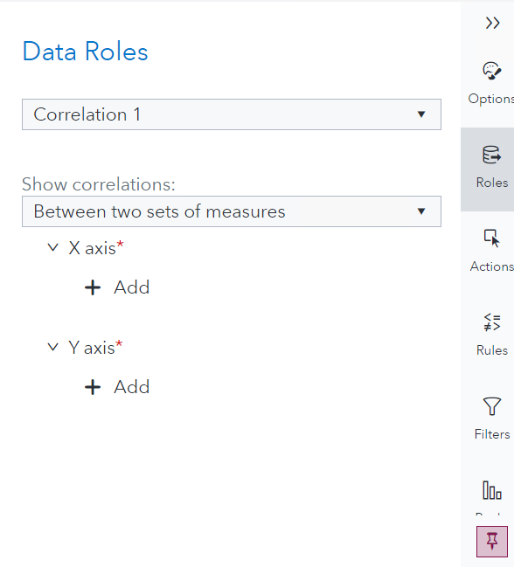
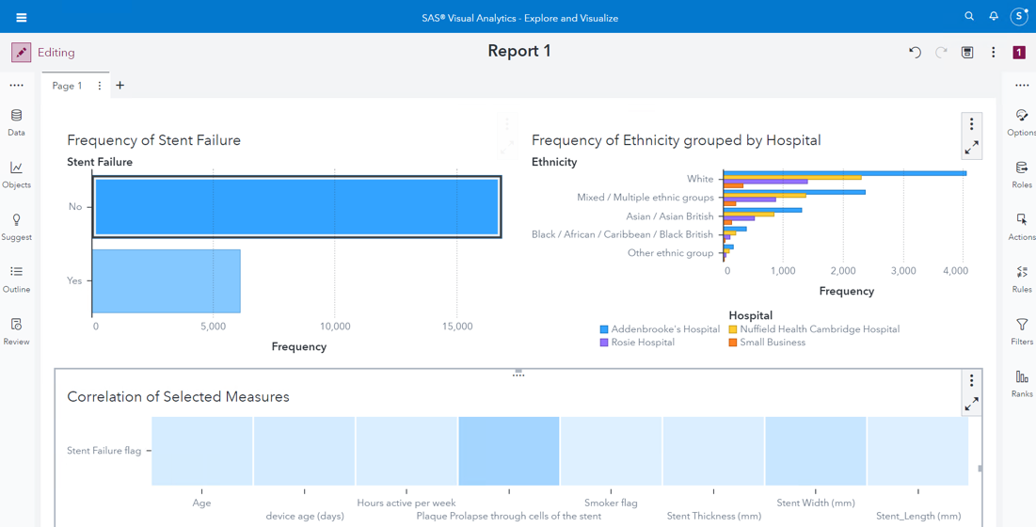
(As the color goes darker, the correlation would be stronger)
- Add an Automated Explanation object to a new page with Stent Failure in the RESPONSE role.
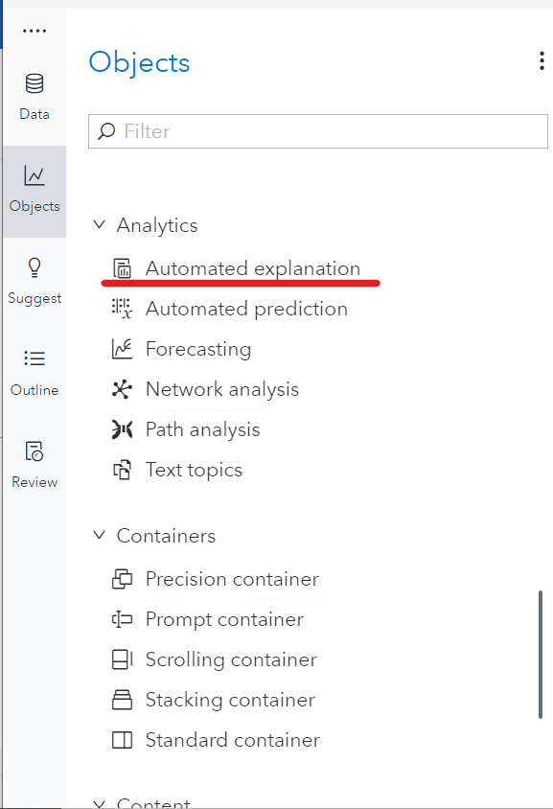
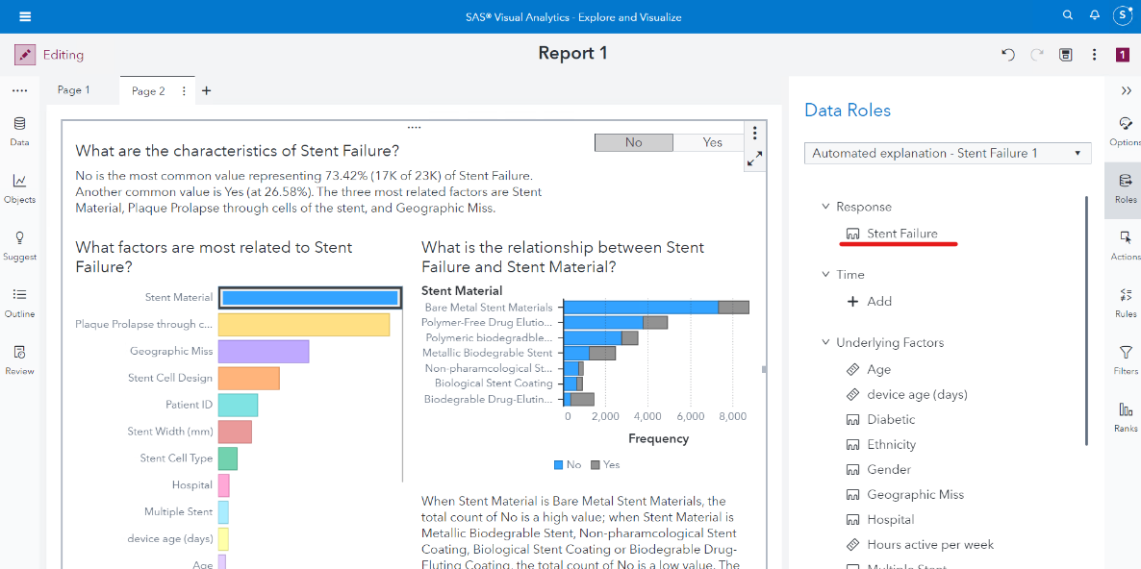
This object will use all available variables to create an overall group using a natural language generation tool to generalize the groups. It also creates several cluster groups that each have their own probability

Use your report to answer the following:
- What is the factor in aggregate measures that have the strongest relationship with Stent Failure?
- Is there an ethnic group that has a higher proportion of Stent Failure?

Part 2: Transform and Modify
Before building models, always remember ‘garbage in, garbage out’. Cleaning data is always one of the most important processes to go through.

While some models, like regression, cannot manage missing values, other models like decision trees, can. We may handle these situations by using imputation, avoiding the need to delete observations with missing values, as well as situations when the automatic approach would be ineffective.

1. Check if data has missing values.

- Click View measure details within the Data pane.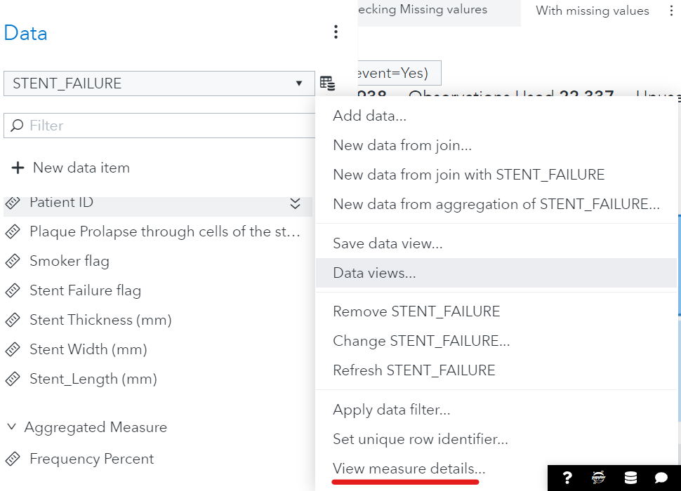
- Check the Number Missing for each variable.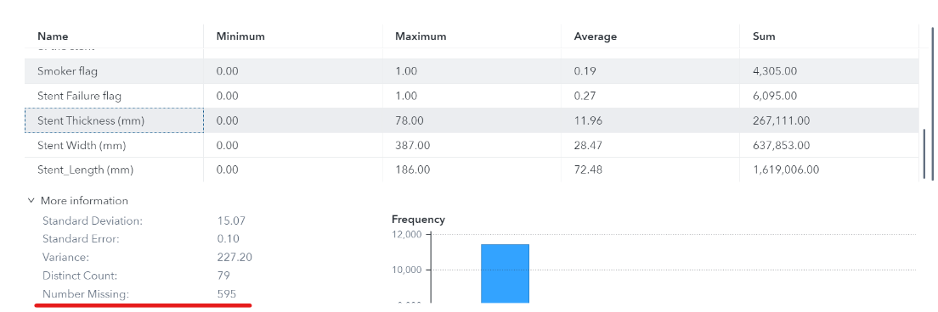

Questions:
- Which type of variables are shown in the Measure Details window?
- Which data items have missing values?

2. Complete the following steps below to use imputation for the missing values.
- Under the Data pane, click on + New data item and add a calculated item.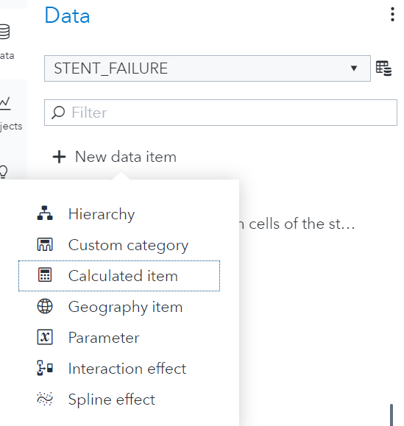
- Create calculated item for each variable that has missing values. Name the new categorical variables Thickness _Imp, and set it to be based on Stent Thickness (mm).
- Expand the Boolean option under the Operators tab and use the IF…ELSE operator.
- Assign Thickness _Imp to be Stent Thickness (mm) when not missing and 0 when Stent Thickness (mm) is missing. Your expression should like this: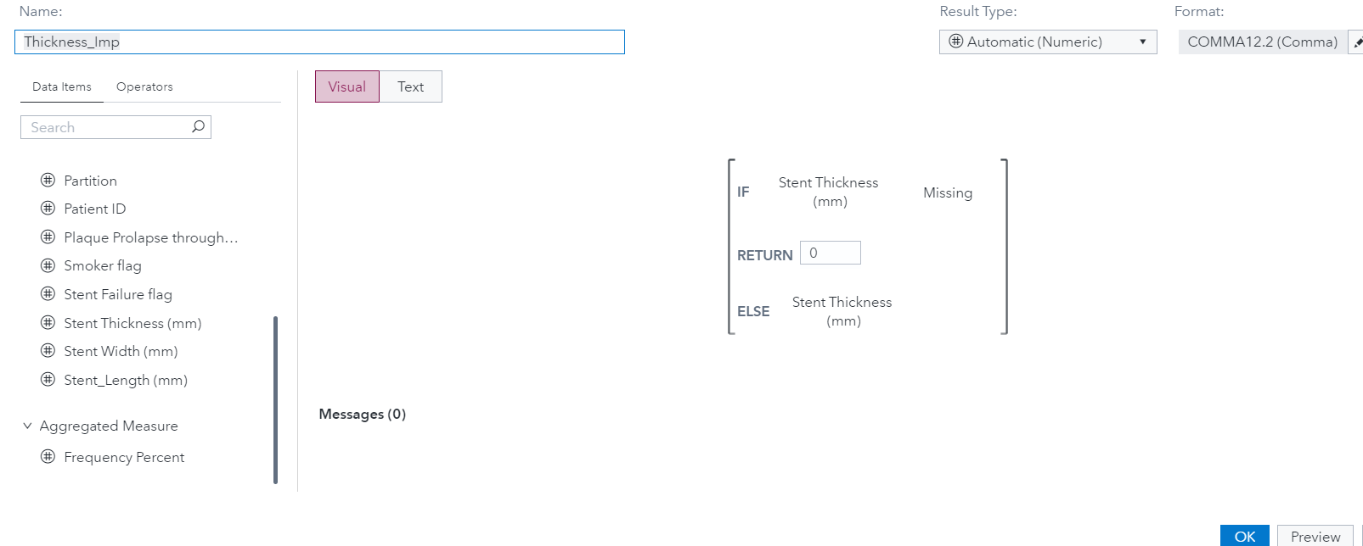If you preview the new calculated item, you will now see that where the Stent Thickness (mm) has a missing value, the new imputed variable has replaced it with 0.
- Repeat this for Width_Imp and Length_Imp based on Stent Width (mm), and Stent_Length (mm), respectively.

3. Complete the following steps to prepare the partition variable:
- In the Data pane click to create a new partition variable.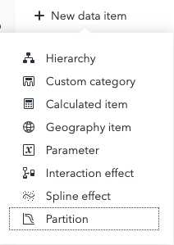
- Select Simple Random Sampling as the sampling method.
- Include 2 partitions with a 70% training percentage.
- Check the box and input a random number seed 772020. If you leave this option unchecked, SAS Viya choose a different random number seed so results will vary.

Part 3: Model

Model 1: Decision Tree Model
A decision tree is a supervised predictive model, which means it requires one response variable and at least one predictor. The response can be a category (classification tree) or a measure (regression tree). A predictor can be a category or measure variable but not an interaction term. The decision tree creates a segmentation of the data based on a series of rules that are applied sequentially, resulting in a hierarchy called a tree. The initial node is called the root node. A node and all its successors form a branch. The final nodes are called leaves. On each leaf, a decision is defined about the response.

Using SAS Visual Analytics, a decision tree will be automatically built, but you can also manually train and prune nodes by entering interactive mode.

Create a decision tree:
- Add another page to the report and rename it “Decision Tree”.
- Select Decision Tree on the Objects pane and drag it to the canvas.
- Add Stent Failure as the response variable.
- Assign the following variables as predictors:
  - Diabetic
  - Ethnicity
  - Gender
  - Geographic Miss
  - Hospital
  - Multiple Stent
  - Stent Cell Design
  - Stent Cell Type
  - Stent Material
  - Upsteam and Downstream disease in the Coronary
  - Age
  - device age (days)
  - Hours active per week
  - Plaque Prolapse through cells of the stent
  - Smoker flag
  - Stent Thickness(mm)
  - Stent Width(mm)
  - Stent length(mm)
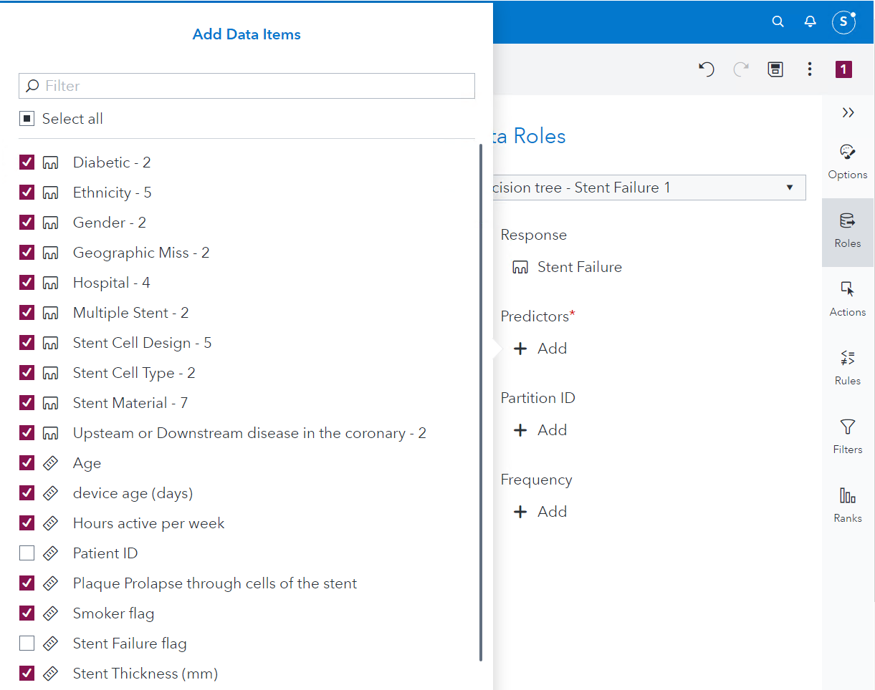
- Assign your partition variable to the Partition ID role.
- Look at the leaves and hover over to check its rules and statistics. Examine the plots provided. Make sure to select the validation partition when examining the statistics for the model.
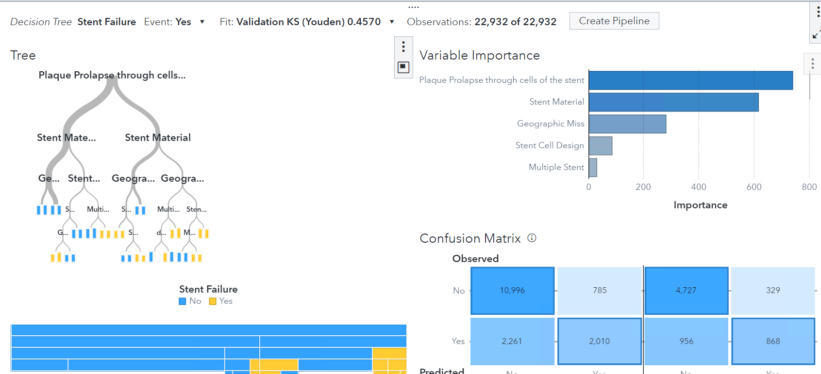
- Explore the results in more detail by maximizing the decision tree object.
Note: The details table is displayed at the bottom of the canvas.
Questions:
- Which variables are being used by the model?
- Which variable is the first split? On which value?
- How many leaves do we have?
- What is the Validation cumulative lift on the 5th percentile? And on the 20th percentile?
- What is the KS Statistic?
- View the Misclassification Chart. How many false negatives are there in Validation?
- What are the Misclassification Rates on Training and Validation?

Model 2: Logistic Regression Model
A logistic regression attempts to predict the value of a binary response variable. The model approximates the probability that an individual observation belongs to the level of interest. It requires a categorical response variable and at least one effect variable or interaction term.

Complete the following steps to create a logistic regression model.
- Instead of creating the logistic regression model from scratch, click the object menu on the top right and duplicate as a logistic regression.
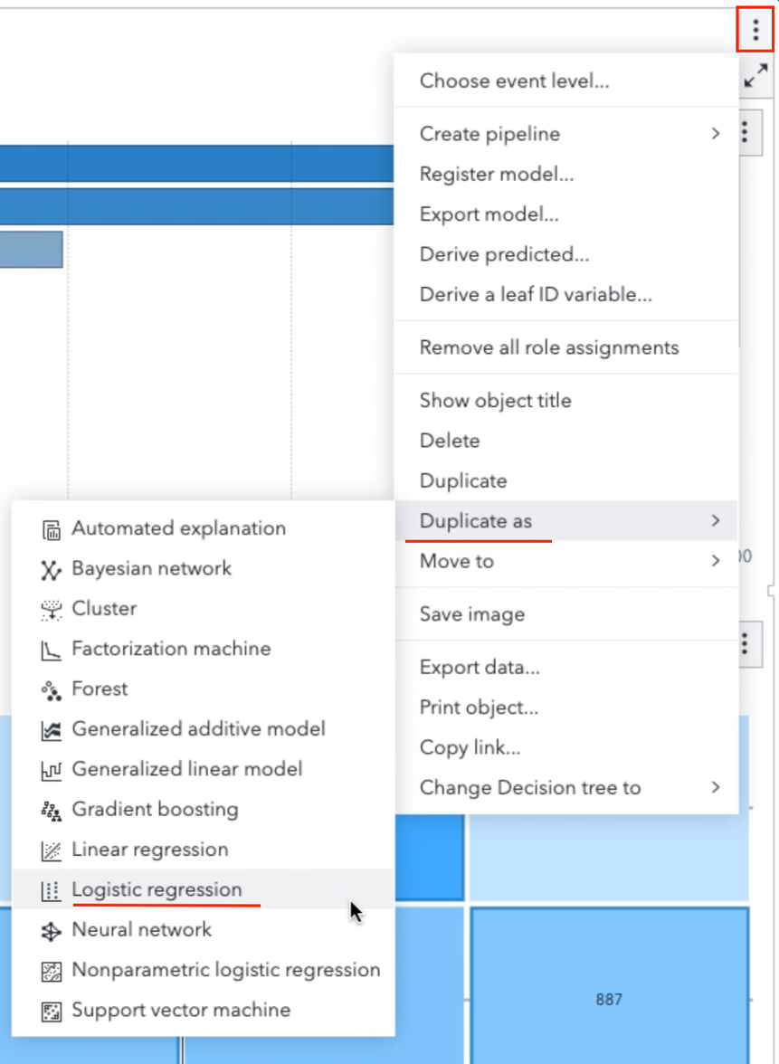
- Move your Logistic regression to a new page and rename the page “Logistic Regression”
- Under Options:
  - Select a variable selection method and selection criterion at your will.
- The Fit Summary window plots the relative importance of each variable as measured by its p-value. The variables are ranked by the order of importance, the significant ones are shown in green. The residual plot shows the relationship between the predicted value of an observation and the residual (the difference between the predicted value and the actual response value). Obvious patterns in the residual plot can indicate that the model might not fit the data, or they can be used to detect non-constant variance in the data. In combination with other methods, the residual plot can help identify outliers
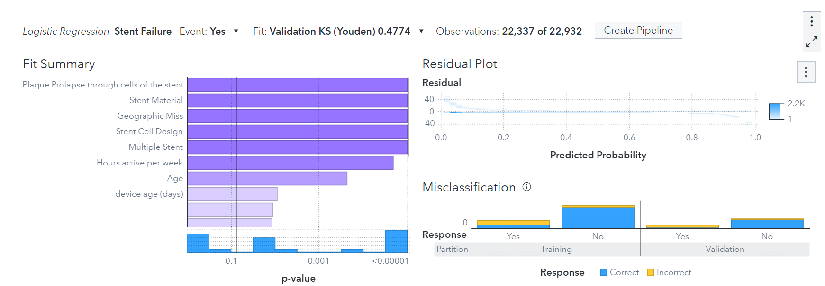
- Examine the Lift, ROC, and misclassification rates.
- Explore the results in more detail by maximizing the logistic regression object.
Note: The details table is displayed at the bottom of the canvas.

Questions:
- Which variables were selected by the model?
- What is the Validation cumulative lift on the 5th percentile? And on the 20th percentile?
- What is the KS Statistic?
- View the Misclassification Chart. How many false negatives are there in Validation?
- What are the Misclassification Rates on Training and Validation?

Model 3: Gradient Boosting Model
Gradient boosting is a machine learning technique used in regression and classification tasks, among others. It gives a prediction model in the form of an ensemble of weak prediction models, which are typically decision trees. When a decision tree is the weak learner, the resulting algorithm is called gradient-boosted trees; it often outperforms random forest. A gradient-boosted trees model is built in a stage-wise fashion as in other boosting methods, but it generalizes the other methods by allowing optimization of an arbitrary differentiable loss Function.
- Go to the menu and duplicate the logistic regression as a gradient boosting. Move it to its own page and rename the page “Gradient Boosting”.
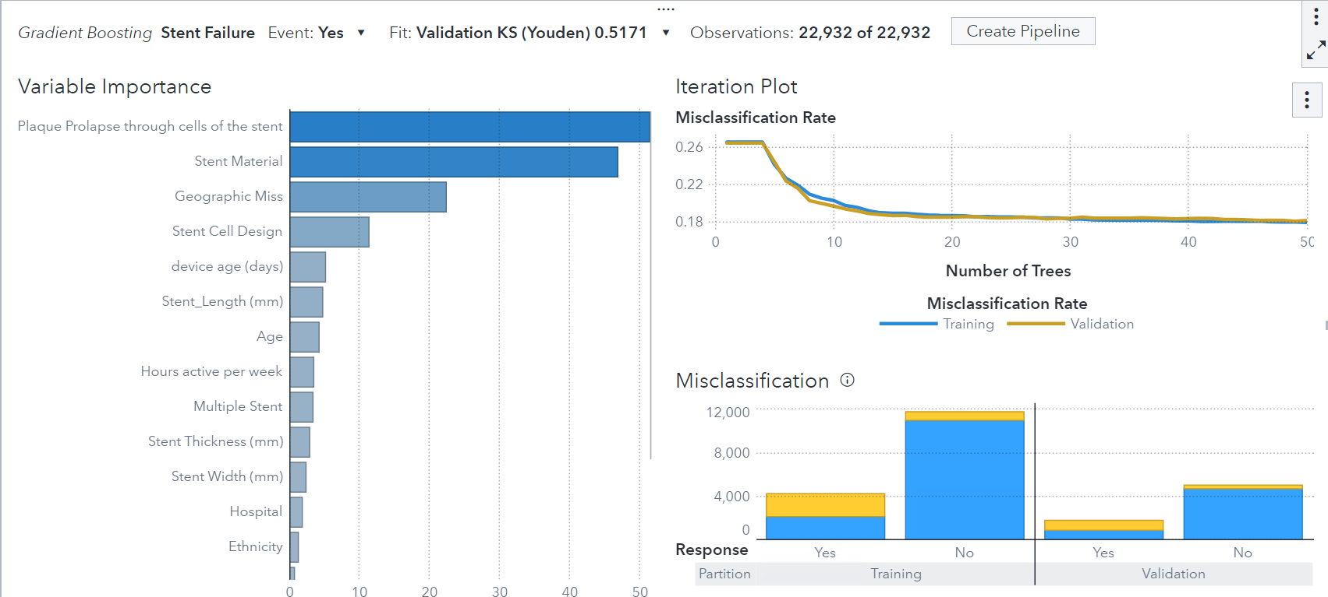
- Change the number of trees to 100 from 50 under Options.
- Examine the Lift, ROC, and misclassification rates.
- Explore the results in more detail by maximizing the Gradient Boosting object.
Note: The details table is displayed at the bottom of the canvas.

Questions:
- Which variables were selected by the model?
- What is the Validation cumulative lift on the 5th percentile? And on the 20th percentile?
- What is the KS Statistic?
- View the Misclassification Chart. How many false negatives are there in Validation?
- What are the Misclassification Rates on Training and Validation?

Model 4: Neural Network Model
The design of a neural network was inspired on the biological structures of the brain. Neural networks consist of predictors (input variables), hidden layers, an output layer, and the connections between each of those. The results of those connections are determined by an activation function. Specify an activation function for each hidden layer.

Build a Neural Network:
- Add a new page called “Neural Network”.
- Select Neural Network in the Objects pane and drag it into the new page.
- Select Stent_Failure as the response variable.
- Assign the following variables as predictors:
  - Diabetic
  - Ethnicity
  - Gender
  - Geographic Miss
  - Hospital
  - Multiple Stent
  - Stent Cell Design
  - Stent Cell Type
  - Stent Material
  - Upsteam and Downstream disease in the Coronary
  - Age
  - Device age(days)
  - Hours active per week
  - Plaque Prolapse through cells of the stent
  - Smoker flag
  - Stent Thickness(mm)
  - Stent length(mm)
  - Stent width(mm)
- Explore the results in more detail by maximizing the neural network object.
Note: the details table is displayed at the bottom of the canvas.
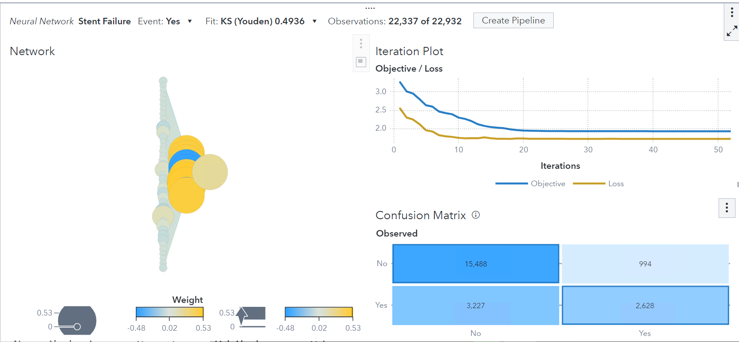
Questions:
- Which variables are used by the model?
- What is the Validation cumulative lift on the 5th percentile? And on the 20th percentile?
- What is the KS Statistic?
- How many false negatives are there in Validation?
- What are the Misclassification Rates on Training and Validation?

Model 5: Forest Model
A forest is an ensemble model that contains a specific number of decision trees. To ensure that a forest does not over fit the data, two key steps are taken. First, each tree in the forest is built on a different sample of the training data, which means that the training data for each tree in the forest excludes some of the available data (out-of-bag sample). Second, when splitting each node, a set of candidate inputs for the split are selected at random, and the best split is selected from those. Other than these two steps, the trees in a forest are trained like standard trees. To predict the target value of a new observation, that observation is fed through each tree, and the predicted value can be the average or the majority across all trees

- Add a new page to the report and name the page “Forest”. Select Forest in the Objects pane and drag it into the new page.
- Select Stent_Failure as the response variable.
- Assign the following variables as predictors:
  - Diabetic
  - Ethnicity
  - Gender
  - Geographic Miss
  - Hospital
  - Multiple Stent
  - Stent Cell Design
  - Stent Cell Type
  - Stent Material
  - Upsteam and Downstream disease in the Coronary
  - Age
  - Device age(days)
  - Hours active per week
  - Plaque Prolapse through cells of the stent
  - Smoker flag
  - Stent Thickness(mm)
  - Stent length(mm)
  - Stent width(mm)
- Explore the results in more detail by maximizing the forest object.
Note: the details table is displayed at the bottom of the canvas.
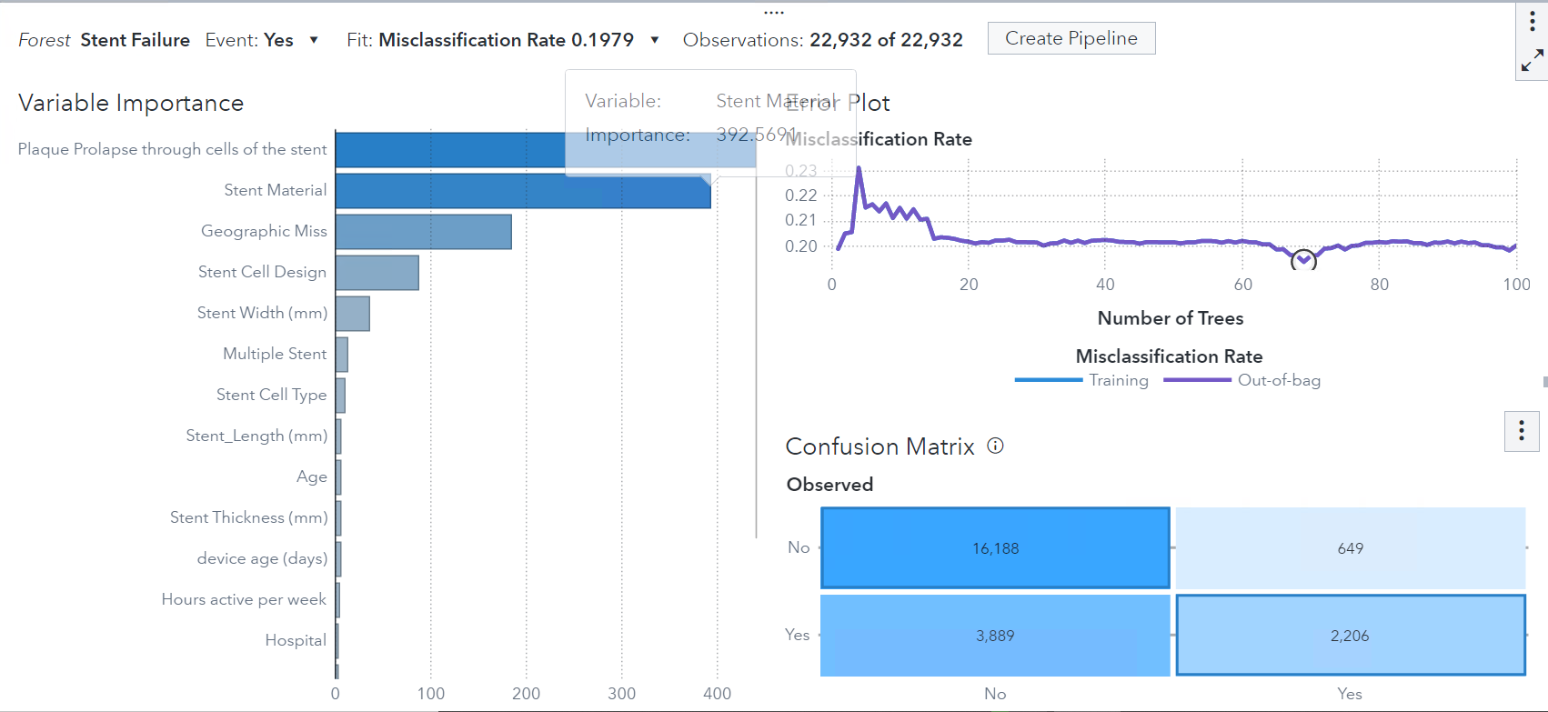
Questions:
- Which variables are been used by the model?
- What is the Validation cumulative lift on the 5th percentile? And on the 20th percentile?
- What is the KS Statistic?
- How many false negatives are there in Validation?
- What are the Misclassification Rates on Training and Validation?

Model Comparison
Now that we have our different predictive models, we want to compare their performance and select the most appropriate one. The model comparison tool can compare the performance of competing models using various benchmarking criteria. The comparison criteria available depend on the models and response variable used in the analysis. A model comparison requires that at least one model is trained before performing a comparison.

Before using the model comparison tool, ensure that all models are initialized and updated then complete the following steps:

1. Add a page named “Assess”.
2. In the Objects pane, select Model Comparison and drag it into the canvas.
3. Select all available models and click OK.
4. Adjust the prediction cutoff to 0.3. Verify the Fit statistics of the models using the different metrics.

Questions:
1. Which model was selected by default (using prediction cutoff: 0.3)?
2. Which model provides the best Validation FPR (False Positive Rate)?
3. Which model provides the best Validation KS Statistic?

Now that you have completed the tasks for this case study, clean up your report in an interactive and meaningful way.

Be sure to save your report in SAS Visual Analytics for future use.

Machine Learning in Healthcare Case Study: Advanced Level

A stent procedure has a low margin for error, and each type, shape, or material, has a different effect per demographic group. The idea is to apply machine learning to predict the most suitable stent for each individual patient and receive a probability score on its likely failure. This ensures that even the at-risk patients will receive regular check-up prior to the stent failure. We can use state-of-the-art Machine Learning algorithms to predict an appropriate medical procedure before it’s even started.

This procedure could become more automated, so that as soon as a doctor writes down the patient’s information, the ideal combination of material, type etc. could be ordered and installed, thus reducing times and improving accuracy. The idea is that this process can be further applied to other medical procedures as well, as Machine Learning in Healthcare is an increasingly invested topic. Additionally, each decision needs to be understood by the doctor. Thus machine learning needs to be transparent to ensure ethical and explainable use of AI.

Complete the following tasks:
1. Explore the data
2. Use predictive models to determine patients who most likely will have stent failures.

Part 1: Exploration
Before starting the analysis and exploration of the data. Consider the following:
- Create charts to explore the Stent Failure Indicator variables.
- Filter the Stent Failure Indicator variable by Plaque Prolapse through cells of the stent and verify if any category has a higher proportion of Stent Failure. (Hint: Change Classification type of the variable)
- Create charts to explore Ethnicity, Gender, Age, Hospital and Stent Failure
- Explore other variables as desired.
- Inspect the measurement details of the data to verify which variables present missing values.

Part 2: Transform and Modify
After exploration of the data, determine whether there is a need to transform and manipulate the data. Make the proper transformations and modifications to prepare the data for modeling. Transformation and modifications should include:

Handling Missingness
As seen before, some variables in the data present missing values. Some modeling techniques, such as decision trees, can handle them, but others like regressions cannot.

Linear regression, logistic regression, and generalized linear models do not accept observations that contain a missing value well. By default, for these models, any observations with missing values in any assigned role variable are ignored. In some cases, the fact that an observation contains a missing value provides relevant information. In SAS Visual Analytics, selecting the informative missingness property handles missing values automatically. For measure variables missing values are imputed with the observed mean, and an indicator variable is created. For category variables, missing values are considered a distinct level.

To avoid discarding observations containing missing values and to deal with cases where the automatic process would not be appropriate, we can “treat” these cases. This process is usually called imputation.

Partitioning for Honest Assessment
When working with predictive models, it is a good practice to have a separate holdout partition for validation. In this way, the model is built using only the observations whose partition column value corresponds to the training data. Next, the observations corresponding to the validation data are fed through the model. The model’s results are compared using partition statistics.

Create a partition variable for this purpose. Use random sampling with a 70% to training data and 30% to validation data. Specify random number seed 772020.

Part 3: Model
With SAS Visual Analytics, we can quickly explore and visualize our data to better understand it and uncover patterns or trends. Using the SAS Visual Statistics and SAS Visual Data Mining and Machine Learning add-ons, you can rapidly build predictive models.

Build different predictive models using clustering, logistic regression, gradient boosting, forests, neural networks, and other machine learning techniques.

Model 1: Decision Tree Model
A decision tree is a supervised predictive model, in the sense that it requires one Response variable and at least one Predictor. The response can be a category (classification tree) or a measure (regression tree). A predictor can be a category or measure variable, but not an interaction term.

Using SAS Visual Analytics, a decision tree will be automatically built, but you can also manually train and prune nodes by entering interactive mode.

Build a classification decision tree to predict when a stent is likely to fail.
- Use Stent Failure as the response.
- Assign the following variables as predictors:
  - Diabetic
  - Ethnicity
  - Gender
  - Geographic Miss
  - Hospital
  - Multiple Stent
  - Stent Cell Design
  - Stent Cell Type
  - Stent Material
  - Upsteam and Downstream disease in the Coronary
  - Age
  - Device age(days)
  - Hours active per week
  - Plaque Prolapse through cells of the stent
  - Smoker flag
  - Stent Thickness(mm)
  - Stent length(mm)
  - Stent width(mm)
Note: Decision trees can handle variables with missing values, thus we do not need to use the imputed variables.
- Assign the partition ID variable to the partition role.

Include a summary in the report that addresses the following questions on the page designated for this model:
- Which variables are being used by the model?
- Which variable is the first split? On which value?
- How many leaves do we have?
- What is the Validation cumulative lift on the 5th percentile? And on the 20th percentile?
- View the Validation ROC chart. What is the KS Statistic?
- View the Misclassification Chart. How many false negatives are there in Validation?
- What are the Misclassification Rates on Training and Validation?

Model 2: Logistic Regression Model
A logistic regression attempts to predict the value of a binary response variable. The model approximates the probability that an individual observation belongs to the level of interest. It requires a categorical response variable and at least one effect variable or interaction term.

Complete the following steps to create a logistic regression model that:
- Use Stent Failure as the response.
- Assign the following variables as predictors:
  - Diabetic
  - Ethnicity
  - Gender
  - Geographic Miss
  - Hospital
  - Multiple Stent
  - Stent Cell Design
  - Stent Cell Type
  - Stent Material
  - Upsteam and Downstream disease in the Coronary
  - Age
  - Device age(days)
  - Hours active per week
  - Plaque Prolapse through cells of the stent
  - Smoker flag
  - Stent Thickness(mm)
  - Stent length(mm)
  - Stent width(mm)
- Assign the partition ID variable to the partition role.

Include a summary in the report that addresses the following questions on the page designated for this model:
- Which variables were selected by the model?
- What is the Validation cumulative lift on the 5th percentile? And on the 20th percentile?
- View the ROC chart. What is the KS Statistic?
- View the Misclassification Chart. How many false negatives are there in Validation?
- What are the Misclassification Rates on Training and Validation?

Examine the relative importance of each variable, and the relationship between the predicted values of the observations and the residual. Take note of how the model fits the data, and what the results suggest about assumptions of the model. Asses the Lift, ROC, and misclassification rates.

Include a summary in the report that addresses the following questions on the page designated for this model:
- Which variables were selected by the model?
- What is the Validation cumulative lift on the 5th percentile? And on the 20th percentile?
- View the ROC chart. What is the KS Statistic?
- View the Misclassification Chart. How many false negatives are there in Validation?
- What are the Misclassification Rates on Training and Validation?

Model 3: Gradient Boosting Model
Gradient boosting is a method standing out for its prediction speed and accuracy, particularly with large and complex datasets. We already know that errors play a major role in any machine learning algorithm. There are mainly two types of error, bias error and variance error. The gradient boost algorithm helps us minimize bias error of the model

Complete the following steps to create a gradient boosting model that:
- Use Stent_Failure as the response.
- Assign the following variables as predictors: Diabetic, Ethnicity, Gender, Geographic Miss, Hospital, Multiple Stent, Stent Cell Design, Stent Cell Type, Stent Material, Upsteam and Downstream disease in the Coronary, Age, Device age(days), Hours active per week, Plaque Prolapse through cells of the stent, Smoker flag, Stent Thickness(mm), Stent Width(mm).
- Assign the partition ID variable to the partition role.

Change the number of trees to 100 from 50 under Option. Examine the Lift, ROC, and misclassification rates. Explore the results in more detail by maximizing the Gradient Boosting object. Note: the details table is displayed at the bottom of the canvas.

Questions:
1. Which variables were selected by the model?
2. What is the Validation cumulative lift on the 5th percentile? And on the 20th percentile?
3. What is the KS Statistic?
4. View the Misclassification Chart. How many false negatives are there in Validation?
5. What are the Misclassification Rates on Training and Validation?

Model 4: Neural Network Model
The design of a neural network was inspired by the biological structures of the brain. Neural networks consist of predictors (input variables), hidden layers, an output layer, and the connections between each of those. The results of those connections are determined by an activation function. Specify an activation function for each hidden layer.
- Use Stent_Failure as the response.
- Assign the following variables as predictors: Diabetic, Ethnicity, Gender, Geographic Miss, Hospital, Multiple Stent, Stent Cell Design, Stent Cell Type, Stent Material, Upsteam and Downstream disease in the Coronary, Age, Device age(days), Hours active per week, Plaque Prolapse through cells of the stent, Smoker flag, Stent Thickness(mm), Stent Width(mm).
- Assign the partition ID variable to the partition role.
Include a summary in the report that addresses the following questions on the page designated for this model:
- Which variables are been used by the model?
- What is the Validation cumulative lift on the 5th percentile? And on the 20th percentile?
- What is the KS Statistic?
- How many false negatives are there in Validation?
- What are the Misclassification Rates on Training and Validation?

Model 5: Forrest Model
A forest is an ensemble model that contains a specific number of decision trees. To predict the target value of a new observation, that observation is fed through each tree, and the predicted value can be the average or the majority across all trees.

Build a Forest to predict who is likely to purchase organic products.
- Use Stent_Failure as the response.
- Assign the following variables as predictors: Diabetic, Ethnicity, Gender, Geographic Miss, Hospital, Multiple Stent, Stent Cell Design, Stent Cell Type, Stent Material, Upsteam and Downstream disease in the Coronary, Age, Device age(days), Hours active per week, Plaque Prolapse through cells of the stent, Smoker flag, Stent Thickness(mm), Stent Width(mm).
- Assign the partition ID variable to the partition role.

Include a summary in the report that addresses the following questions on the page designated for this model:
- Which variables are been used by the model?
- What is the Validation cumulative lift on the 5th percentile? And on the 20th percentile?
- What is the KS Statistic?
- How many false negatives are there in Validation?
- What are the Misclassification Rates on Training and Validation?

Model Comparison
Now that we have our different predictive models, we want to compare their performance and select the most appropriate one. The model comparison tool enables you to compare the performance of competing models using various benchmarking criteria.

Run a model comparison and choose a champion model. Be sure to:
- Select all available models in the model comparison
- Adjust the prediction cutoff to 0.3.
- Verify the Fit statistics of the models using the different metrics.

Write a comprehensive summary of the results from building the above models that addresses the following questions:
- Which model was selected by default (using prediction cutoff: 0.3)?
- Which model provides the best Validation FPR (False Positive Rate)?
- Which model provides the best Validation KS Statistic?

Be sure to save your report in SAS Visual Analytics for future use.

Appendix

Appendix A: Access Software
Steps to accessing SAS Viya for Learners for the first time:
- Navigate to the SAS Viya for Learners webpage, https://www.sas.com/en_us/software/viya-for-learners.html
- Click the "Access for Educators" or "Access for Students" button based on your role.
- Log in with your SAS Profile that is linked to an academic affiliation. If you don't have a SAS Profile, click here to set one up.
- Access the software by clicking on "Launch SAS Viya for Learners 3.5"

For future sessions with VFL, you can access VFL by visiting https://vle.sas.com/vfl.

Contact us at academic@sas.com if you have any questions about access.

Appendix B: Helpful Documentation
There are several helpful online resources that can help you better understand predictive modeling in SAS Visual Analytics. Here are some helpful SAS video links to get you started:
- SAS Tutorial | Getting Started with SAS Viya for Learners - YouTube (8 min)
- Diving Into Data With SAS Visual Analytics in SAS Viya (48 min)
- SAS Tutorial | SAS Visual Statistics in SAS Viya (28 min)
- SAS Tutorial | Training Machine Learning Models Quickly and Interactively (50 min)

Appendix C: Recommended Learning
The SAS Global Academic Program offers free e-learning courses for students to learn SAS through the Student Skill Builder. The following e-learning courses and paths available are recommended to help with this activity:
- SAS Visual Analytics 1 for SAS Viya: Basics
- SAS Visual Analytics 2 for SAS Viya: Advanced
- SAS Visual Statistics in SAS Viya: Interactive Model Building
- SAS Visual Data Mining and Machine Learning in SAS Viya: Interactive Machine Learning

Alternatively, the SAS Learning Subscription grants you access to an extensive library of SAS eLearning courses. Sign up for a free 30-day trial.

Appendix D: Solutions
Below are proposed solutions for both the Intermediate and Advanced Levels.
Note: these solutions provide information about each of the models, not what the overall report should look like regarding design and interactivity. Model results might be different because of the random sampling, so the solutions will be provided with screenshots of where you can find your answers in VA.

Intermediate Level - Part 1: Solutions
Questions
- Plaque Prolapse through cells of the stent
- Black/ African/ Caribbean/ Black British
  - 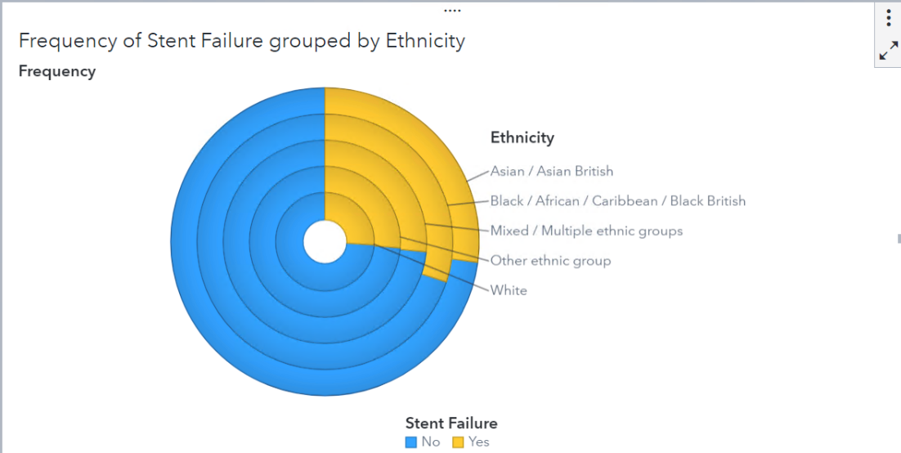

Intermediate Level - Part 2: Solutions
Question:
- Only the numeric, or measures, are shown
- Stent_Length, Stent_Width, Stent_Thickness

Complete the following steps to prepare the partition variable:
- In the Data pane click to create a new partition variable.
- Select Simple Random Sampling as the sampling method.
- Include 2 partitions with a 70% training percentage.
- Check the box and input a random number seed 772020. If you leave this option unchecked, SAS Viya choose a different random number seed so results will vary.
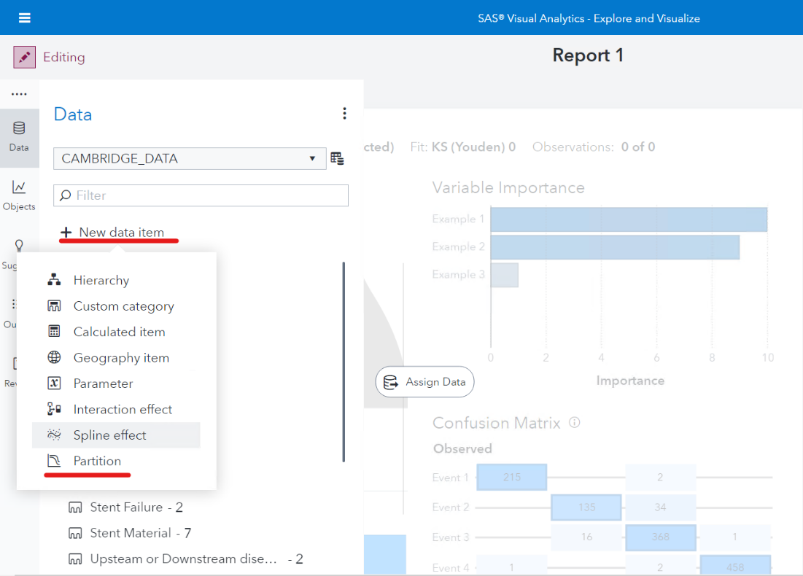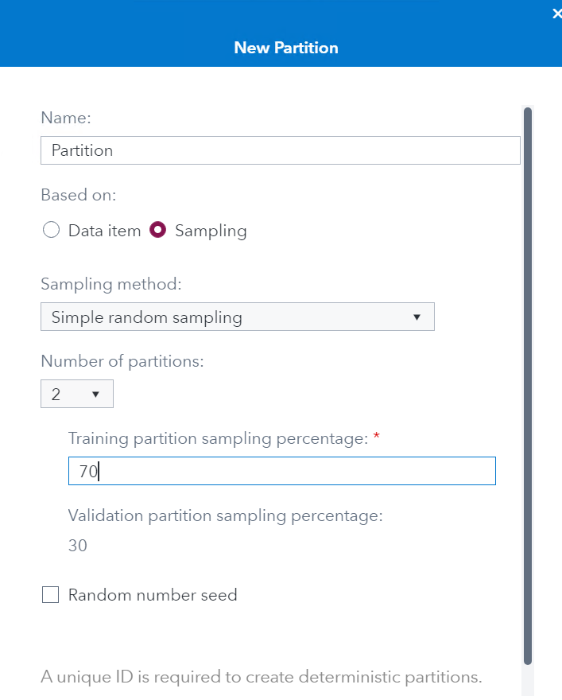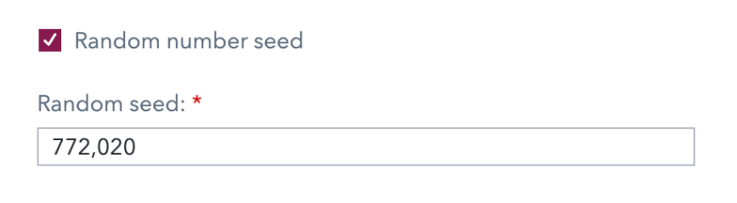

Intermediate Level - Part 3: Solutions
Model 1: Decision Tree Model
Questions:
- Plaque Prolapse through cells of the stent, Stent Material, Geographic Miss, Stent Cell Design, Multiple Stent, device age(days)
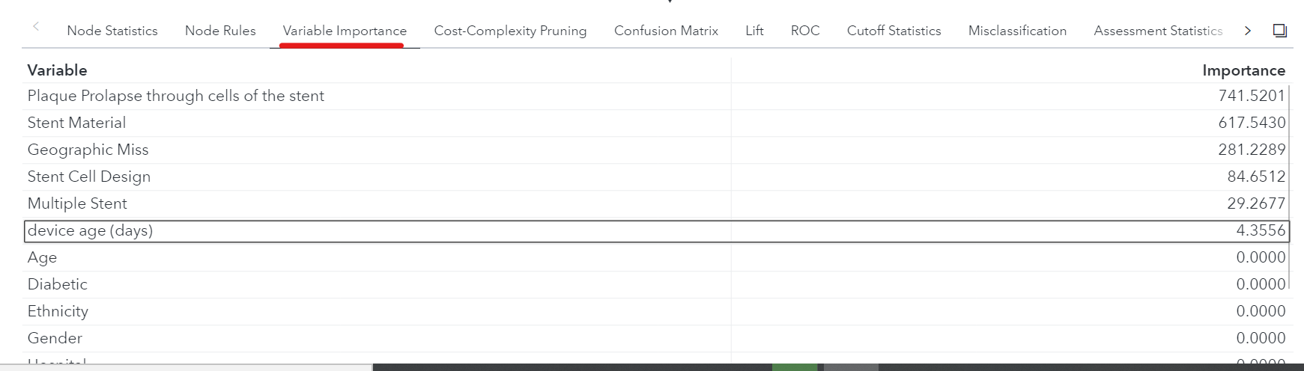
- Plaque Prolapse through cells of the stent. Rules: “<1 or Missing” and “>=1” 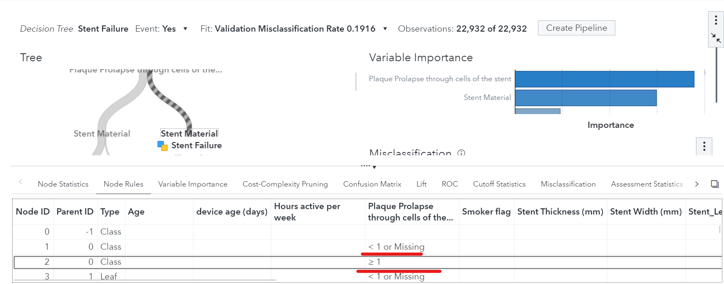
Note: You can see more detail by maximizing the decision tree object. The details table is displayed at the bottom of the canvas)

- 13 (Leaf nodes are the nodes of the tree that have no additional nodes coming off them)
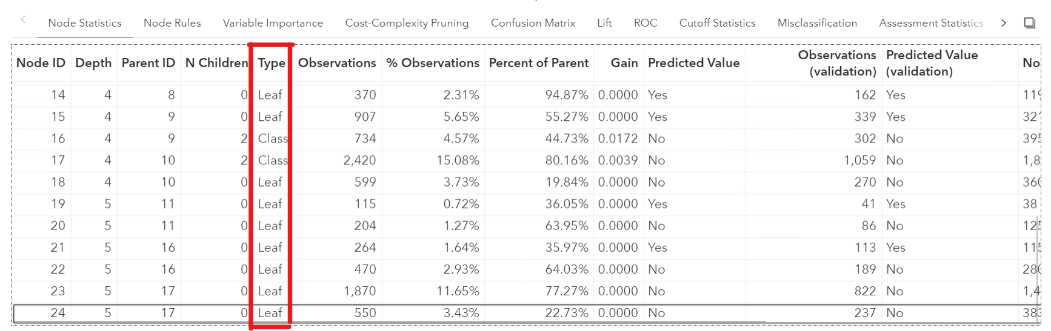
- Answer: 3.3007, 2.5829
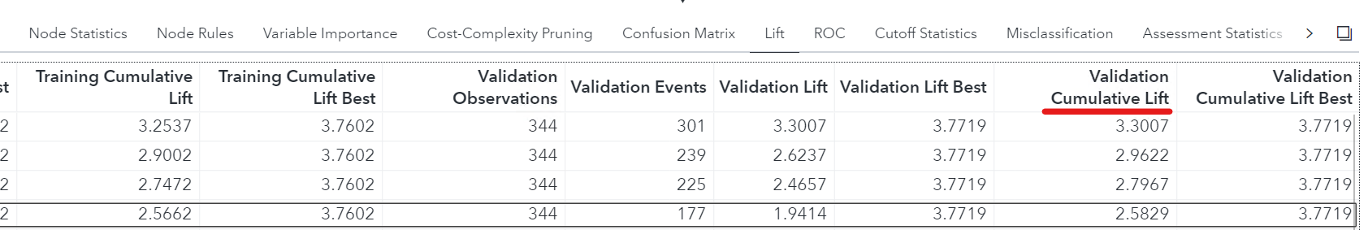
OR 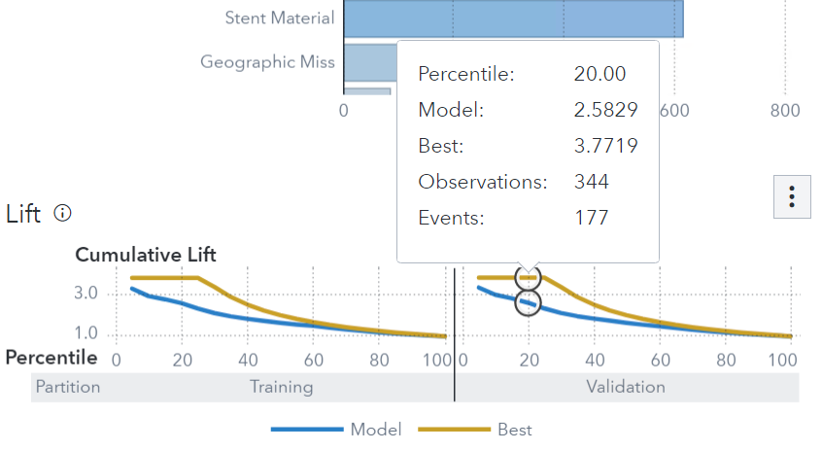
- Answer: VK-S is 0.4570
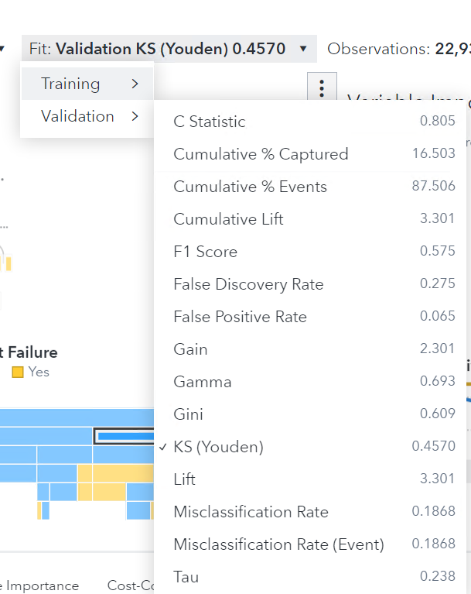
NOTE: K-S should be a high value (Max =1.0) when the fit is good and a low value (Min = 0.0) when the fit is not good. When the K-S value goes below 0.05, you will be informed that the Lack of fit is significant.
- 956
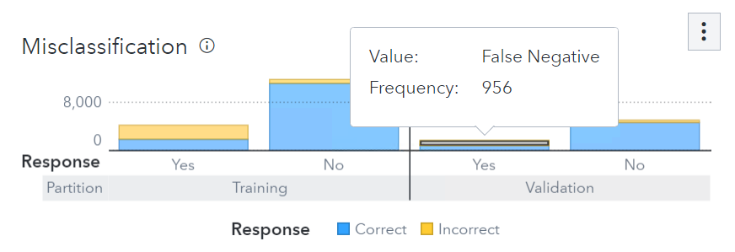
- 0.1868 on validation set
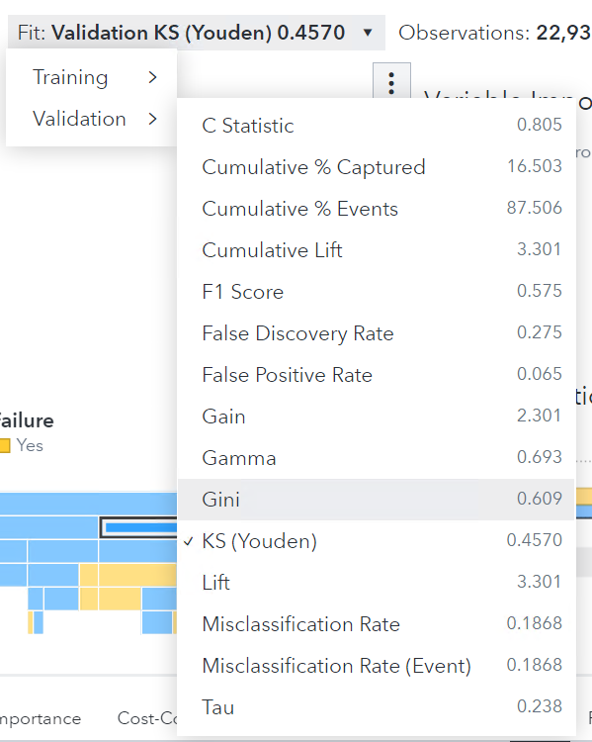
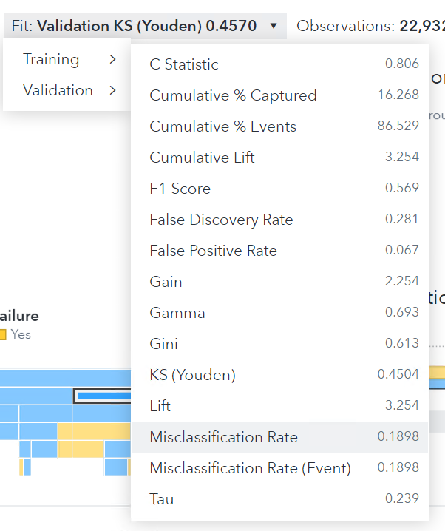

Model 2: Logistic Regression
Question:
- Plaque Prolapse through cells of the stent, Stent Material, Geographic Miss, Stent Cell Design, Multiple Stent, Hours active per week, Age, Device age(days), Ethnicity, Hospital and Stent Thickness(mm), Upsteam and Downstream disease in the Coronary
- 3.1869, 2.4747
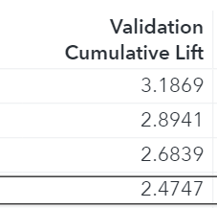
- 0.4774
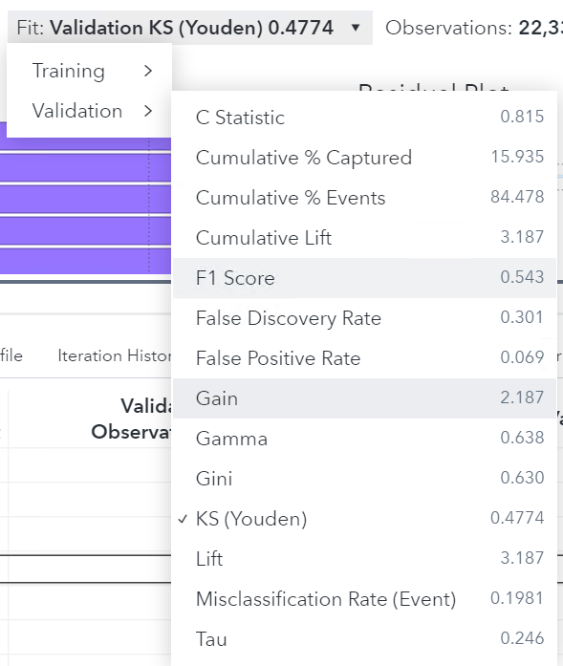
- 988
- 0.1981 on Validation. 0.1835 on Training

Model 3: Gradient Boosting
Question:
- All variables
- 3.5417, 2.6672
- 0.5178
- 920
- 0.1849 on validation, 0.1710 on training

Model 4: Neural Network Model
Question:
- All variables
- 3.1306, 2.4944
- 0.4765
- 1031
- 0.2004 on validation, 0.1849 on training

Model 5: Forrest Model
Question:
- All variables
- 3.2469, 2.4299
- 0.4658
- 1281
- 0.2129 on validation, 0.1956 on training

Model Comparison
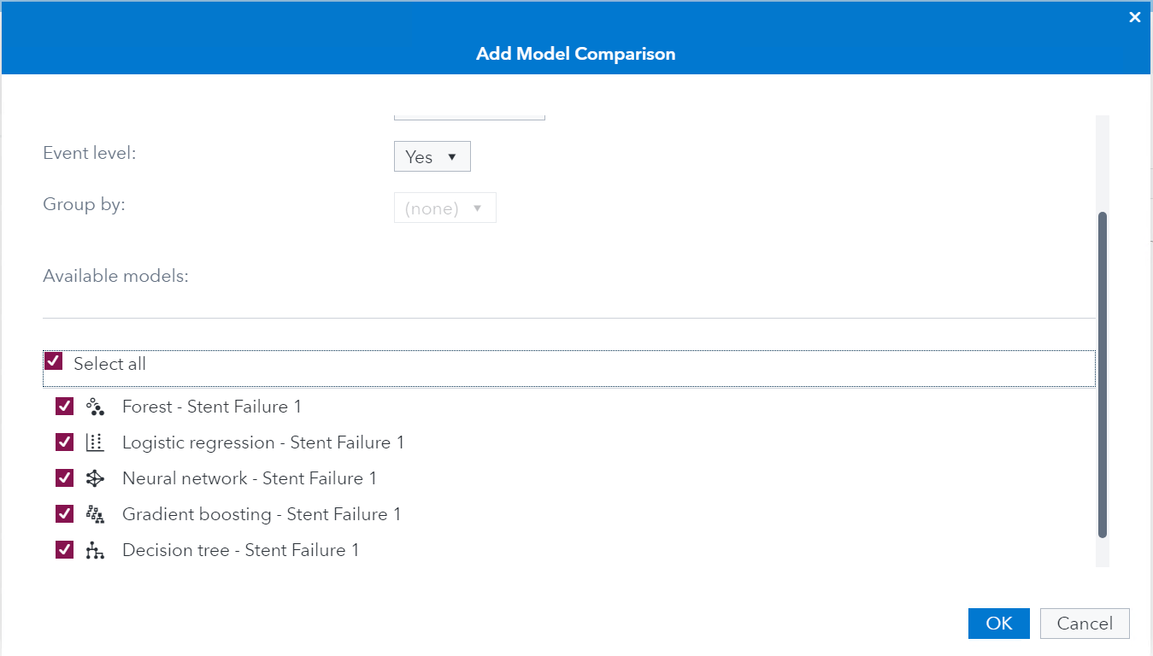

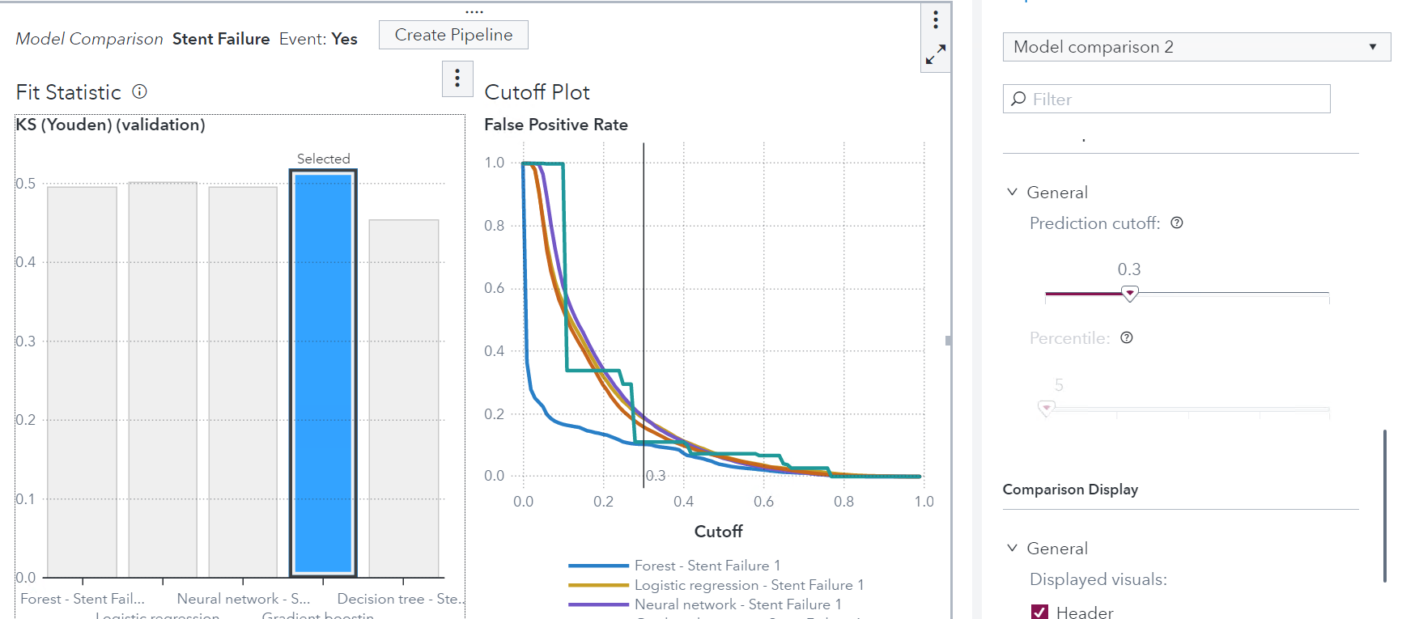

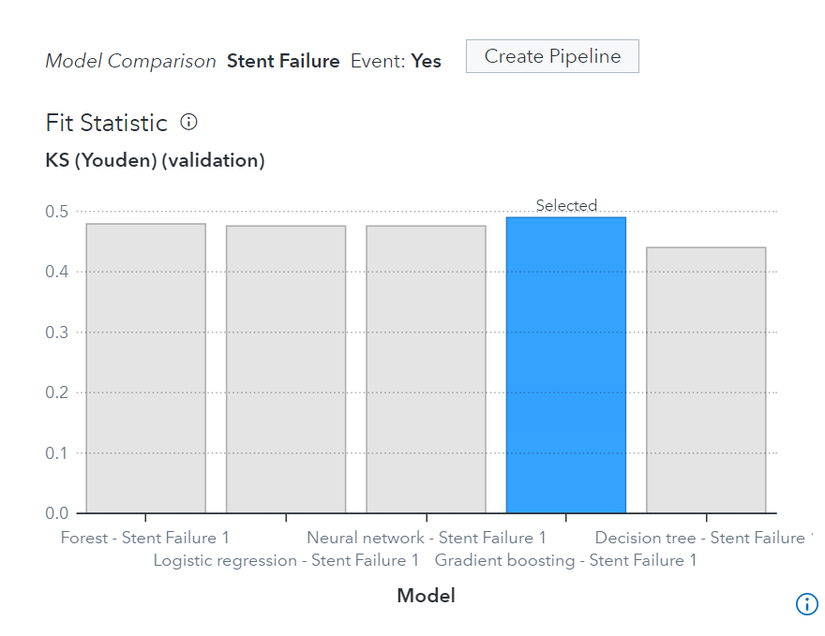
Questions:
- Gradient Boosting
- Forrest (VFPR: 0.109)
- Gradient Boosting (VK-S:0.5174)

Advanced Level - Part 3: Solutions
Model 1: Decision Tree Model
Questions:
- Plaque Prolapse through cells of the stent, Stent Material, Geographic Miss, Stent Cell Design, Multiple Stent, Age, Hospital
- Plaque Prolapse through cells of the stent. “< 1 or missing” and “>=1”
- 17
- 2.9469, 2.5243
- VK-S is 0.4409
- 1012
- 0.1946 on validation. 0.1871 on training

Model 2: Logistic Regression
Questions:
- Plaque Prolapse through cells of the stent, Stent Material, Geographic Miss, Stent Cell Design, Multiple Stent, Hospital, Hours active per week, Stent Thickness (mm), Ethnicity, Upsteam and Downstream disease in the Coronary.
- 3.3662, 3.6952
- VK-S is 0.4937
- 976
- 0.1904 on validation. 0.1861 on training

Model 3: Gradient Boosting
Questions:
- All variables
- 3.4496, 2.6387
- 0.5109
- 926
- 0.1836 on validation. 0.1714 on training.

Model 4: Neural Network Model
Questions:
- All variables
- 3.3201, 2.5867
- 0.4994
- 1011
- 0.1908 on validation. 0.1896 on training

Model 5: Forrest Model
Question:
- All variables
- 3.3151, 3.6615
- 0.4869
- 1269
- 0.2077 on validation. 0.1962 on training.

Model Comparison

Questions:
- Gradient Boosting
- Forrest
- Gradient Boosting

Authors and Contributors
Title & name | University | Subject(s) | Contact details
Haidar Altaie | University of Kent | Statistics | Via www.sas.com/uk
Biography
Additional Contributions
Jeff Thompson
Kuteluke Ainiwaer
Rachel McLawhon

