Group By Basics
List customer ID, names, and their orders
The output below is at order level, not customer
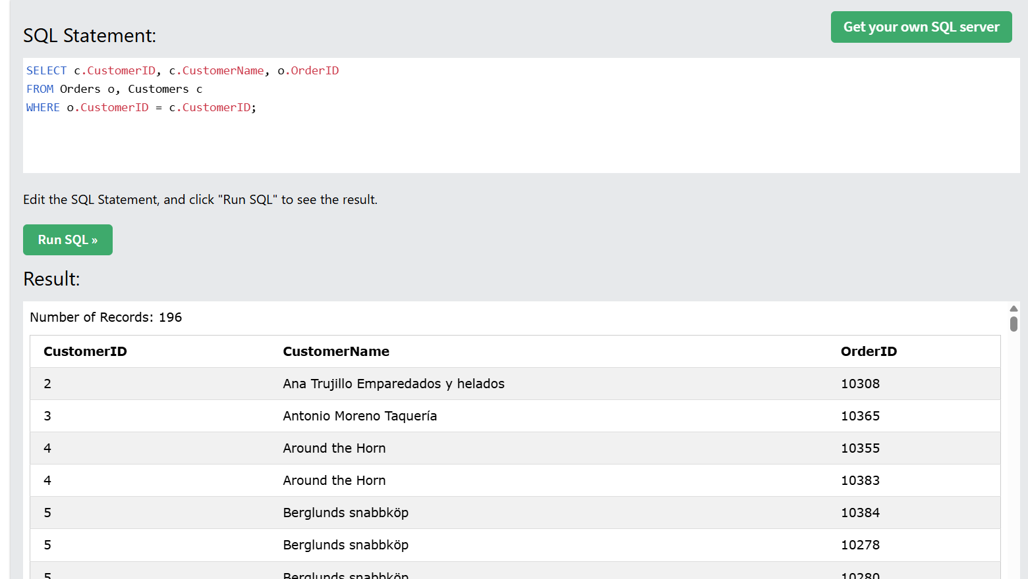
What id you want customer-level output showing customer ID, names, and count number of orders?
Well, you need to group by CustomerID and CustomerName (both, not just CustomerID or CustomerName alone), and count OrderID

SELECT c.CustomerID, c.CustomerName, Count(o.OrderID) as NoOfOrders
FROM Orders o, Customers c
WHERE o.CustomerID = c.CustomerID
GROUP BY c.CustomerID, c.CustomerName;

If you group by CustomerID only, but SELECT clause includes both ID and Name, you’ll get an error message.
