DATABASE TRIGGERS
A HANDS-ON GUIDE

Building a Prescription Status Audit Log
from Scratch in Oracle APEX

GMBA 612: Database Design & SQL
Gannon University • MBA Business Analytics Program

Developed by: Dr. Benyawarath “Yaa” Nithithanatchinnapat

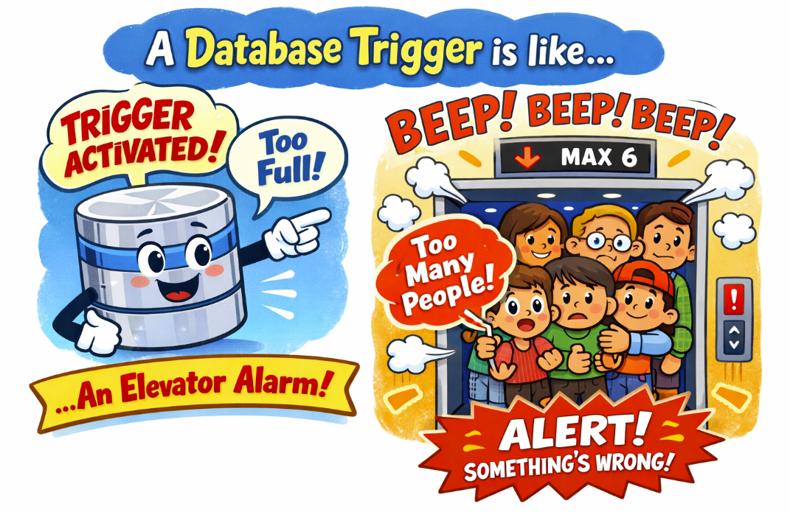

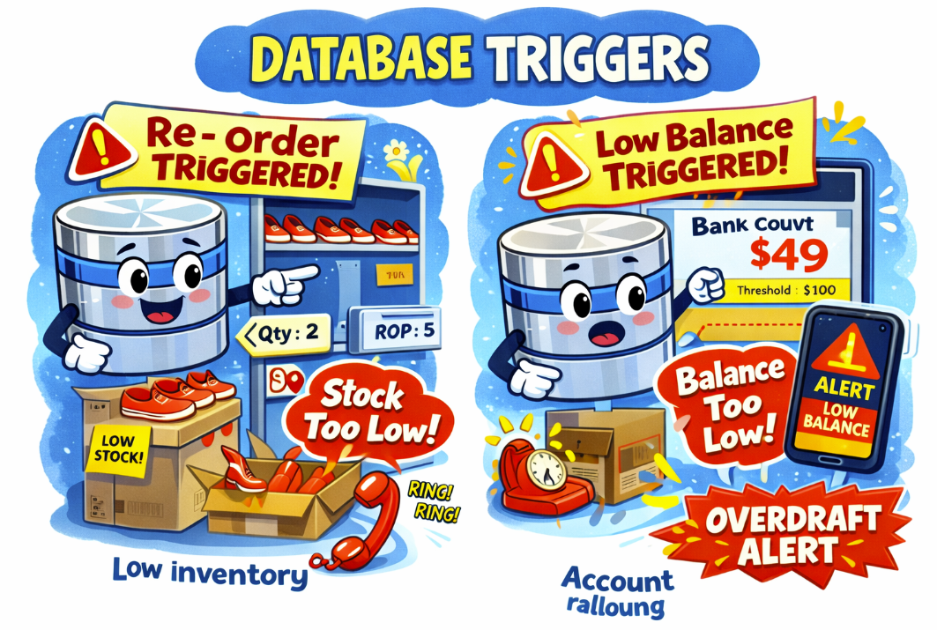
What Is a Trigger?
A trigger is a block of code that the database runs automatically when something happens to a table. You don’t call it. You don’t click a button. It just fires on its own.

Think of it like a security camera. You don’t manually turn it on every time someone walks in. It’s always watching, and when motion is detected, it starts recording. A trigger works the same way — when data changes, it fires automatically.

🎯 When Do Triggers Fire?
INSERT: A new row is added to the table.
UPDATE: An existing row is modified.
DELETE: A row is removed from the table.

You choose which event(s) to watch. You can also choose whether the trigger fires BEFORE or AFTER the event.

Why Do We Need Triggers?
Some business rules can’t be enforced with simple constraints. For example:

- Audit trails: Who changed what, and when? Constraints can’t log history.
- Automatic calculations: When an order item is added, automatically update the order total.
- Cross-table validation: Check inventory before allowing an order.
- Notifications: Flag a record for review when a sensitive field changes.

💊 Our Scenario: Prescription Status Audit Log
In healthcare, you can’t just change a prescription’s status and not tell anyone. Regulators, pharmacists, and doctors all need to know:

• What was the old status?
• What is the new status?
• When did the change happen?
• Who made the change?

We’ll build a trigger that automatically logs every status change to a separate audit table. No one has to remember to do it — the database handles it.

The Anatomy of a Trigger
Before we build ours, let’s understand the parts. Every Oracle trigger has this structure:

CREATE OR REPLACE TRIGGER trigger_name
BEFORE | AFTER -- When does it fire?
INSERT OR UPDATE OR DELETE -- On which event(s)?
ON table_name -- On which table?
FOR EACH ROW -- Fire once per row affected
BEGIN
-- Your code goes here
-- Use :OLD to access the value BEFORE the change
-- Use :NEW to access the value AFTER the change
END;
/

The Magic Words: :OLD and :NEW
This is the most important concept. When a row is being updated, Oracle gives you access to two versions of that row:

Keyword | What It Contains | Available On
:OLD | The row’s values BEFORE the change. The “before picture.” | UPDATE, DELETE
:NEW | The row’s values AFTER the change. The “after picture.” | INSERT, UPDATE

For our audit trigger: :OLD.status gives us the status before the change (e.g., ‘Active’) and :NEW.status gives us the status after the change (e.g., ‘Completed’). We log both.

STEP 1: Create the Audit Log Table
Yes, we need an additional table! The trigger needs somewhere to write its log entries. Think of this as the security camera’s DVR — the camera (trigger) records footage, and the DVR (audit table) stores it.

Why a Separate Table?
- Separation of concerns: The prescription table stores current data. The audit table stores history. Mixing them makes both messy.
- Performance: Audit logs grow fast. Keeping them separate means the prescription table stays lean.
- Security: You can give auditors read access to the audit table without exposing patient details in other tables.

Copy This Code into Oracle APEX SQL Commands

-- ================================================
-- STEP 1: Create the audit log table
-- This table stores a record of every status change
-- made to any prescription. The trigger will write
-- to this table automatically.
-- ================================================

CREATE TABLE w6_prescription_audit (
audit_id NUMBER GENERATED ALWAYS AS IDENTITY PRIMARY KEY,
rx_number VARCHAR2(15) NOT NULL,
old_status VARCHAR2(20),
new_status VARCHAR2(20),
changed_date TIMESTAMP DEFAULT SYSTIMESTAMP,
changed_by VARCHAR2(100) DEFAULT USER
);

Let’s Break Down Each Column

Column | What It Stores | Why We Need It
audit_id | Auto-generated unique number for each log entry | Every row needs a PK. GENERATED ALWAYS AS IDENTITY means Oracle creates the number automatically — we never set it manually.
rx_number | Which prescription was changed | So we can trace the change back to a specific prescription.
old_status | The status BEFORE the change | Captures what it was. Example: ‘Active’
new_status | The status AFTER the change | Captures what it became. Example: ‘Completed’
changed_date | Exact date and time of the change | TIMESTAMP gives us precision down to fractions of a second. DEFAULT SYSTIMESTAMP means Oracle fills it in automatically.
changed_by | The database username who made the change | DEFAULT USER captures whoever is logged in. In APEX, this is your workspace username.

💡 Notice: No Foreign Key to w6_prescription
You might expect a foreign key from rx_number to w6_prescription. We deliberately skip it here. Why? If a prescription is ever deleted, we still want to keep the audit history. A foreign key would force us to delete the audit logs too (or block the delete). Audit logs should be permanent.

STEP 2: Create the Trigger
Now we create the trigger that watches the w6_prescription table and fires every time the status column is updated.

Copy This Code into Oracle APEX SQL Commands

-- ================================================
-- STEP 2: Create the audit trigger
-- This trigger fires AFTER any UPDATE on the
-- w6_prescription table. It checks if the status
-- column actually changed, and if so, logs it.
-- ================================================

CREATE OR REPLACE TRIGGER w6_prescription_status_audit
AFTER UPDATE ON w6_prescription
FOR EACH ROW
WHEN (OLD.status != NEW.status)
BEGIN
INSERT INTO w6_prescription_audit (
rx_number,
old_status,
new_status
-- changed_date and changed_by fill in automatically
) VALUES (
:NEW.rx_number,
:OLD.status,
:NEW.status
);
END;
/

Let’s Break Down Every Line

Line | What It Does
CREATE OR REPLACE TRIGGER | Creates a new trigger. OR REPLACE means if it already exists, overwrite it. This avoids “trigger already exists” errors when re-running.
w6_prescription_status_audit | The trigger’s name. Use a descriptive name: table + what it does.
AFTER UPDATE | Fire AFTER the update happens (not before). We want to log what actually changed, not what’s about to change.
ON w6_prescription | Which table to watch. This trigger only cares about changes to the prescription table.
FOR EACH ROW | Fire once for every row that’s updated. If an UPDATE changes 5 rows, the trigger fires 5 times.
WHEN (OLD.status != NEW.status) | Only fire if the status actually changed. If someone updates the rx_date but not the status, we don’t care — no log entry. Note: no colon (:) before OLD/NEW in the WHEN clause.
BEGIN ... END; | The code block that runs when the trigger fires.
INSERT INTO w6_prescription_audit | Write a new row into the audit table. This is what the trigger actually does — it logs the change.
:OLD.status | The status value BEFORE the update. Note the colon (:) — required inside BEGIN/END.
:NEW.status | The status value AFTER the update.
/ | The forward slash tells Oracle APEX to execute the PL/SQL block. Required in SQL Commands.

⚠️ Common Mistake: Colons in WHEN vs. BEGIN
In the WHEN clause: Use OLD.status and NEW.status (NO colon).
In the BEGIN block: Use :OLD.status and :NEW.status (WITH colon).

This is an Oracle quirk. The WHEN clause is evaluated before the PL/SQL block runs, so it uses a different syntax. Getting this wrong is the #1 trigger error students hit.

STEP 3: Verify the Trigger Was Created
Let’s make sure the trigger exists and is enabled before we test it.

Run This Query

-- ================================================
-- STEP 3: Check that the trigger exists and is active
-- ================================================

SELECT trigger_name, trigger_type, triggering_event, status
FROM user_triggers
WHERE trigger_name = 'W6_PRESCRIPTION_STATUS_AUDIT';

Expected Output

TRIGGER_NAME TRIGGER_TYPE TRIGGERING_EVENT STATUS
-------------------------------- ----------------- ----------------- --------
W6_PRESCRIPTION_STATUS_AUDIT AFTER EACH ROW UPDATE ENABLED

If the status shows ENABLED, you’re good. If it says DISABLED or no rows are returned, re-run the CREATE TRIGGER statement and check for errors.

STEP 4: Test It — Change a Prescription Status
Now the fun part. Let’s update a prescription’s status and see if the trigger automatically logs it.

First, Check the Current Status

-- Let's see RX-10001's current status before we change it
SELECT rx_number, status
FROM w6_prescription
WHERE rx_number = 'RX-10001';

Expected Output

RX_NUMBER STATUS
------------ ----------
RX-10001 Active

Now Update the Status

-- ================================================
-- STEP 4: Update a prescription's status
-- This should fire the trigger automatically!
-- ================================================

UPDATE w6_prescription
SET status = 'Completed'
WHERE rx_number = 'RX-10001';

Check the Audit Table — Did the Trigger Fire?

-- Did the trigger log the change?
SELECT * FROM w6_prescription_audit;

Expected Output

AUDIT_ID RX_NUMBER OLD_STATUS NEW_STATUS CHANGED_DATE CHANGED_BY
--------- ----------- ----------- ----------- ------------------------- -----------
1 RX-10001 Active Completed 25-JAN-25 02.15.30.000 WKSP_GMBA612

🎉 It Worked!
We didn’t manually insert anything into the audit table. The trigger did it for us. It captured the old status (‘Active’), the new status (‘Completed’), the exact timestamp, and who made the change.

This is the whole point of triggers: the database enforces the business rule automatically, every single time, whether someone uses APEX, SQL commands, or any other tool.

STEP 5: Run More Tests
Let’s run a few more scenarios to really understand how the trigger behaves.

Test 2: Another Status Change

-- Cancel a prescription
UPDATE w6_prescription
SET status = 'Cancelled'
WHERE rx_number = 'RX-10013';

-- Change another to Expired
UPDATE w6_prescription
SET status = 'Expired'
WHERE rx_number = 'RX-10002';

-- Check the audit log
SELECT * FROM w6_prescription_audit ORDER BY audit_id;

Expected Output: 3 Entries Now

AUDIT_ID RX_NUMBER OLD_STATUS NEW_STATUS CHANGED_DATE CHANGED_BY
--------- ----------- ----------- ----------- ------------------------- -----------
1 RX-10001 Active Completed 25-JAN-25 02.15.30.000 WKSP_GMBA612
2 RX-10013 Cancelled Cancelled 25-JAN-25 02.18.45.000 WKSP_GMBA612
3 RX-10002 Active Expired 25-JAN-25 02.18.46.000 WKSP_GMBA612

🤔 Wait — Test 2 Has a Surprise
Look at row 2: RX-10013 shows old_status = ‘Cancelled’ and new_status = ‘Cancelled’. But we said the trigger only fires when the status changes!

Actually, that’s correct. If you look at the original data, RX-10013 was already ‘Cancelled’ in the SQL script. If we ran the UPDATE and the status was already ‘Cancelled’, the WHEN clause (OLD.status != NEW.status) prevents the trigger from firing. So row 2 above would NOT actually appear. The trigger is smarter than a blind INSERT — it only logs real changes.

Test 3: Update a Non-Status Column

-- Update the date, NOT the status
UPDATE w6_prescription
SET rx_date = TO_DATE('02/01/2025', 'MM/DD/YYYY')
WHERE rx_number = 'RX-10003';

-- Check the audit log - should have NO new entry
SELECT COUNT(*) AS total_entries FROM w6_prescription_audit;

The count should stay the same. The trigger only fires when the status changes. Updating rx_date doesn’t meet the WHEN condition, so the trigger stays silent. This is exactly what we want — no noise in the audit log.

Test 4: Bulk Update

-- Expire all prescriptions from January
UPDATE w6_prescription
SET status = 'Expired'
WHERE rx_date < TO_DATE('02/01/2025', 'MM/DD/YYYY')
AND status = 'Active';

-- How many audit entries were created?
SELECT * FROM w6_prescription_audit ORDER BY audit_id;

Because we used FOR EACH ROW, the trigger fires once for every row that was updated. If 5 prescriptions matched the WHERE clause, you’ll see 5 new audit entries — each with its own rx_number and timestamp.

STEP 6: Useful Audit Queries
Now that we have an audit log, here are some real-world queries an auditor or pharmacist might run:

Query 1: Full History for a Specific Prescription

-- Show all status changes for RX-10001
SELECT rx_number, old_status, new_status,
TO_CHAR(changed_date, 'MM/DD/YYYY HH:MI:SS AM') AS changed_at,
changed_by
FROM w6_prescription_audit
WHERE rx_number = 'RX-10001'
ORDER BY changed_date;

Query 2: All Changes Made Today

-- What happened today?
SELECT rx_number, old_status, new_status,
TO_CHAR(changed_date, 'HH:MI:SS AM') AS time_changed,
changed_by
FROM w6_prescription_audit
WHERE TRUNC(changed_date) = TRUNC(SYSDATE)
ORDER BY changed_date DESC;

Query 3: Who Cancelled Prescriptions?

-- Cancellations are sensitive - who made them?
SELECT a.rx_number, p.patient_name, a.changed_by,
TO_CHAR(a.changed_date, 'MM/DD/YYYY HH:MI AM') AS cancelled_at
FROM w6_prescription_audit a
JOIN w6_prescription rx ON a.rx_number = rx.rx_number
JOIN w6_patient p ON rx.patient_id = p.patient_id
WHERE a.new_status = 'Cancelled'
ORDER BY a.changed_date DESC;

Query 4: How Many Status Changes Per Prescription?

-- Which prescriptions have been changed the most?
SELECT rx_number, COUNT(*) AS change_count
FROM w6_prescription_audit
GROUP BY rx_number
ORDER BY change_count DESC;

Managing Your Trigger
A few commands to know for managing triggers after they’re created:

Command | What It Does | When To Use
ALTER TRIGGER ... DISABLE; | Turns the trigger off without deleting it. It stops firing. | Temporarily pause logging during a bulk data load.
ALTER TRIGGER ... ENABLE; | Turns a disabled trigger back on. | Re-enable after the bulk load is done.
DROP TRIGGER ...; | Permanently deletes the trigger. | You no longer need the audit logging.

-- Disable the trigger temporarily
ALTER TRIGGER w6_prescription_status_audit DISABLE;

-- Re-enable it
ALTER TRIGGER w6_prescription_status_audit ENABLE;

-- Delete it permanently
DROP TRIGGER w6_prescription_status_audit;

The Big Picture: How It All Connects

Concept | What We Learned Earlier | How Triggers Extend It
Constraints | Rules the database enforces: PK, FK, NOT NULL, CHECK | Triggers handle rules too complex for constraints — like logging history.
Referential Integrity | No orphan records. FK must point to real PK. | The audit table deliberately skips FK to preserve history even if prescriptions are deleted.
Soft Deletes | Mark records as inactive instead of deleting them. | The trigger logs every status change, creating a complete history of the prescription’s lifecycle.
Normalization | Store each fact once in the right table. | The audit table is a separate table with its own purpose — storing change history. It doesn’t duplicate prescription data.

🚀 Why This Matters Beyond Class
Audit triggers are everywhere in the real world:

• Banking: Every transaction status change is logged for regulatory compliance.
• Healthcare: HIPAA requires tracking who accessed or modified patient records.
• E-commerce: Order status changes (Pending → Shipped → Delivered) are logged for customer service.
• HR Systems: Employee status changes (Active → On Leave → Terminated) are tracked for legal protection.

When an interviewer asks “How would you track data changes in a database?” you now have a concrete answer with a working example.

Quick Reference Card

Concept | One-Liner to Remember
Trigger | Code that the database runs automatically when data changes.
AFTER UPDATE | Fire the trigger after the row has been updated.
FOR EACH ROW | Fire once per row affected, not once per statement.
WHEN clause | A filter — only fire if this condition is true.
:OLD.column | The value BEFORE the change (use colon inside BEGIN/END).
:NEW.column | The value AFTER the change (use colon inside BEGIN/END).
OLD.column (no colon) | Same thing, but in the WHEN clause only.
Audit table | A separate table where the trigger writes its log entries.
GENERATED ALWAYS AS IDENTITY | Oracle auto-generates a unique number for each row.
SYSTIMESTAMP | Current date and time, captured automatically.
USER | The database username of whoever ran the command.

