⭐ ✨ 🌙
A Bedtime Story for
Future Operations Managers

The Midnight Bakery
A Lean Six Sigma Fairy Tale
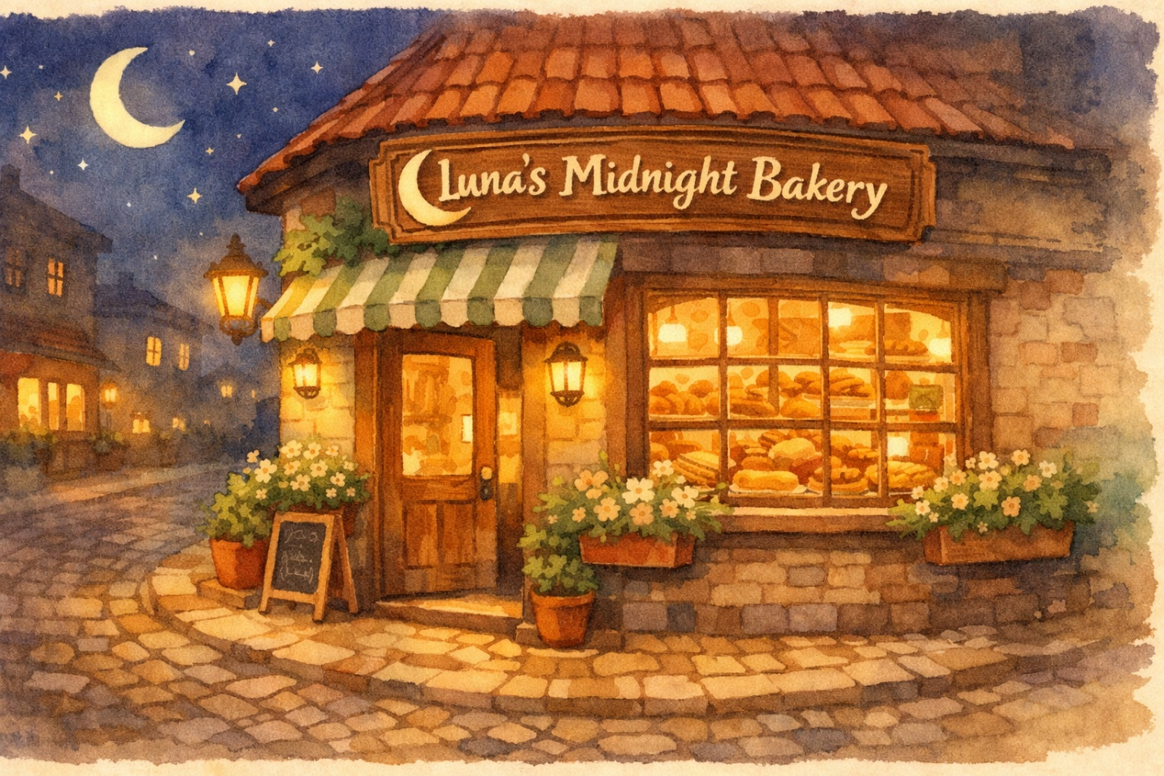
Teaching the Seven Quality Tools, DMAIC, TIMWOOD Wastes,
5S, Kaizen, Poka-Yoke & More Through Storytelling

BCOR-440 / IE-425 | created by Dr. Benyawarath “Yaa” Nithithanatchinnapat

Chapter One
The Bakery That Never Sleeps

Once upon a time, on a quiet street that smelled like cinnamon and possibility, there was a little bakery called Luna’s Midnight Bakery.

Luna had started it with nothing but a grandmother’s sourdough recipe, a second-hand oven, and a stubborn belief that the world needed warm bread at midnight. And for a while, it was magic.
But lately… things had gotten messy.

Croissants came out lopsided. Flour dusted every surface like indoor snow. Orders got mixed up. Customers waited too long. And one terrible Tuesday, a wedding cake went out with “Happy Birthday, Greg” written on it.

Luna: “Something has to change. But I don’t even know where to start.”

That’s when she found the letter.

Tucked behind the old oven, in an envelope that smelled like vanilla, was a note from her grandmother:

“My darling Luna — If the bakery ever feels like it’s crumbling, don’t panic. Follow the path of the Seven Friends. They will show you how to see what’s really happening, find the root of every problem, and make things better, one small step at a time. Start with the Flowchart. She will show you the way.”

Luna turned the letter over. On the back, in her grandmother’s handwriting, were two words:
DMAIC. TIMWOOD.

Luna: “What on earth is a TIMWOOD?”

✨ CONCEPT SPOTLIGHT: DMAIC — The Problem-Solving Journey
Define — Identify customers and their priorities. Measure — Determine how to measure the process and how it’s performing. Analyze — Determine the most likely causes of defects. Improve — Identify means to remove the causes of defects. Control — Determine how to maintain the improvements. Think of DMAIC as a detective story: first you name the crime, then you gather evidence, then you figure out who did it, then you fix it, and finally you make sure it never happens again.

💼 INTERVIEW TIP: If an interviewer asks ‘How would you approach a process problem?’ say: ‘I’d follow the DMAIC framework — first clearly define the problem, measure current performance, analyze root causes with tools like fishbone diagrams, implement targeted improvements, and establish controls to sustain the gains.’

Chapter Two
The Flowchart — Mapping the Midnight Maze

The first friend arrived at exactly 12:01 AM.
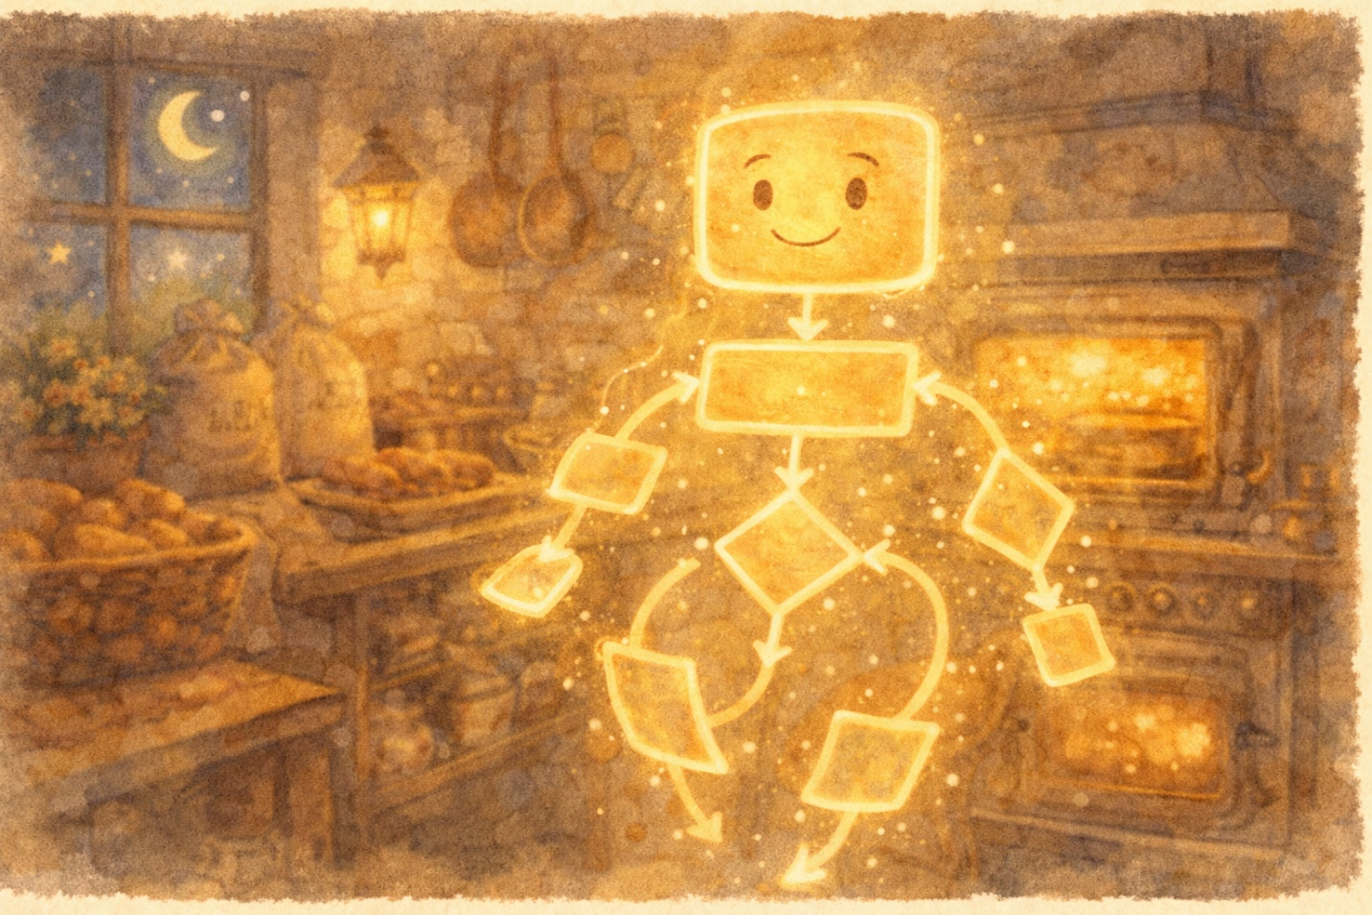
She didn’t knock. She simply appeared—a luminous figure shaped like a road map, with glowing arrows tracing paths across her body.

Flowchart: “I’m the Flowchart, Luna. I show you the sequence of every step in your process. Before you can fix anything, you need to see the whole journey your croissants take—from raw flour to a customer’s hands.”

Together, they traced Luna’s entire baking process on the big chalkboard wall. Every step. Every decision point (those became diamonds). Every handoff.
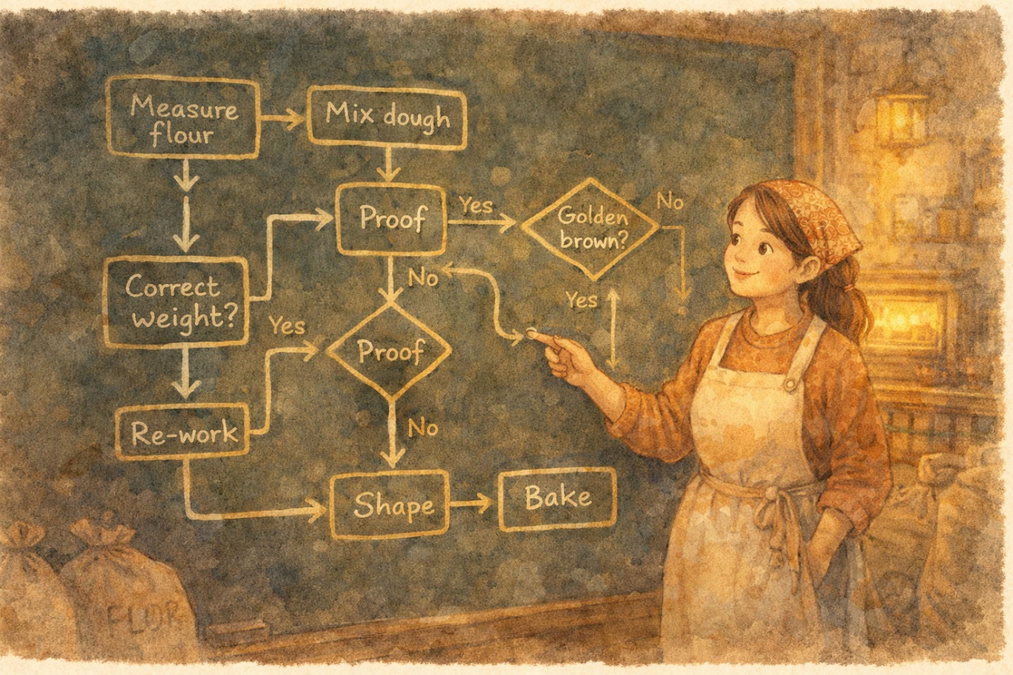

Luna: “I never realized there were 47 steps just to get a loaf of sourdough out the door. No wonder things go wrong!”

Flowchart: “Now you can see where things tangle up. And my cousin, the Opportunity Flow Diagram, can help you figure out which of those 47 steps actually add value for the customer—and which ones are just… waste.”

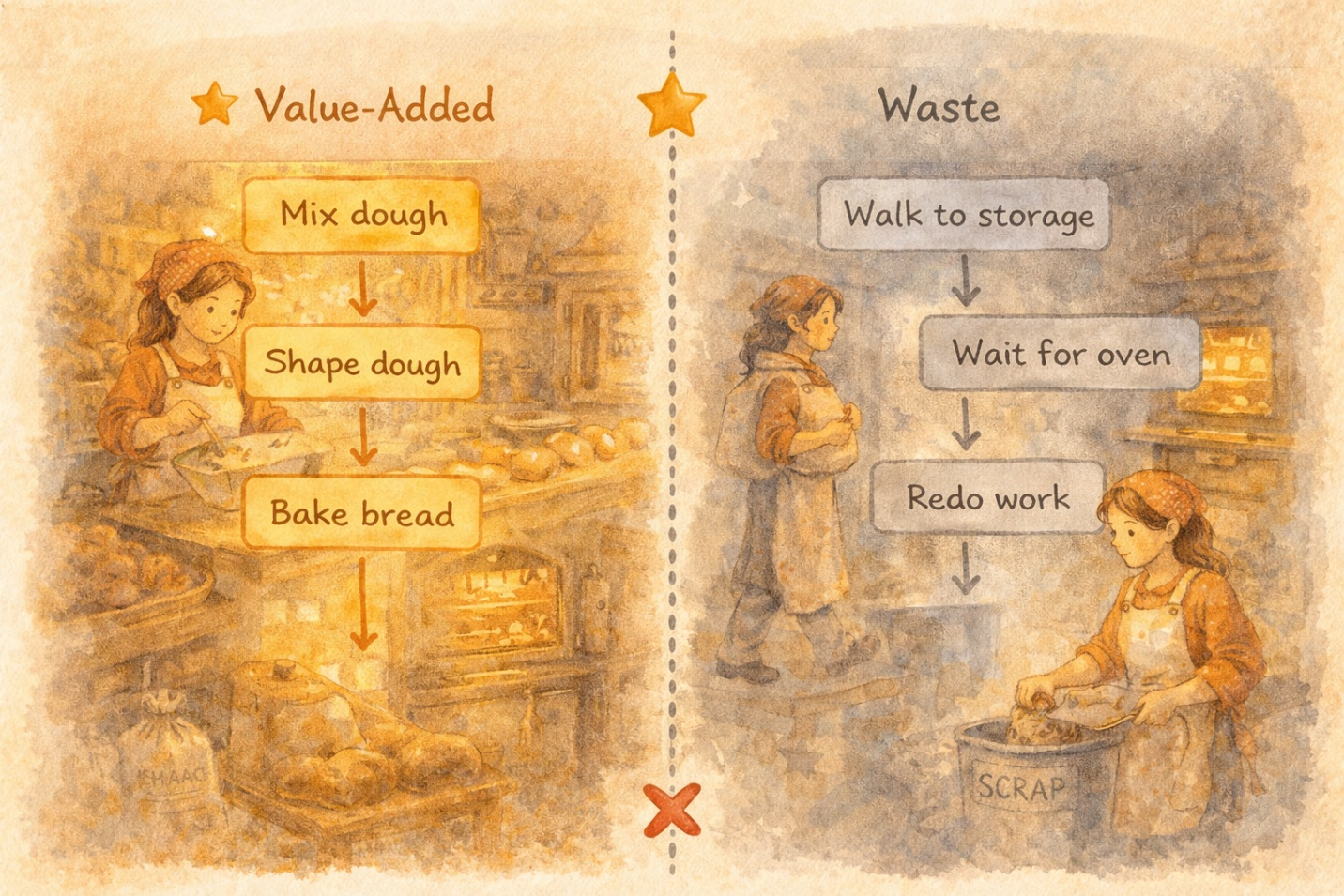

✨ CONCEPT SPOTLIGHT: Flowchart & Opportunity Flow Diagram
A Flowchart is a diagram of the sequence of operations in a process. It uses rectangles for steps, diamonds for decisions, and arrows for flow. An Opportunity Flow Diagram goes further—it separates value-added steps (things the customer would pay for) from non-value-added steps (waste). This is one of the Seven Basic Quality Tools and it’s your starting point for any process improvement effort.

💼 INTERVIEW TIP: In interviews, say: ‘The first thing I’d do is map the current process with a flowchart to understand every step, then use an opportunity flow diagram to distinguish value-added from non-value-added activities.’ This shows structured thinking.

Chapter Three
The Check Sheet — Tallying the Truth

The second friend was quieter. Practical. He arrived carrying a clipboard and a stubby pencil.
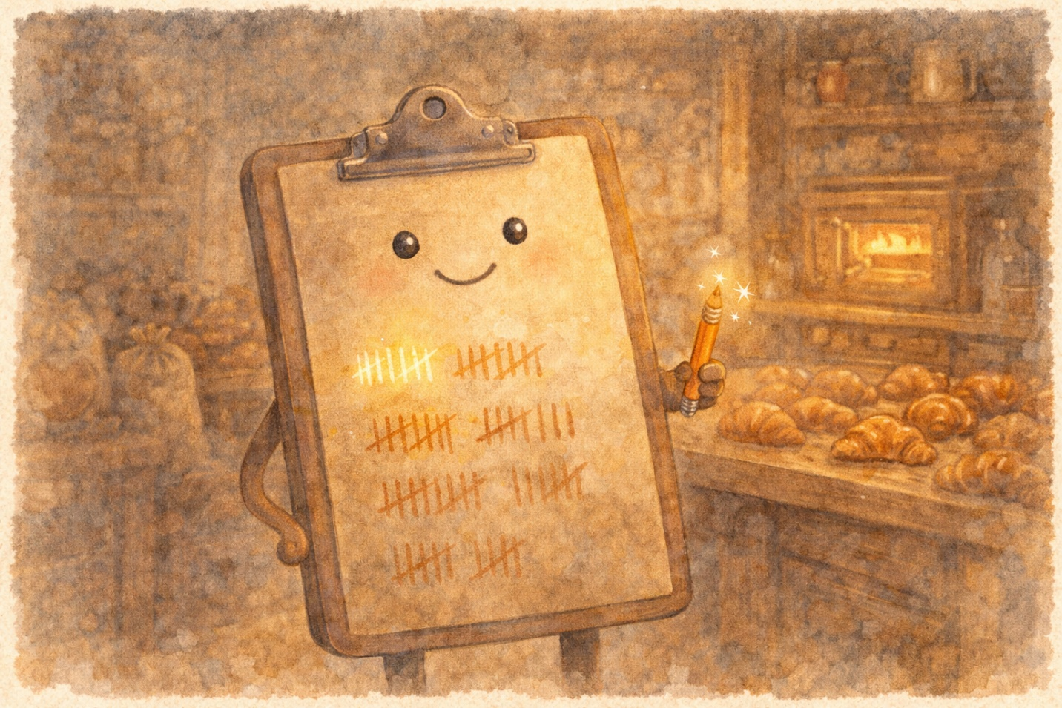
Check Sheet: “I’m simple, Luna, but don’t underestimate me. I’m a structured form for collecting data. Before you can improve anything, you need facts—not feelings.”

For one full week, Luna used the Check Sheet to tally every problem that happened in the bakery. Every burnt batch. Every wrong order. Every time someone slipped on spilled flour. Every delivery that arrived late.
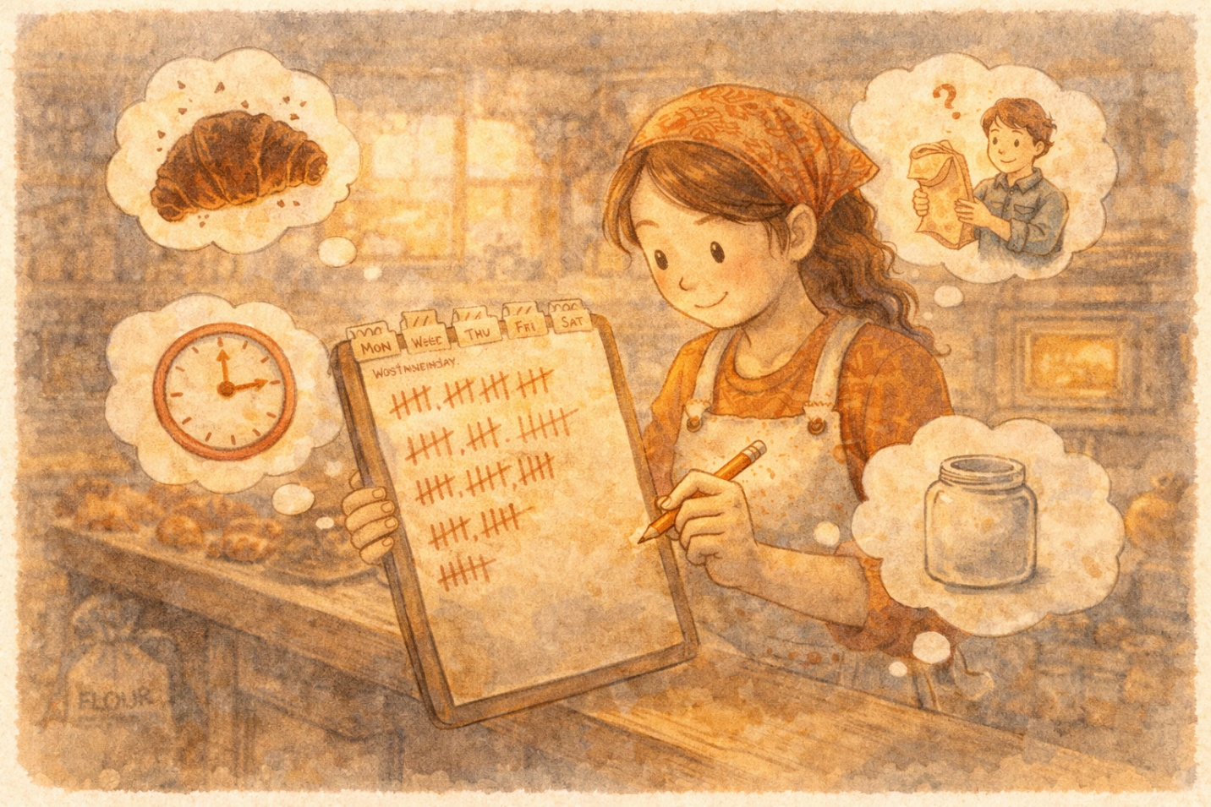
By Friday, the data told a story no guessing ever could:
• Wrong orders: 23 tallies
• Burnt pastries: 18 tallies
• Late deliveries: 14 tallies
• Ingredient shortages: 9 tallies
• Equipment breakdowns: 4 tallies
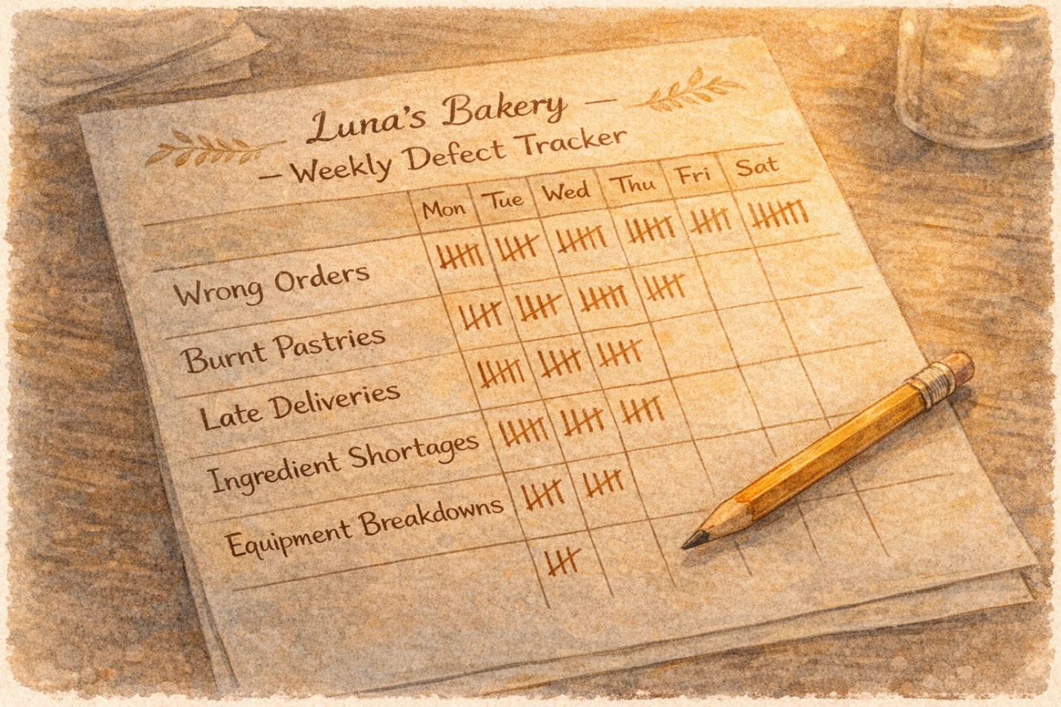
Check Sheet: “Now you’re not guessing. You’re measuring. And that, Luna, is the ‘M’ in DMAIC.”

✨ CONCEPT SPOTLIGHT: Check Sheet (Checksheet)
A Check Sheet is a basic, structured form used to collect and tally data in real time. It lists the characteristics or conditions of interest and provides a place to record their frequency. It often includes columns for date, operator, comments, and stratification factors. It’s the foundation of data-driven decision making—you can’t improve what you haven’t measured.

Chapter Four
The Pareto Chart — Finding the Vital Few

🎨 IMAGE PROMPT: A bar chart character with descending bars of warm gold, terracotta, and sage, with a glowing cumulative line curving upward. The character stands proudly in the bakery, pointing at the tallest bar. A small histogram character (like a colorful column of building blocks) stands beside it. Storybook watercolor.

The third friend swooped in dramatically, wearing a cape made of descending bars.


Pareto: “I’m the Pareto Chart, and I’m here to tell you the most important secret in quality management: roughly 80% of your problems come from about 20% of the causes. I call them the ‘vital few.’”

Pareto took Luna’s check sheet data and arranged the problems from most frequent to least. The tall bars on the left screamed for attention: wrong orders and burnt pastries accounted for over 60% of all problems.
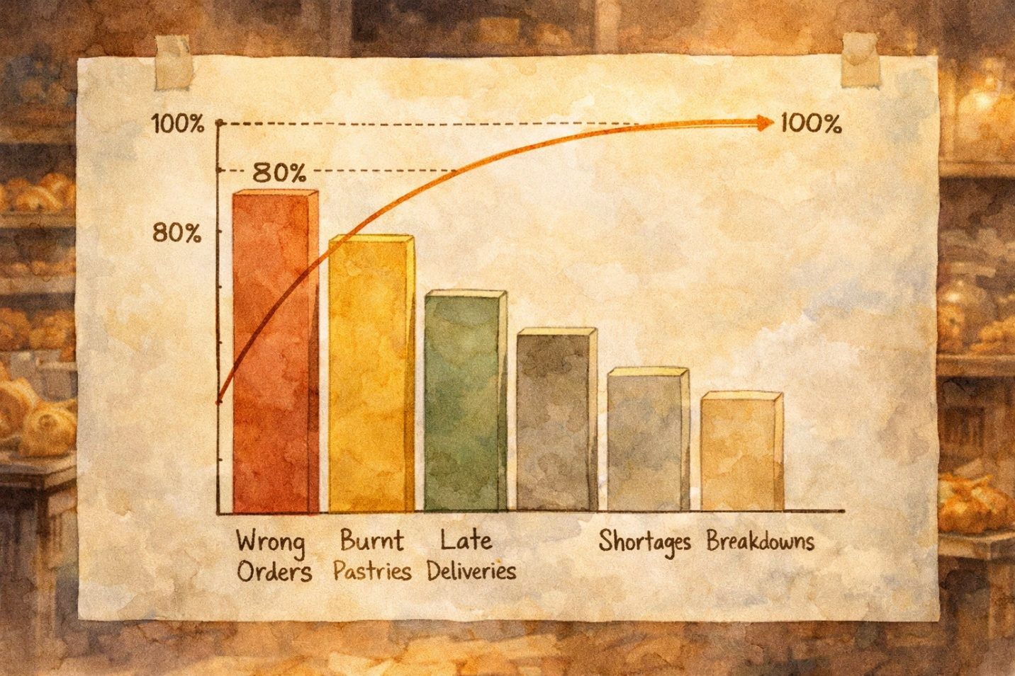

Luna: “So if I fix just those two things, I solve most of my headaches?”
Pareto: “Exactly! Don’t try to fix everything at once. Attack the vital few first.”

Pareto’s quieter friend, the Histogram, stepped forward to add depth. She showed Luna the distribution of burnt pastry bake times—most clustered around the correct range, but there was a suspicious second peak at much higher temperatures.
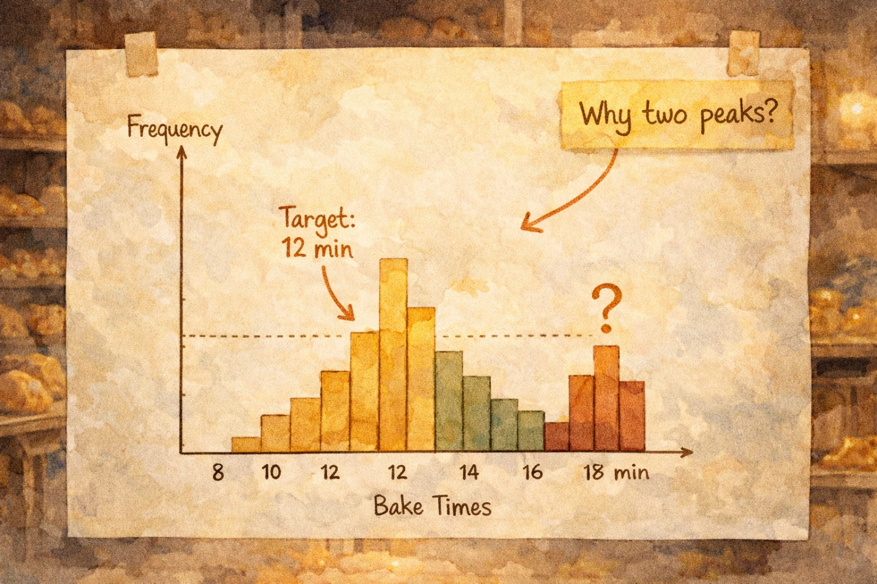
Histogram: “You see that bump? That’s not random variation. Something specific is causing a group of pastries to bake too long. That’s a clue.”

✨ CONCEPT SPOTLIGHT: Pareto Chart & Histogram
A Pareto Chart is a bar chart that ranks problems by frequency (or cost) from highest to lowest, with a cumulative percentage line. It embodies the 80/20 rule—the vital few causes drive most of the problems. A Histogram shows the frequency distribution of data—how often each value occurs. It helps you see the shape of your data: is it normal? Skewed? Bimodal (two peaks)? Both are among the Seven Basic Quality Tools.

💼 INTERVIEW TIP: In case interviews, if given a long list of problems, say: ‘I’d use a Pareto analysis to identify the vital few causes driving most of the impact, so we focus resources where they’ll make the biggest difference.’ Consultants love this language.

Chapter Five
The Fishbone — Swimming Upstream to the Root Cause

The fourth friend arrived as a shimmering fish skeleton—beautiful, intricate, and surprisingly wise.
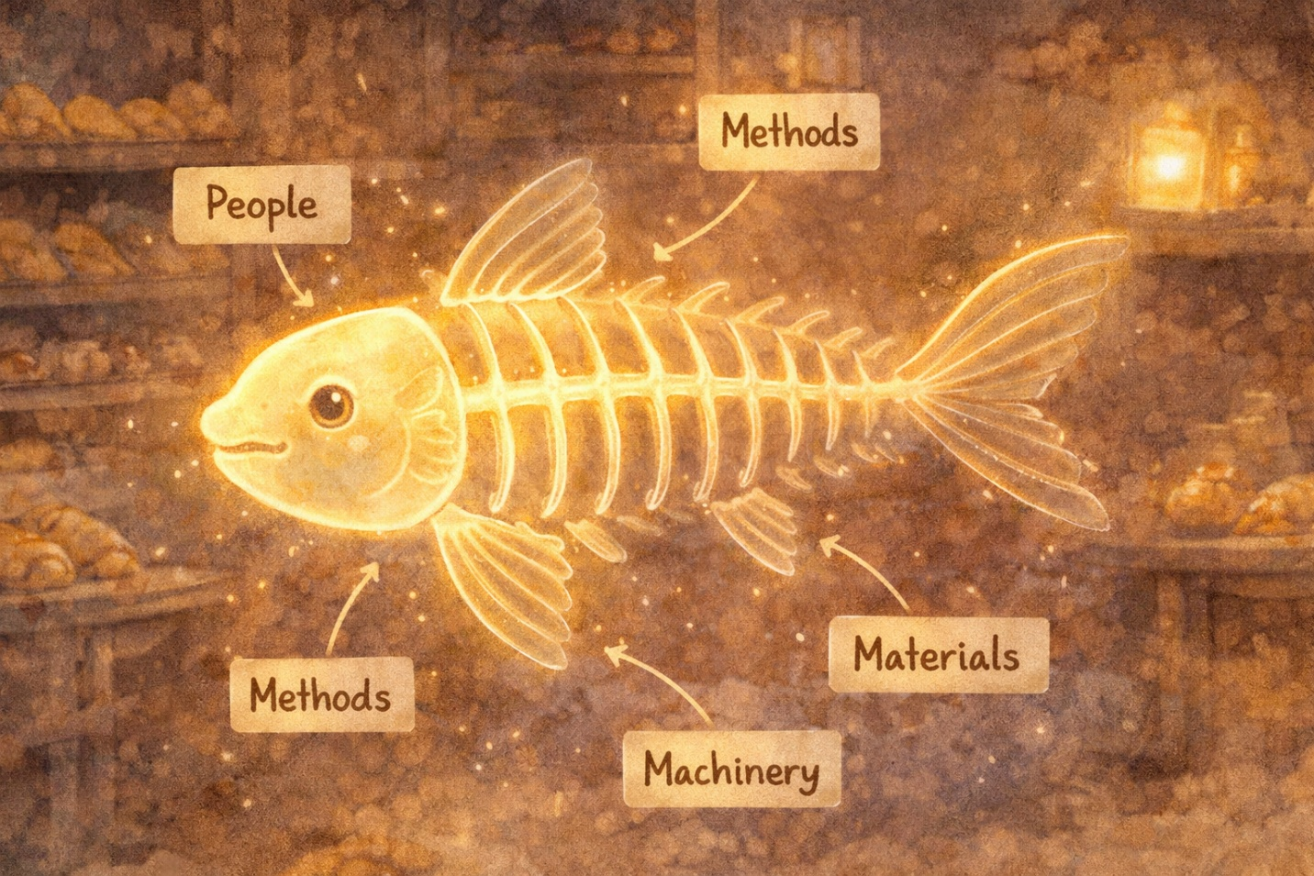

Fishbone: “I’m the Cause-and-Effect Diagram. Some call me the Fishbone. Others call me the Ishikawa Diagram, after the brilliant Kaoru Ishikawa who created me. My job is to help you organize all the possible causes of a problem.”

Together, they drew a long horizontal arrow pointing to the problem: “Burnt Pastries.” Then they added the bones—the major categories of causes:
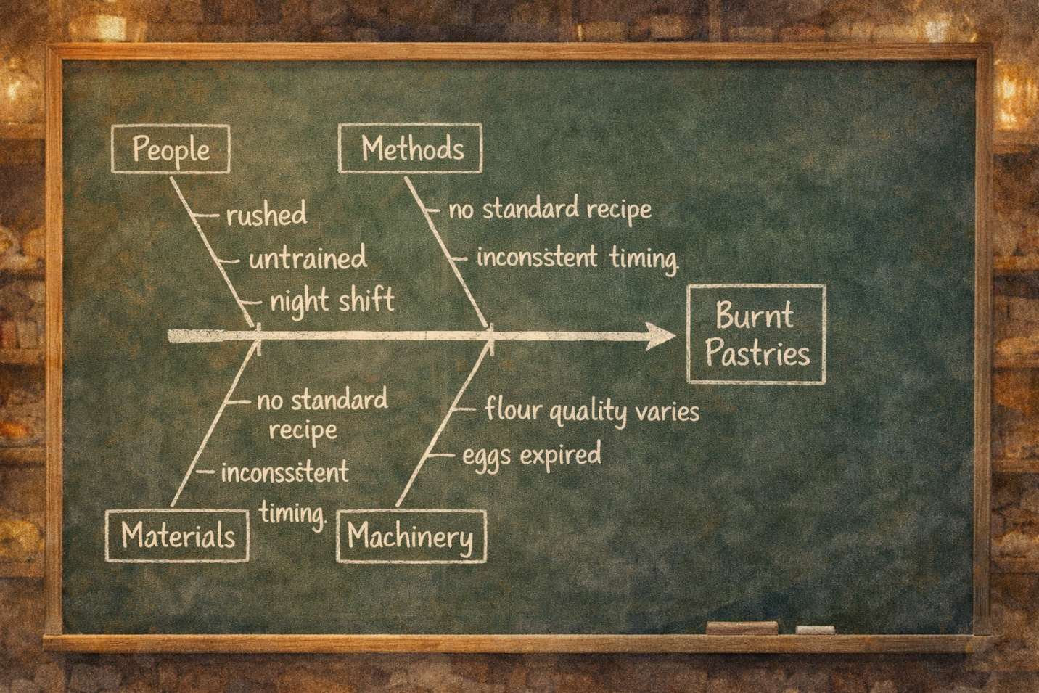

People — Was the night baker properly trained? Were they rushed?
Methods — Was the recipe being followed? Were bake times standardized?
Materials — Was the flour different this week? Were the eggs fresh?
Machinery/Equipment — Was the oven thermostat accurate? Was it calibrated recently?

Fishbone: “Now do something powerful, Luna. For each possible cause, ask ‘Why?’ five times.”

Why were pastries burning? Because the oven was too hot.
Why was the oven too hot? Because the thermostat was off by 25 degrees.
Why was the thermostat off? Because it hadn’t been calibrated in a year.
Why hadn’t it been calibrated? Because there was no maintenance schedule.
Why was there no schedule? Because nobody was responsible for it.
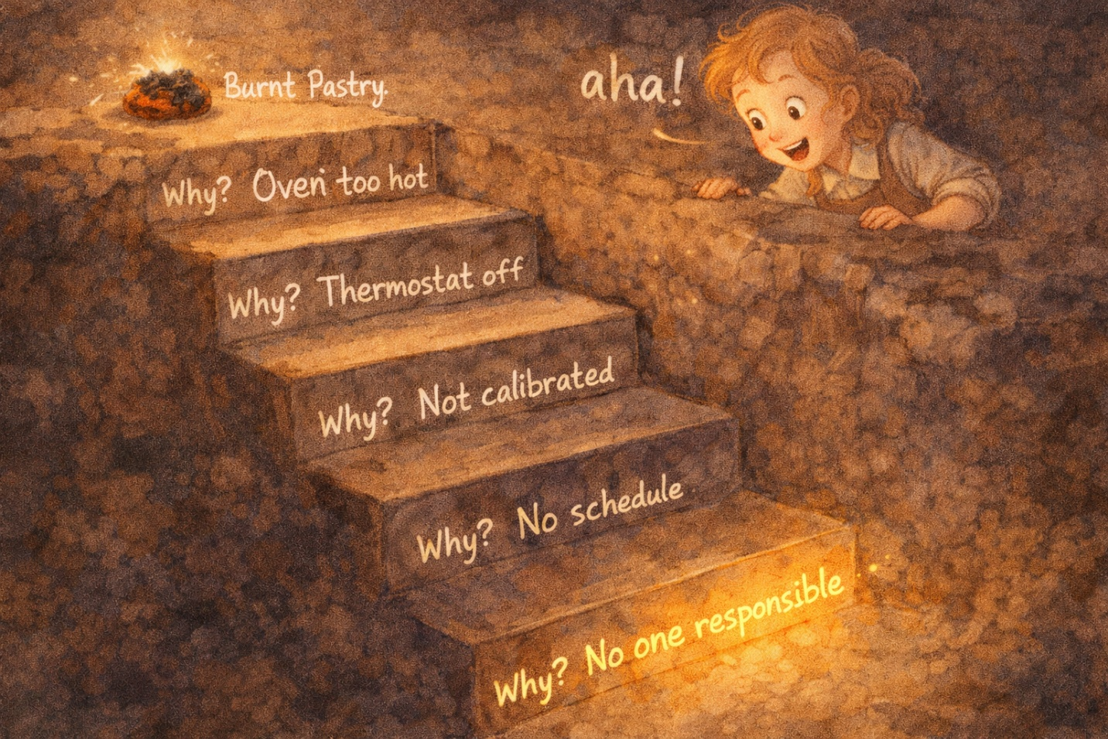
Luna: “So the burnt pastries aren’t really about the oven at all. They’re about not having a maintenance system!”
Fishbone: “Now you’re at the root cause. That’s the ‘A’ in DMAIC—Analyze.”

✨ CONCEPT SPOTLIGHT: Cause-and-Effect (Fishbone/Ishikawa) Diagram + Five Whys
The Fishbone Diagram organizes potential causes of a problem into major categories (typically: People, Methods, Materials, Machinery/Equipment, Measurement, Environment). The ‘head’ of the fish is the effect (problem). Each ‘bone’ is a category. Smaller bones are specific causes. The Five Whys technique probes deeper into each cause by repeatedly asking ‘Why?’ to reach the root cause. Both are essential root cause analysis tools.

💼 INTERVIEW TIP: When asked ‘How do you find root causes?’ say: ‘I’d start with a fishbone diagram to brainstorm all possible causes across categories like people, methods, materials, and equipment. Then I’d use the Five Whys technique to drill down to the true root cause, not just the symptoms.’

Chapter Six
The Night Watchers — Run Charts, Scatter Diagrams & Control Charts

Three friends arrived together, just as the clock struck 2 AM. They called themselves the Night Watchers.
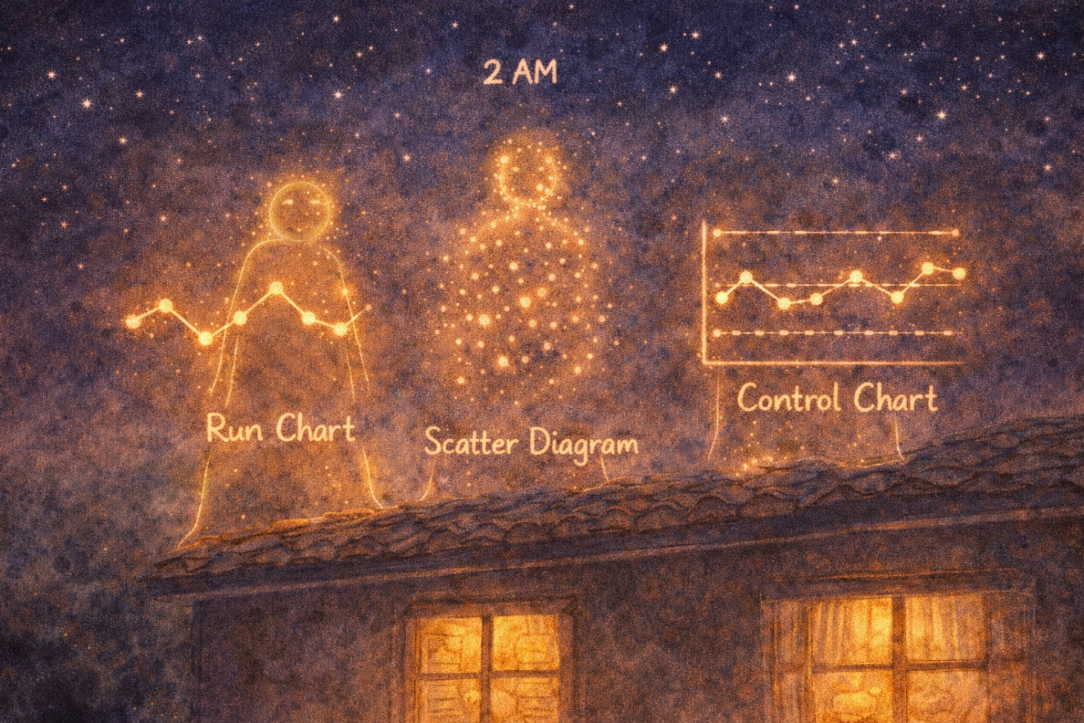

Run Chart: “I show you trends over time. Plot your data day by day and I’ll reveal patterns you’d never notice otherwise—are things getting better? Worse? Is there a cycle?”

Luna plotted her burnt pastry count for the past 30 days. The Run Chart revealed something fascinating: burnt pastries spiked every Thursday and Friday.
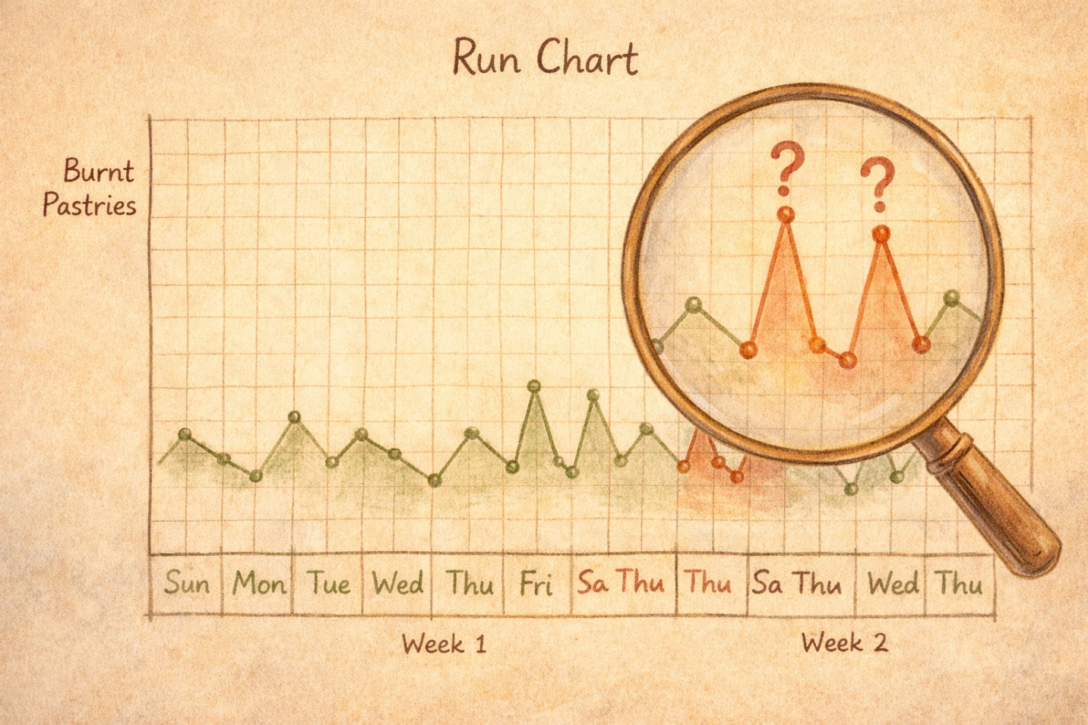

Luna: “Those are the nights the new hire, Marcus, works alone!”

Scatter Diagram: “And I can test that hunch. I’m the Scatter Diagram—I plot pairs of data to see if there’s a relationship between two variables.”

They plotted “Hours of baking experience” against “Defect rate” for each baker. The dots formed a clear downward pattern—more experience meant fewer defects.
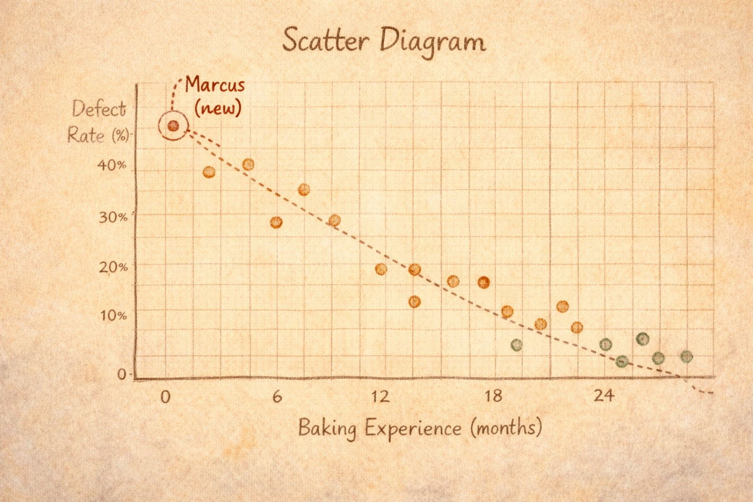

Control Chart: “And I’m the one who tells you whether variation is normal or a problem. Every process has some natural variation. I draw upper and lower control limits—as long as your data points stay between them, you’re in control. But if a point jumps outside? That’s a signal. Something assignable caused it.”
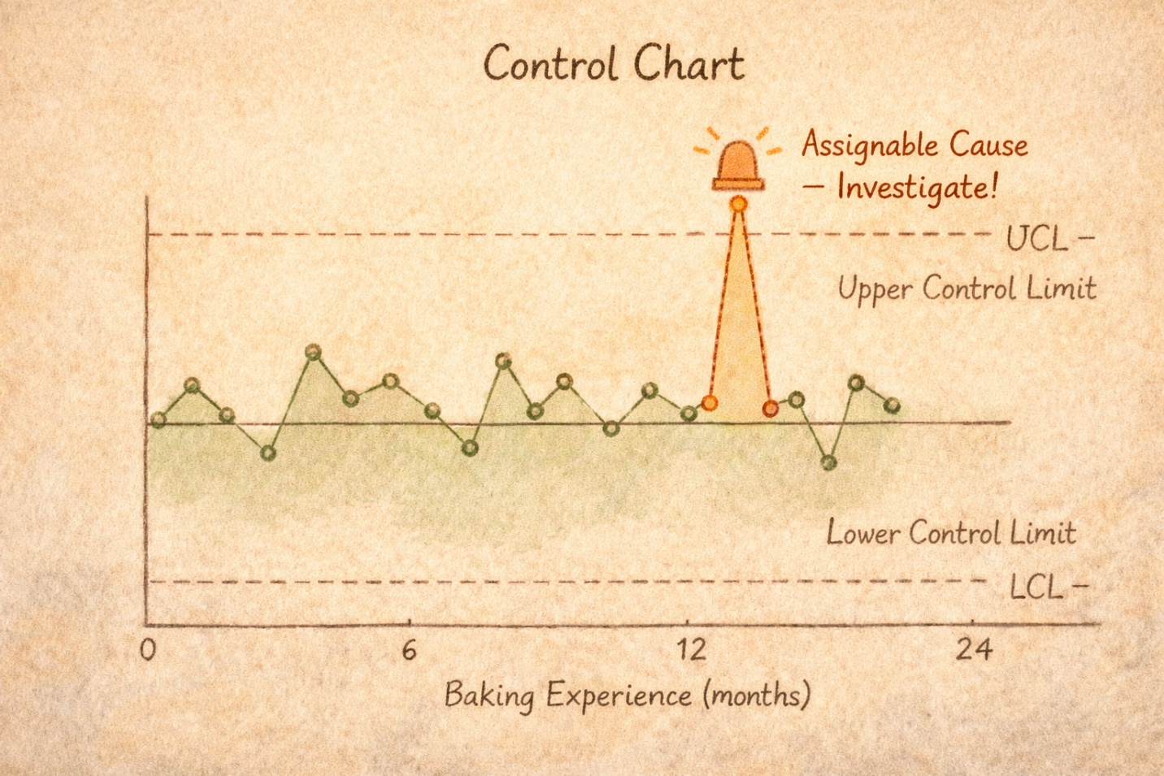

✨ CONCEPT SPOTLIGHT: Run Chart, Scatter Diagram & Control Chart
A Run Chart depicts trends in data over time, plotting values in sequence to reveal patterns and trends. A Scatter Diagram plots pairs of numerical data on two axes to look for a relationship (positive correlation, negative correlation, or none). A Process Control Chart monitors a process over time with a center line and upper and lower control limits (UCL and LCL). Data within the limits = common cause variation (normal). Data outside = assignable cause variation (investigate!). These complete the Seven Basic Quality Tools.

💼 INTERVIEW TIP: Know the difference between common cause and assignable cause variation. In an interview, say: ‘Common cause variation is inherent in every process and can only be reduced by redesigning the process itself. Assignable cause variation is unusual—something specific went wrong, and we need to find and fix it.’

Chapter Seven
The Seven Gremlins of Waste — TIMWOOD

At 3 AM, Luna heard scratching sounds. Tiny creatures were scurrying through the bakery, causing invisible havoc. Her grandmother’s letter had warned her about them.
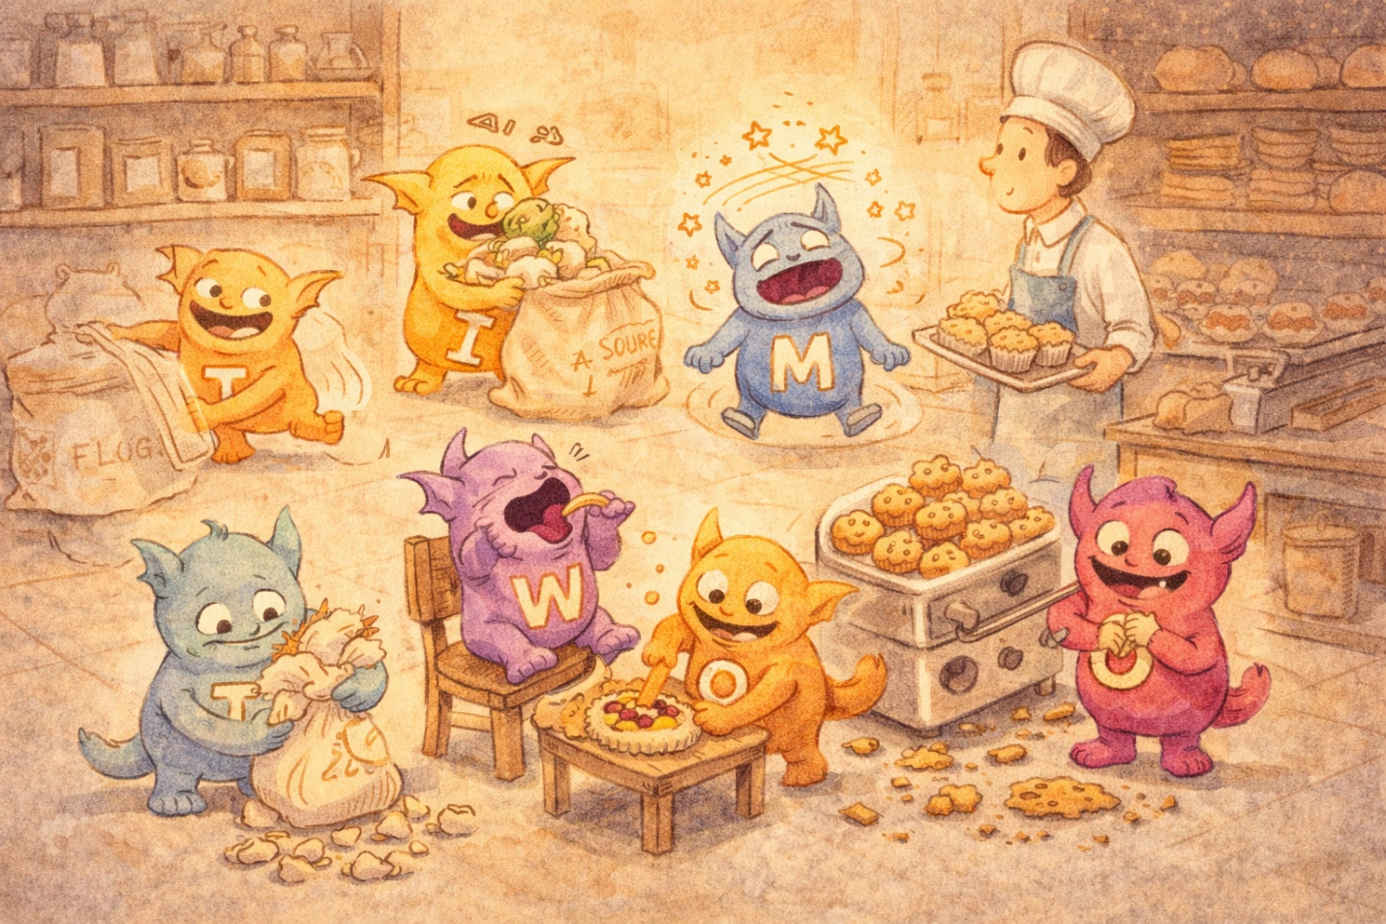
“They are the Seven Gremlins of Waste, Luna. In Japanese, we call waste ‘Muda.’ Learn their names. Learn them by heart. They go by TIMWOOD.”

Luna turned on all the lights and finally saw them:
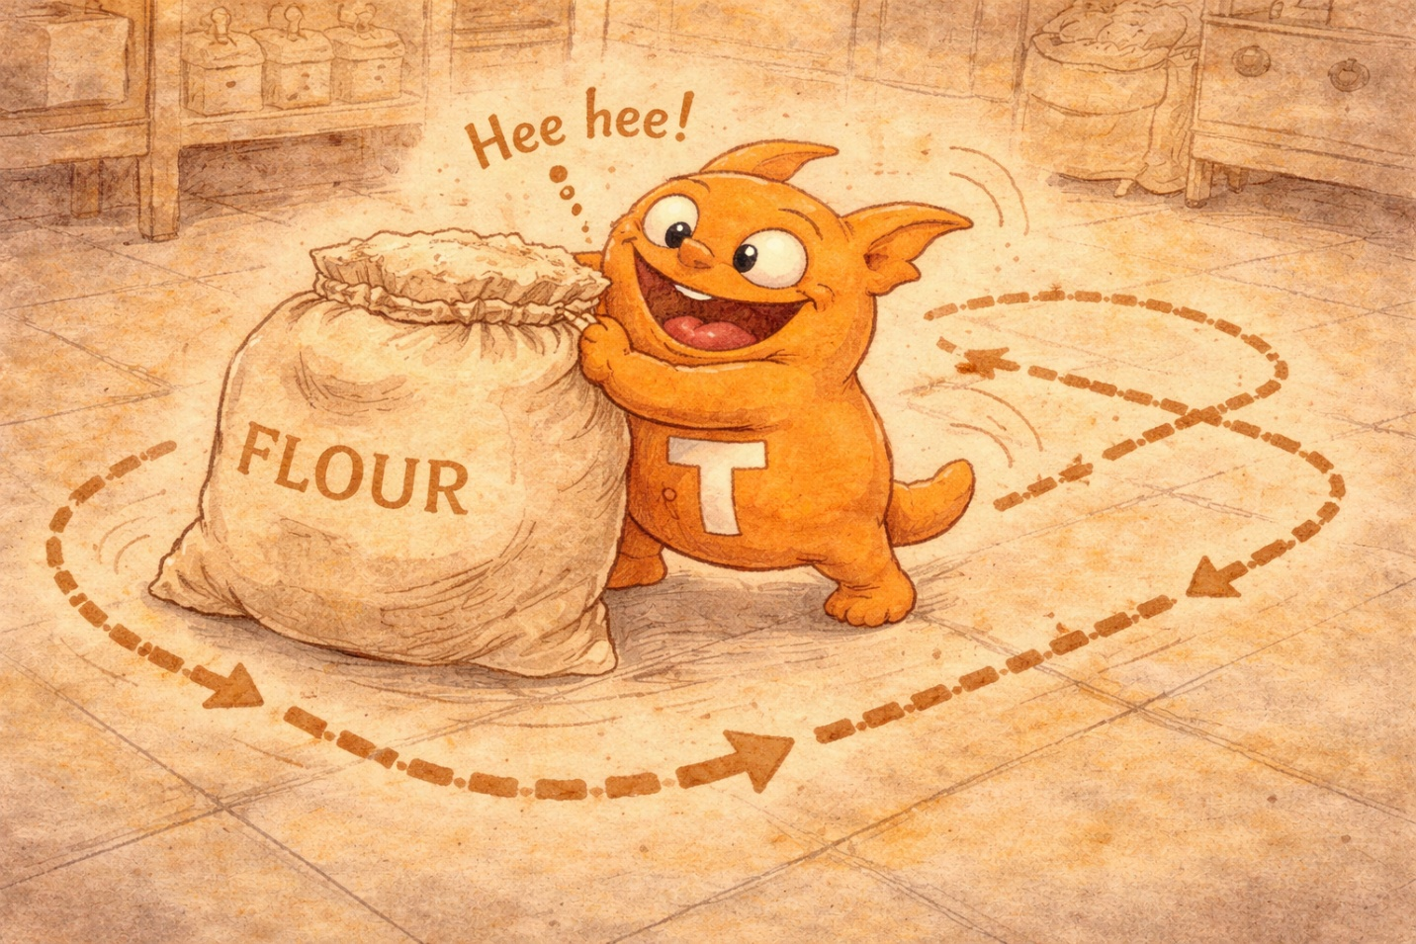
T — TRANSPORT: A gremlin pushing flour bags back and forth across the kitchen for no reason. Unnecessary movement of materials.
I — INVENTORY: A gremlin stacking mountains of ingredients that would expire before anyone could use them. Excess stock.
M — MOTION: A gremlin making bakers walk in circles because tools weren’t stored near where they were used. Unnecessary movement of people.
W — WAITING: A gremlin sitting smugly on a stool, doing nothing, while bakers stood idle waiting for the oven to free up. Idle time.
O — OVERPRODUCTION: A gremlin cranking out 200 muffins when the order was for 80. Making more than needed.
O — OVER-PROCESSING: A gremlin spending 20 minutes hand-decorating a cookie that sold for $1. Doing more work than the customer values.
D — DEFECTS: A gremlin crumbling pastries and writing wrong names on cakes. Errors that require rework or scrap.

Luna: “They’ve been here this whole time! In every corner of my process!”
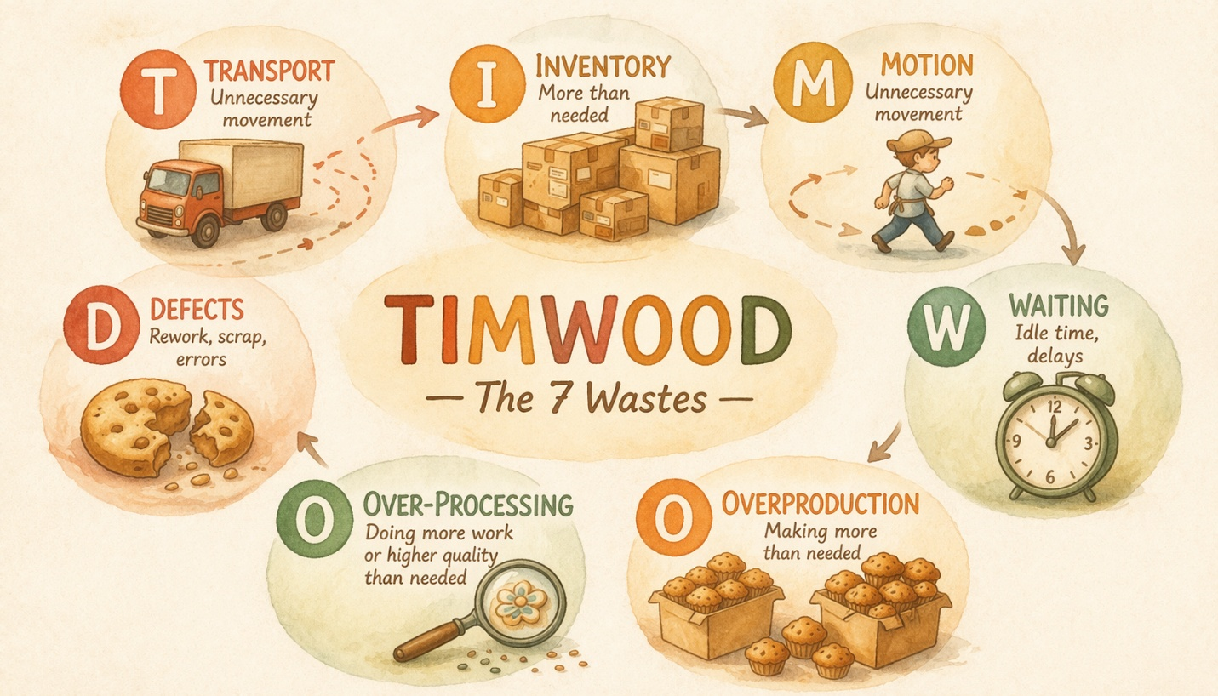

✨ CONCEPT SPOTLIGHT: TIMWOOD — The Seven Wastes (Muda)
Lean manufacturing identifies seven classic wastes that consume resources without creating value for the customer: Transport, Inventory, Motion, Waiting, Overproduction, Over-processing, and Defects. The acronym TIMWOOD (or TIMWOODS, adding Skills/underutilized talent) helps you remember them. Some use DOWNTIME as an alternative: Defects, Overproduction, Waiting, Non-utilized talent, Transportation, Inventory, Motion, Extra-processing. Eliminating waste is the core mission of Lean.

💼 INTERVIEW TIP: Memorize TIMWOOD cold. In an interview: ‘I’d walk the process and look for the seven wastes—Transport, Inventory, Motion, Waiting, Overproduction, Over-processing, and Defects. In my experience, Waiting and Over-processing are the two most commonly overlooked.’ Bonus points if you use a specific example.

Chapter Eight
The 5S Cleanup Crew & the Spirit of Kaizen

To banish the gremlins, Luna needed reinforcements. Five cheerful workers arrived at dawn, wearing matching aprons with Japanese characters on them.


Seiri: “I’m Sort! Let’s go through everything in this kitchen. If you haven’t used it in a month, it goes. That broken mixer? Gone. Those expired spices? Gone.”
Seiton: “I’m Set in Order! Everything that stays gets a home. Measuring cups next to the mixing station. Piping bags next to the decorating table. A place for everything, everything in its place.”
Seiso: “I’m Shine! We’re scrubbing this kitchen until it sparkles. A clean workspace reveals problems—you can see leaks, cracks, and spills immediately.”
Seiketsu: “I’m Standardize! We’re posting checklists and visual guides so everyone does things the same way, every time. No guessing.”
Shitsuke: “And I’m Sustain. The hardest one. All of this only works if you make it a habit. Discipline. Every single day.”
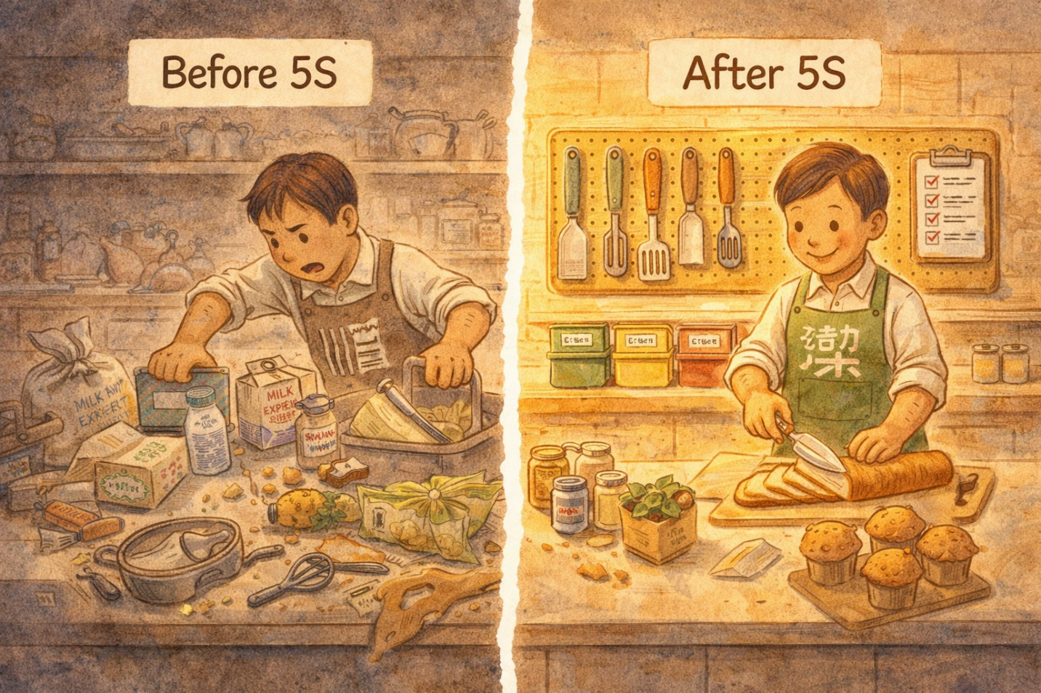
As the 5S crew worked, a gentle presence filled the room. It wasn’t a person—it was a feeling. A spirit.

“That’s Kaizen, Luna. It means ‘continuous improvement.’ Not big dramatic changes. Small ones. Every day. A little better today than yesterday. A little better tomorrow than today. Forever.”
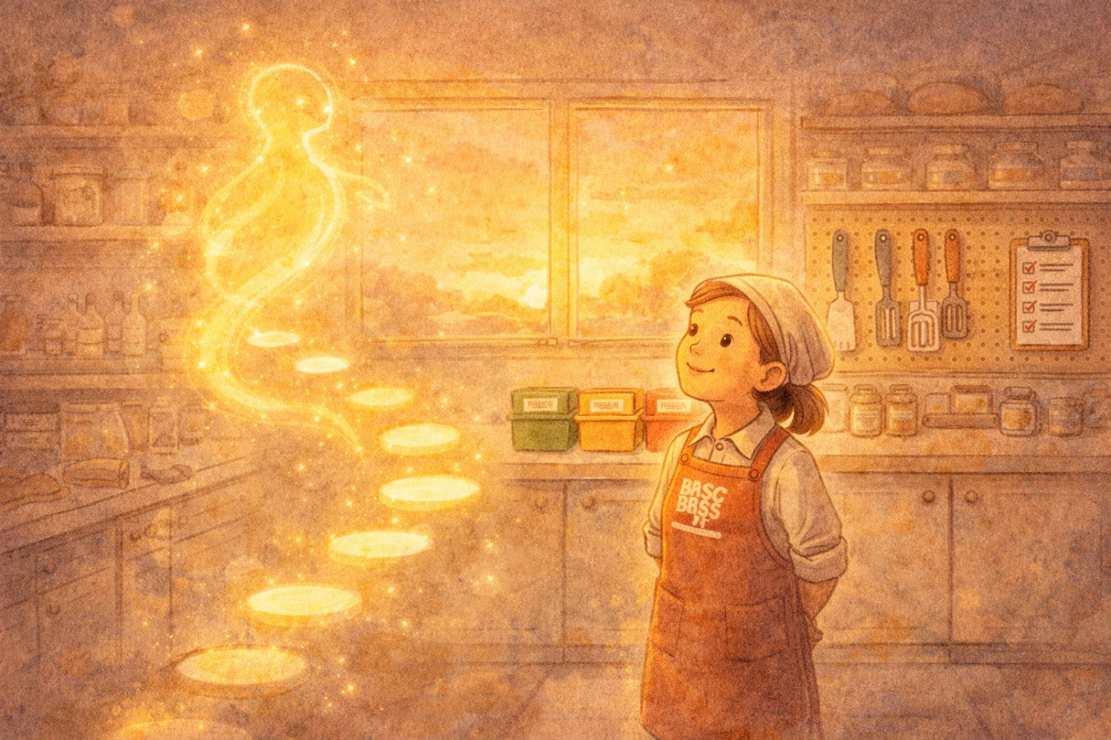

✨ CONCEPT SPOTLIGHT: 5S + Kaizen
5S is a workplace organization method: Sort (Seiri)—remove unnecessary items. Set in Order (Seiton)—organize what remains. Shine (Seiso)—clean the workspace. Standardize (Seiketsu)—create consistent procedures. Sustain (Shitsuke)—maintain discipline. Kaizen means ‘continuous improvement’—a philosophy of small, incremental changes over time, rather than dramatic overhauls. Together, 5S and Kaizen create the cultural foundation for Lean operations.

💼 INTERVIEW TIP: If asked about workplace efficiency: ‘I’m a big believer in 5S—Sort, Set in Order, Shine, Standardize, Sustain. It sounds simple, but it creates the foundation for spotting problems quickly. Combined with a Kaizen mindset of daily incremental improvements, it drives sustained results.’

Chapter Nine
The Mistake-Proof Spell — Poka-Yoke

Luna had fixed many problems, but one nagged at her: human error. Marcus was learning, but people make mistakes. That’s just… human.

Her grandmother’s letter had one more secret:

“You cannot remove humans from the process, Luna. But you can design the process so that mistakes become nearly impossible to make. The Japanese call this Poka-Yoke—mistake-proofing.”

Luna looked around her bakery with fresh eyes and started building mistake-proof systems:
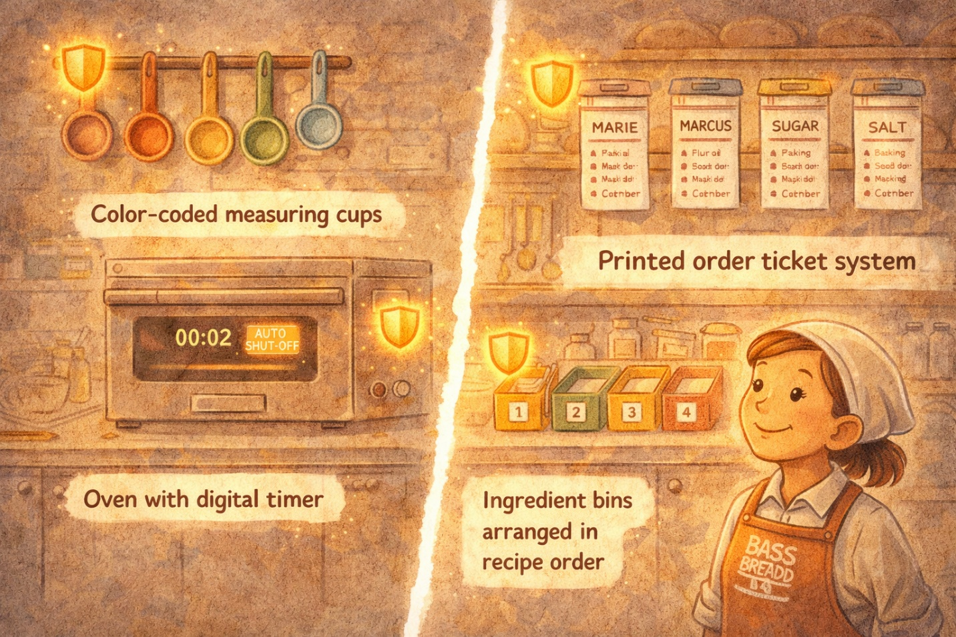
Color-coded measuring cups so bakers couldn’t accidentally use the wrong size.
Timers that automatically shut off ovens when the bake cycle was complete.
Order tickets with printed customer names to eliminate handwriting confusion.
Ingredient bins arranged in recipe order so nothing gets skipped.

Luna: “It’s like building gentle guardrails. Not punishing people for mistakes—preventing the mistakes from happening in the first place!”

✨ CONCEPT SPOTLIGHT: Poka-Yoke (Mistake-Proofing)
Poka-Yoke, developed by Shigeo Shingo at Toyota, means ‘mistake-proofing.’ It’s any mechanism that helps workers avoid errors. Shingo argued that defects come from human errors, and the best approach is to design feedback systems: successive checks (the next person checks the previous step), self-checks (you verify your own work), and source inspections (catch errors at their origin). Poka-yoke includes checklists, special tooling, color-coding, and physical constraints that make errors impossible or immediately detectable.

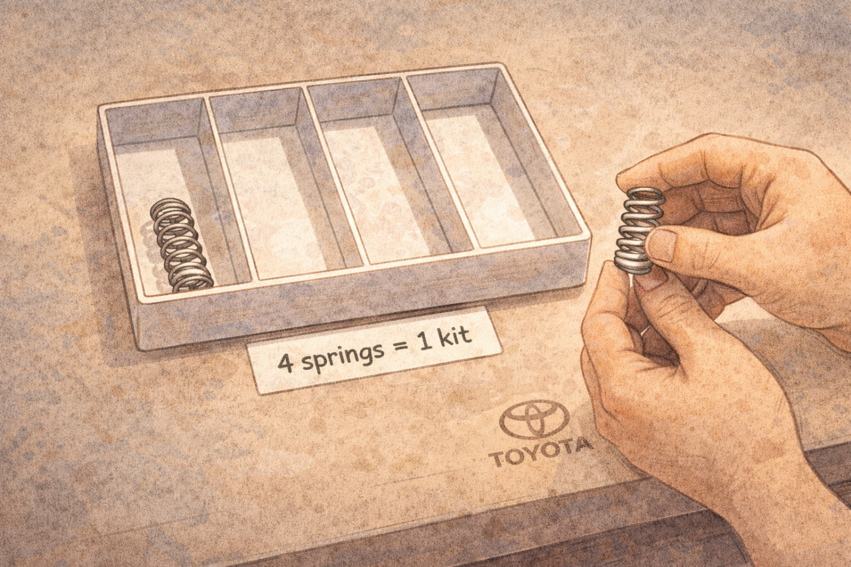

💼 INTERVIEW TIP: Companies love hearing about poka-yoke: ‘Rather than relying on training alone, I look for ways to design mistake-proof processes. For example, at Toyota, Shingo introduced part kitting—pre-packaging exactly the right number of components so workers physically can’t miss one. I look for those same opportunities in every process.’

Chapter Ten
Counting the Cost — And Preventing the Next Crisis

With the bakery running more smoothly, Luna sat down to count the true cost of all those problems. Not just the wasted ingredients—everything.

She divided her costs into four buckets:

Prevention Costs — Money spent to prevent defects: training Marcus, calibrating the oven, buying those color-coded measuring cups. (These are investments.)
Appraisal Costs — Money spent checking quality: inspecting pastries before they go out, taste-testing new recipes, quality audits. (Necessary, but doesn’t add value directly.)
Internal Failure Costs — The cost of catching defects before the customer sees them: scrapped burnt pastries, rework on lopsided croissants. (Waste, but at least it didn’t reach the customer.)
External Failure Costs — The worst: defects that reach the customer. Greg’s wrong birthday cake. Refunds. Lost customers. Reputation damage. (The most expensive category by far.)
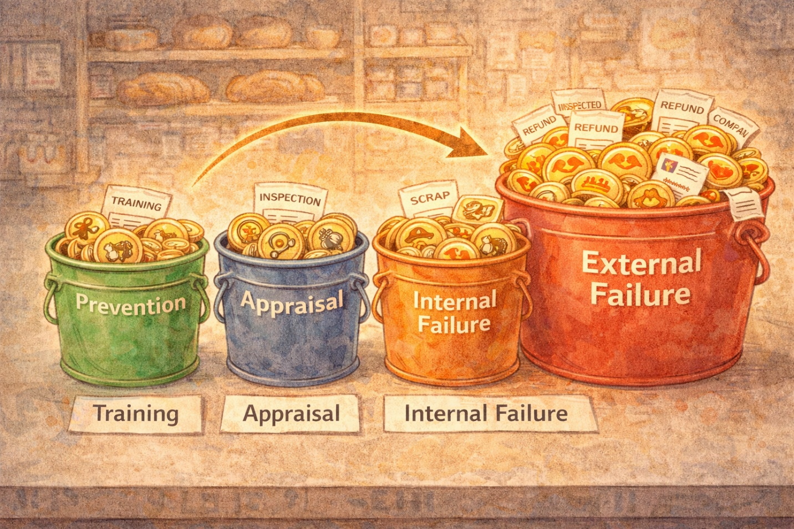
Luna: “So spending more on prevention actually saves me money by reducing all the other costs?”
“Exactly, my dear. An ounce of prevention is worth a pound of cure. That’s the heart of quality economics.”

Luna also learned about two more powerful tools:

FMEA (Failure Mode and Effect Analysis) — A structured way to think ahead. For every step in her process, Luna asked: What could go wrong? How bad would it be? How likely is it? How detectable is it? She assigned risk scores and focused her prevention efforts on the highest-risk items.
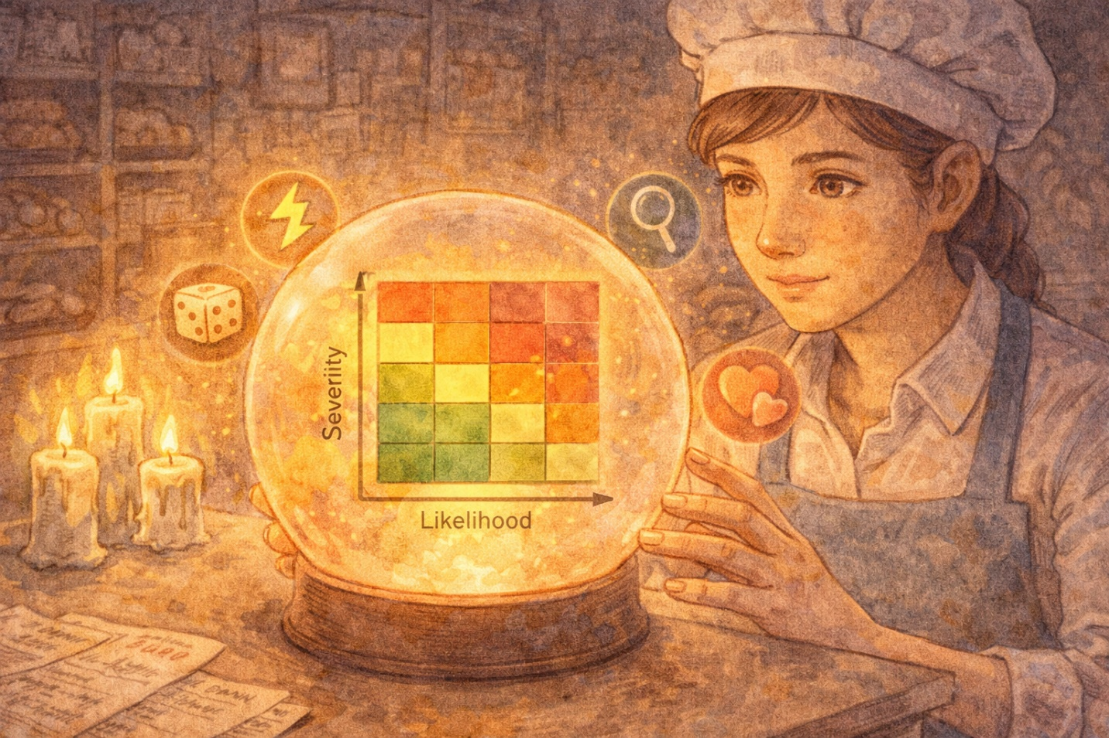
DOE (Design of Experiments) — A statistical method to test multiple variables at once. Instead of changing one thing at a time (temperature today, flour brand tomorrow), DOE let Luna test several changes simultaneously to find the best combination.

✨ CONCEPT SPOTLIGHT: Cost of Quality + FMEA + DOE
Cost of Quality has four categories: Prevention Costs (training, maintenance, planning), Appraisal Costs (inspection, testing, audits), Internal Failure Costs (scrap, rework caught before shipping), and External Failure Costs (warranty, returns, lost customers—the most expensive). FMEA (Failure Mode and Effect Analysis) is a structured approach to identify, estimate, prioritize, and evaluate risk of possible failures at each stage. DOE (Design of Experiments) is a statistical methodology to determine cause-and-effect relationships between process variables and output, permitting experimentation with many variables simultaneously.

Chapter Eleven
The Sunrise — Lean Six Sigma & Happily Ever After

As the sun rose over Luna’s bakery, everything felt different. Not perfect—no process is ever perfect. But better. Measurably, visibly, sustainably better.

Luna realized that what she’d been doing all night had two names:

Lean — Eliminating waste. Making every step count. Using 5S and Kaizen and TIMWOOD to strip away what doesn’t create value. Lean uses the PDCA cycle (Plan-Do-Check-Act) as its engine for continuous improvement.

Six Sigma — Reducing defects through data and statistical rigor. Using DMAIC and the Seven Quality Tools to measure, analyze, and control variation. The goal: 3.4 defects per million opportunities.

And together?

Lean Six Sigma — The best of both worlds. Lean’s speed and waste-elimination combined with Six Sigma’s statistical precision and structured problem-solving.

Luna: “Grandma, I understand now. It was never about one magic tool. It was about all of them working together—and the mindset of always getting a little better.”

She taped her grandmother’s letter to the wall behind the counter, right next to the new flowchart, the check sheet clipboard, and a Pareto chart of last week’s data.

And the bakery? It never stopped improving.
Because that’s the whole point of Kaizen.

The End.
…for now. Because continuous improvement never really ends.
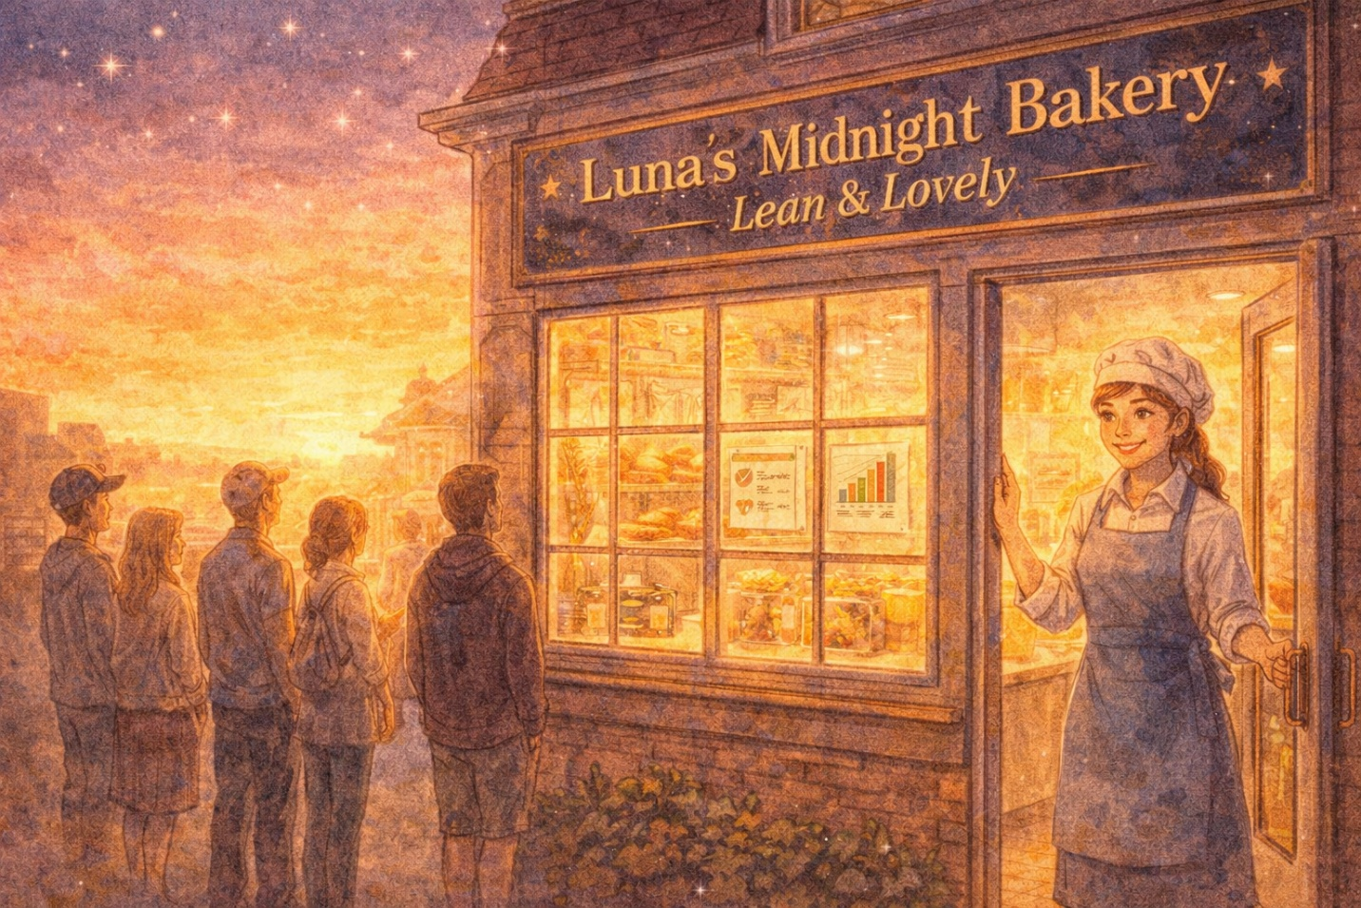

✨ CONCEPT SPOTLIGHT: Lean Six Sigma — The Big Picture
Lean focuses on maximizing customer value while minimizing waste, using tools like 5S, Kaizen, Value Stream Mapping, and TIMWOOD waste identification. It originated at Toyota and uses the PDCA cycle. Six Sigma is a disciplined, data-driven methodology for eliminating defects, using DMAIC and statistical tools. It was developed at Motorola. Lean Six Sigma combines both: Lean’s waste elimination and flow optimization with Six Sigma’s statistical quality control tools. Together, they provide a comprehensive approach to process improvement.

💼 INTERVIEW TIP: The ultimate interview answer: ‘I believe in combining Lean and Six Sigma. Lean helps me identify and eliminate waste across a process. Six Sigma gives me the statistical tools to reduce variation and defects. Together, they let me drive both efficiency and quality. I’d start any improvement effort by mapping the process, collecting data, analyzing root causes with tools like fishbone diagrams and Pareto charts, implementing improvements, and then building controls to sustain the gains.’

Quick Reference — Everything Luna Learned
Tool / Concept | What It Does | When to Use It
Flowchart | Maps the sequence of operations | Starting point—see the whole process
Check Sheet | Structured form for data collection | Measure step of DMAIC—gather facts
Pareto Chart | Ranks problems by frequency (80/20) | Prioritize—find the vital few
Histogram | Shows frequency distribution of data | Understand the shape and spread of data
Fishbone Diagram | Organizes causes by category | Analyze root causes of a problem
Scatter Diagram | Plots variable pairs for correlation | Test if two factors are related
Run Chart | Shows data trends over time | Spot patterns, trends, and cycles
Control Chart | Monitors process with UCL/LCL limits | Distinguish common vs. assignable cause
Five Whys | Asks ‘Why?’ repeatedly to find root cause | Drill past symptoms to true cause
Opportunity Flow | Separates value-added from non-value-added | Identify waste in a process
DMAIC | Define-Measure-Analyze-Improve-Control | Structured problem-solving cycle (Six Sigma)
PDCA | Plan-Do-Check-Act | Continuous improvement cycle (Lean)
TIMWOOD | 7 Wastes: Transport, Inventory, Motion, Waiting, Overproduction, Over-processing, Defects | Waste identification (Lean)
5S | Sort, Set in Order, Shine, Standardize, Sustain | Workplace organization
Kaizen | Continuous small improvements daily | Cultural mindset for improvement
Poka-Yoke | Mistake-proofing mechanisms | Prevent human errors at the source
Cost of Quality | Prevention + Appraisal + Internal/External Failure | Understand the economics of quality
FMEA | Risk assessment: severity × occurrence × detection | Proactive failure prevention
DOE | Test multiple variables simultaneously | Optimize process settings scientifically

