The Midnight Bakery
Part Two
The Night Watchers

A Statistical Quality Control Fairy Tale
Chapter 13 Study Guide

BCOR440 / IE425 · Operations & Supply Chain Management
Dr. Yaa


How to Use This Guide
⭐ Concept Spotlight: Gold Box = Concept Spotlight
Key definitions and formulas you need to memorize for the quiz and for job interviews.

🌟 Interview Tip
Terracotta Box = Interview Tip — How to talk about this concept in a professional setting. These phrases make you sound like you already work in quality management.

🧠 Memorize This!
Purple Box = Memorize This! — These are the facts, formulas, and distinctions most likely to appear on Quiz 2. Know them cold.

Chapter Twelve-and-a-Half
Previously, at the Midnight Bakery...

If you remember from Part One, Luna inherited a struggling bakery from her grandmother and found a mysterious letter inside an old recipe box. The letter introduced her to Seven Friends — magical quality tools that visit the bakery at midnight.

With Flowchart, she mapped her baking process. With Check Sheet, she collected real data. Pareto showed her the vital few problems. Fishbone and Five Whys helped her dig to root causes. She learned about the Seven Wastes (TIMWOOD), implemented 5S, and even started mistake-proofing her kitchen with Poka-Yoke.

But tonight, as Luna locks the front door and flips the sign to CLOSED, she notices something new: the grandmother's letter has more pages. Pages she hadn't seen before. And they begin with a warning:

"Dear Luna, the Seven Friends helped you see your problems. But seeing isn't enough. You need Watchers — guardians who never sleep, who monitor every batch, every oven, every measurement — and sound the alarm before trouble arrives. Tonight, you will meet the Night Watchers. They will teach you Statistical Quality Control."

Chapter One
The Two Faces of Variation

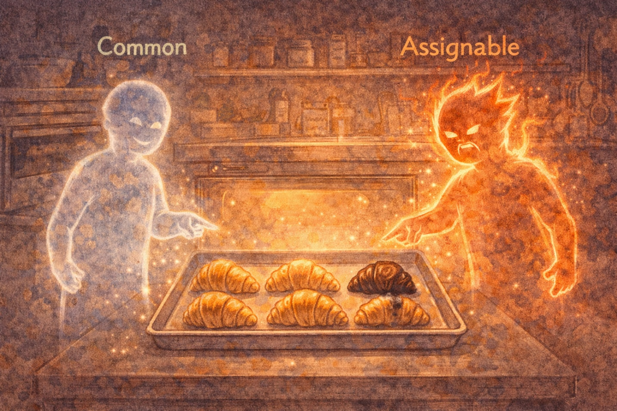
The first Night Watcher appeared as two figures — twins, but utterly different.

The first twin was calm, steady, and slightly translucent — like a gentle breeze that's always there. She introduced herself as Common Variation.

Common Variation: "I'm always here, Luna. Every batch of your croissants will be slightly different — a millimeter taller, a gram heavier. That's me. I'm natural. I'm built into your process. You can't eliminate me completely, and that's okay."

The second twin crackled with restless energy — bright, unpredictable, and a little alarming.

Assignable Variation: "But I'm NOT okay. I show up when something specific goes wrong — a broken thermostat, a new employee who wasn't trained, a bad batch of flour from your supplier. I have a cause, and I can be found and fixed."

Luna looked at her tray of croissants. Most were beautifully golden, varying only slightly in size. But three on the left were noticeably darker and flatter.

Common Variation: "Those slight size differences? Me. Normal. Don't chase them."
Assignable Variation: "But those three burnt ones? That's ME. Something specific caused that — find it!"

⭐ Concept Spotlight: Two Types of Process Variation
Common (Random) Variation: Inherent in the process itself. Natural, expected, always present. Cannot be eliminated without fundamentally changing the process. • Assignable (Special) Variation: Caused by identifiable, specific factors (equipment failure, human error, material defect). Can and should be found and corrected.

🧠 Memorize This!
A process with ONLY common variation is called 'in control.' When assignable variation appears, the process is 'out of control' and must be investigated. The whole point of SPC is to distinguish between the two!

🌟 Interview Tip
In an interview, say: 'I understand the difference between common-cause and special-cause variation. Common variation is inherent in any process, while special-cause variation signals something has changed that we need to investigate. Control charts help us tell them apart.'

Chapter Two
The Magical Scrolls — Control Charts

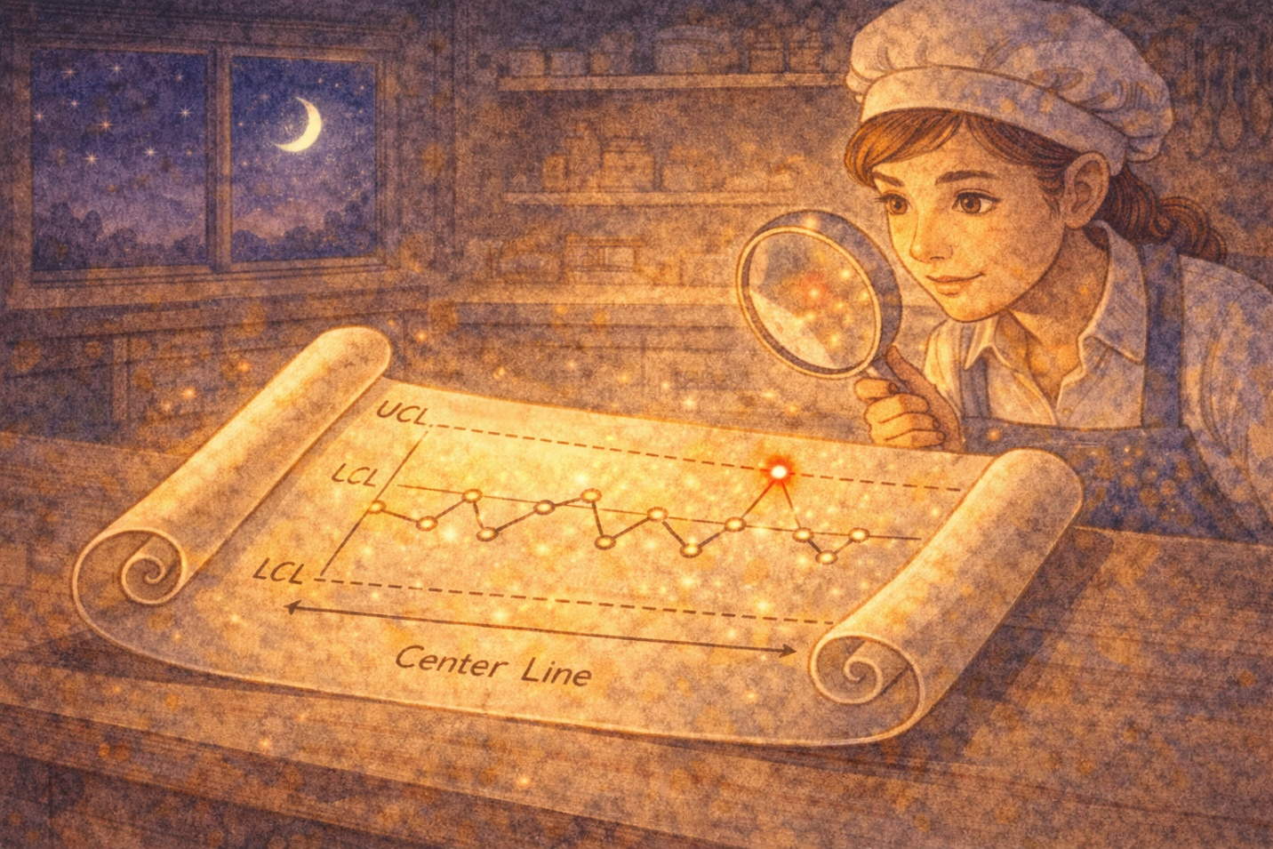
The twins reached behind the oven and unrolled a magnificent scroll across the flour-dusted counter. It glowed softly with golden light.

Three horizontal lines stretched across the scroll, like roads on a map.

Common Variation: "The middle line is the Center Line — the average of your process. This is where your process wants to live."
Assignable Variation: "The top line is the Upper Control Limit — UCL. The bottom line is the Lower Control Limit — LCL. Together, they create a boundary. As long as your data points stay between these lines, your process is in control."
Common Variation: "But if a point crosses a limit — or if the pattern looks strange — that's my twin showing up. That means something assignable happened, and you need to investigate."

⭐ Concept Spotlight: Control Charts
A control chart plots sample measurements over time against three reference lines: (1) Center Line (CL) = process average, (2) Upper Control Limit (UCL) = CL + 3 standard deviations, (3) Lower Control Limit (LCL) = CL - 3 standard deviations. We generally use z = 3 (three sigma). If all points fall within the limits with no non-random patterns, the process is 'in statistical control.'

🧠 Memorize This!
Control Limits are NOT Specification Limits! Control limits come from the PROCESS (what it actually does). Specification limits come from the CUSTOMER or DESIGN (what it should do). A process can be in control but still not meet specifications — that's a capability problem, not a control problem.

Luna noticed something exciting: when the scroll's data points wandered close to a control limit but stayed inside, the scroll stayed golden. But when she imagined a point jumping above the UCL, the scroll flashed red and a tiny alarm bell rang.

Assignable Variation: "That red flash? That's me telling you: STOP. Something changed. Don't keep baking until you figure out what happened."

🌟 Interview Tip
When asked about process monitoring: 'We use control charts to visually track process stability over time. The beauty is they separate signal from noise — so you don't overreact to normal variation or miss real problems.'

Chapter Three
The Inspector — p-Charts for Attribute Data

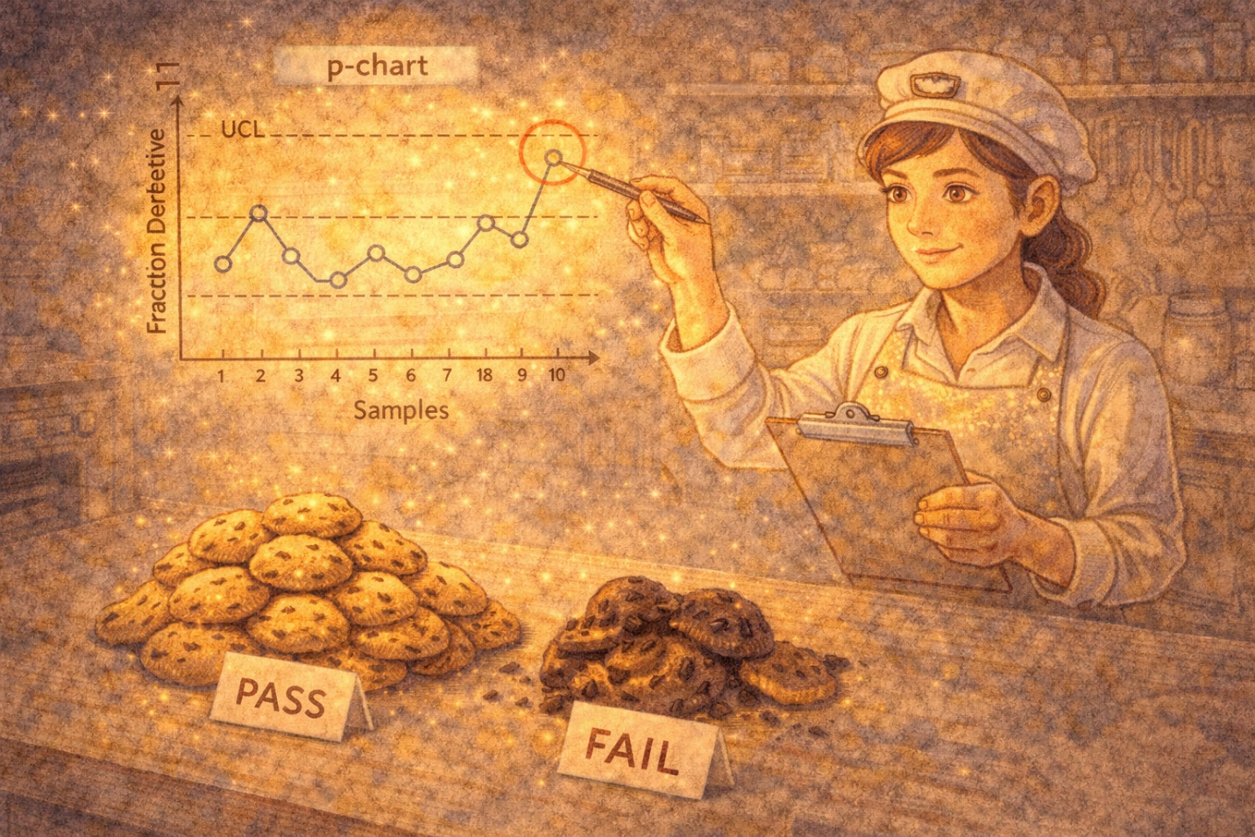
The next Night Watcher arrived carrying a clipboard and wearing wire-rimmed glasses. She was the Inspector.

The Inspector: "Some quality questions have only two answers, Luna. Is this cookie cracked? Yes or no. Did this order arrive on time? Yes or no. Is this loaf properly shaped? Yes or no. This is called attribute data — it's binary. Pass or fail. Good or bad. And for attribute data, I use the p-chart."

The Inspector picked up ten trays of cookies from different batches, each tray holding exactly 100 cookies. She sorted each tray into GOOD and BAD piles, then wrote the fraction defective on her clipboard.

Tray 1: 3 bad out of 100 = 0.03. Tray 2: 5 bad = 0.05. Tray 3: 2 bad = 0.02. And so on, for all ten trays.

The Inspector: "Now I calculate the overall fraction defective: p-bar. That's the total number of defectives divided by the total number inspected across ALL samples. Then I find the standard deviation and set control limits at p-bar plus or minus 3 standard deviations."

⭐ Concept Spotlight: p-Chart Formulas (Fraction Defective)
p-bar = (total defectives) / (total items inspected across all samples). Standard deviation: s_p = sqrt[ p-bar(1 - p-bar) / n ], where n = sample size. UCL = p-bar + z(s_p), typically z = 3. LCL = p-bar - z(s_p). If LCL < 0, set LCL = 0. Plot each sample's fraction defective. If any point falls outside the limits, the process is out of control.

🧠 Memorize This!
p-chart is for ATTRIBUTE data (binary: defective or not). Sample sizes should be large enough to expect at least one defective per sample. The p-chart tracks the PROPORTION (fraction) of defective items.

Luna studied the chart. Nine of ten points fell within the limits. But Tray 7 — the one baked by the new hire on a busy Saturday — had a fraction defective of 0.12, well above the UCL.

The Inspector: "That's your signal. Tray 7 is out of control. Go find out why."

🌟 Interview Tip
'I've used p-charts to track defect rates across production batches. When we saw a spike in fraction defective on one shift, we traced it to inadequate training on a new machine setup. The p-chart gave us the evidence to justify a targeted training program.'

Chapter Four
The Counter — c-Charts for Counting Defects

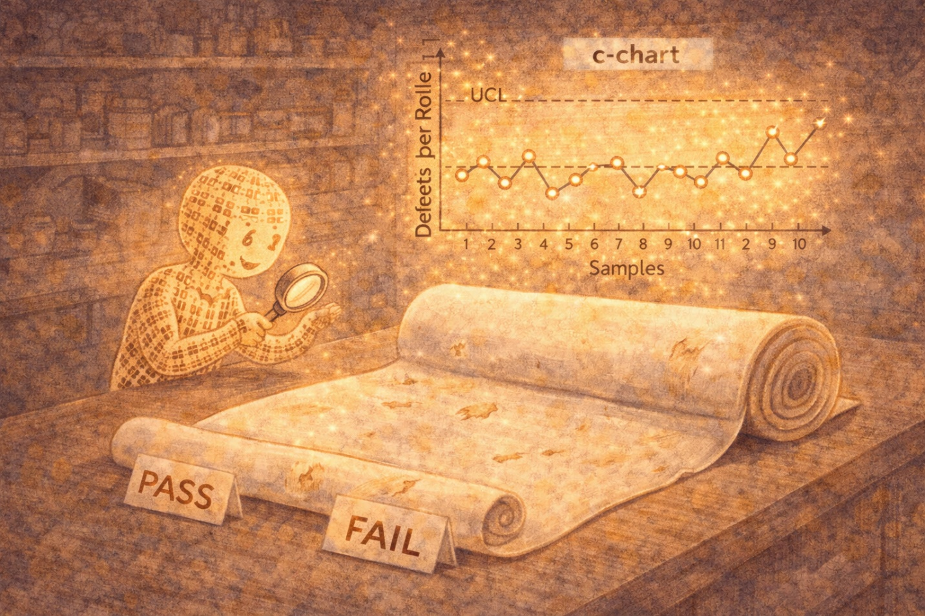
A second inspector appeared — smaller, faster, and obsessed with counting.

The Counter: "My cousin the Inspector asks 'Is this item defective: yes or no?' But I ask a different question: 'How many defects does this single item have?' One sheet of fondant might have 3 tiny tears, 1 discoloration, and 2 thin spots. That's 6 defects in one unit. I don't care whether the sheet 'passes' or 'fails' — I count every flaw."

⭐ Concept Spotlight: c-Chart (Count of Defects)
c-bar = (total defects across all samples) / (number of samples). Standard deviation: s_c = sqrt(c-bar). UCL = c-bar + z(sqrt(c-bar)). LCL = c-bar - z(sqrt(c-bar)). If LCL < 0, set LCL = 0. Plot the number of defects per sample unit (e.g., per roll of fabric, per inspection period).

🧠 Memorize This!
KEY DISTINCTION: p-chart = proportion of DEFECTIVE ITEMS (binary: each item is good or bad). c-chart = COUNT of DEFECTS per unit (one item can have multiple defects). Think: 'p for proportion, c for count.'

🌟 Interview Tip
'We used c-charts to monitor the number of customer complaints per week. When the count trended upward over three consecutive weeks, we investigated and found it correlated with a packaging supplier change.'

Chapter Five
The Precision Twins — X-bar and R Charts

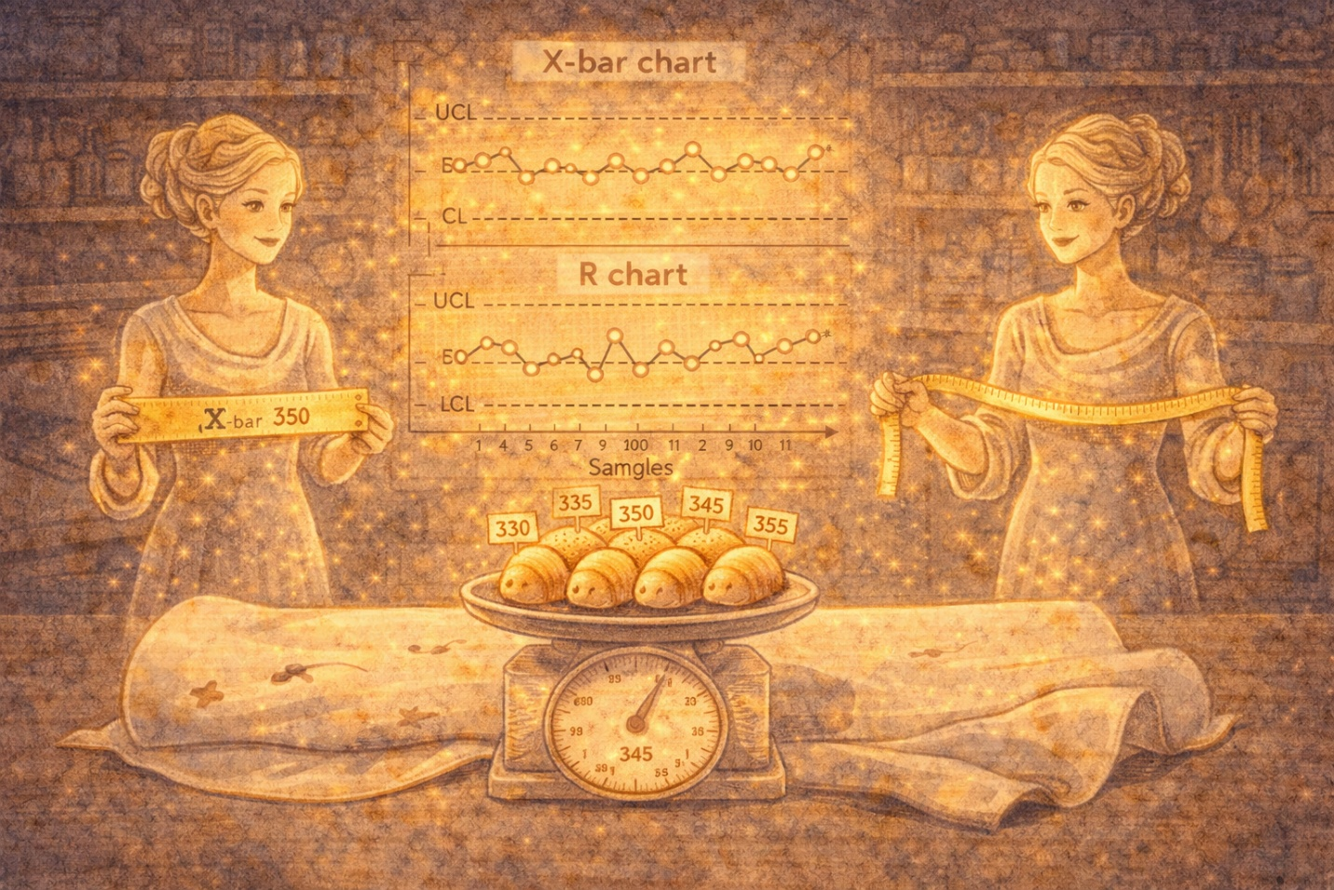
The most precise of all the Night Watchers appeared next: elegant twins who moved in perfect coordination. They introduced themselves as X-bar and R.

X-bar: "The Inspector and the Counter work with attribute data — yes/no, count. But we work with variable data — actual measurements. Weight in grams. Temperature in degrees. Length in millimeters. We measure, not just classify."

R: "I'm the Range chart. For each small sample — usually 4 or 5 items — I calculate the difference between the largest and smallest measurement. That tells you how much spread exists within each sample."

X-bar: "And I track the average of each sample over time. Together, we tell you two things: Is your process centered correctly? And is it consistent?"

Luna weighed five loaves from each of her last 25 batches. For each group of five, she calculated the average weight (X-bar) and the range (heaviest minus lightest).

⭐ Concept Spotlight: X-bar and R Chart Formulas (when process standard deviation is NOT known)
Step 1: Compute X-double-bar (grand average of all sample means) and R-bar (average of all sample ranges). Step 2: Using factors from Exhibit 13.7 based on sample size n: UCL(X-bar) = X-double-bar + A2 * R-bar. LCL(X-bar) = X-double-bar - A2 * R-bar. UCL(R) = D4 * R-bar. LCL(R) = D3 * R-bar. For n=4: A2=0.73, D3=0, D4=2.28. For n=5: A2=0.58, D3=0, D4=2.11.

⭐ Concept Spotlight: X-bar Chart (when process standard deviation IS known)
UCL = X-bar + z * sigma_x. LCL = X-bar - z * sigma_x. Where sigma_x = sigma / sqrt(n) and z is typically 3. This version is used when you already know the true process standard deviation from historical data.

🧠 Memorize This!
X-bar and R charts are ALWAYS used together as a PAIR. Why? Because X-bar monitors the process AVERAGE (is it drifting?) and R monitors the process SPREAD (is it becoming more variable?). You need both! Also: sample sizes are typically small (4-5 units), and you need about 25 samples to set up the charts.

Luna plotted her 25 points on both charts. Everything fell within the limits — except sample 18 on the X-bar chart, which was suspiciously low.

X-bar: "Investigate sample 18. Something shifted your average down. Was it a different flour? A new employee? A calibration issue with the scale?"

🌟 Interview Tip
'In my coursework, I learned to construct X-bar and R charts to monitor process centering and spread. I understand the difference between using A2/D3/D4 factors when sigma is unknown versus the z-sigma approach when the process standard deviation is established.'

Chapter Six
Reading the Signs — Interpreting Control Charts


X-bar leaned closer to Luna and whispered something important.

X-bar: "A point outside the control limits is the obvious alarm. But there are subtler signs of trouble, too. Patterns. Trends. Runs. Even when all points are inside the limits, the pattern might tell you something is wrong."

She showed Luna four warning patterns on the scroll:

1. A single point outside the UCL or LCL — obvious out-of-control signal.
2. A run — seven or more consecutive points on the same side of the center line.
3. A trend — seven or more points moving continuously upward or downward.
4. Hugging — points suspiciously close to the center line might mean the data is being manipulated or the subgroups are too diverse.

🧠 Memorize This!
Out-of-control signals: (1) Any point beyond UCL or LCL. (2) A run of 7+ points on one side of the center line. (3) A trend of 7+ points continuously increasing or decreasing. These are the patterns you need to recognize on the quiz!

🌟 Interview Tip
'Beyond just spotting points outside control limits, I know how to read runs and trends in control chart data. For example, a run of seven points above the center line suggests a process shift even though no single point violated a limit.'

Chapter Seven
The Gatekeeper — Process Capability

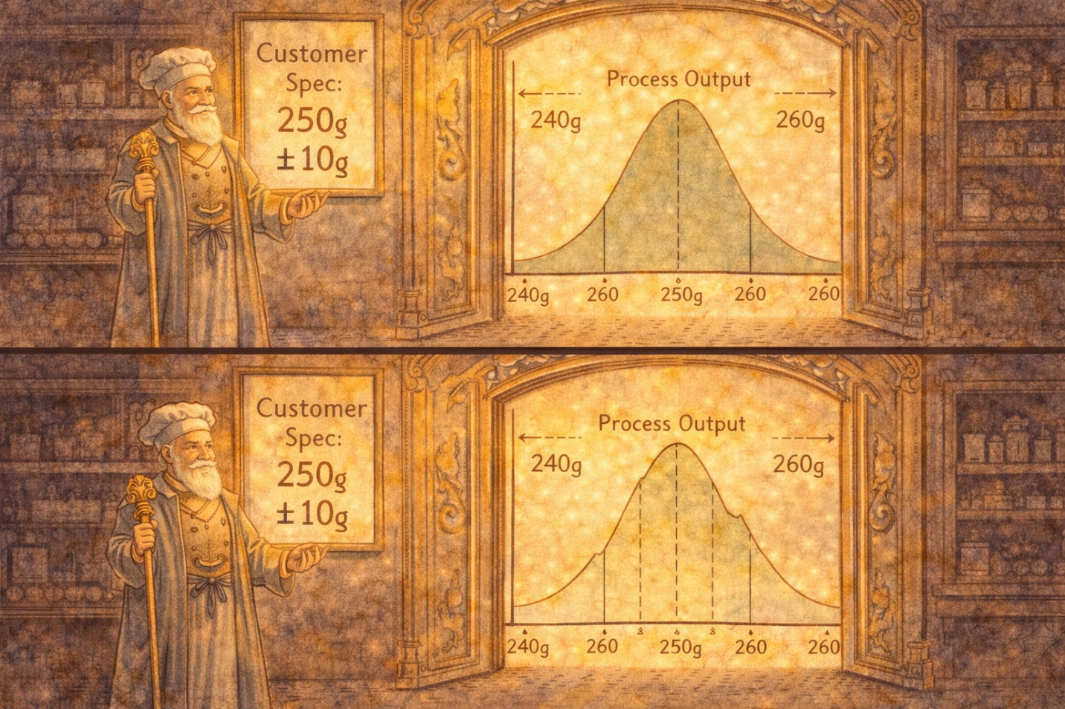
The final Night Watcher was tall, regal, and stood at the bakery's delivery door like a bouncer at an exclusive club. She was the Gatekeeper.

The Gatekeeper: "Your friends the control charts told you whether your process is stable — in control. But I answer a different question: Even if your process is stable, is it GOOD ENOUGH? Can it consistently meet your customer's specifications?"

She drew a picture on the flour-dusted counter. A bell curve representing Luna's bread loaf weights. And two vertical lines — the customer's specification limits: 240g minimum, 260g maximum.

The Gatekeeper: "If your bell curve fits comfortably between those spec limits, your process is capable. If it's wider than the gap — or shifted off-center — you're going to produce loaves that don't meet spec, even if your process is perfectly stable."

⭐ Concept Spotlight: Process Capability Index (Cpk)
Cpk = min[ (USL - mean) / (3 * sigma), (mean - LSL) / (3 * sigma) ]. Where USL = Upper Specification Limit, LSL = Lower Specification Limit, mean = process mean, sigma = process standard deviation. Cpk >= 1.0 means the process is capable (fits within specs). Cpk >= 1.33 is generally desired for existing processes. Cpk < 1.0 means the process is NOT capable — it will produce defective output.

⭐ Concept Spotlight: Cp vs. Cpk
Cp = (USL - LSL) / (6 * sigma). Cp measures potential capability ASSUMING the process is perfectly centered. Cpk measures ACTUAL capability, accounting for how far the mean has drifted from center. Cpk is always <= Cp. If Cpk = Cp, the process is perfectly centered.

🧠 Memorize This!
Cpk >= 1.0 = capable (process fits within spec limits). Cpk >= 1.33 = desirable for existing processes. Cpk < 1.0 = NOT capable (output will exceed spec limits). Cpk takes the MINIMUM of the upper and lower ratios — because you're only as good as your weakest side. Remember: CONTROL (charts) and CAPABILITY (Cpk) are two different questions!

Luna calculated her Cpk for bread loaf weight. Her mean was 251g, her sigma was 3g, with specs of 240-260g.
Upper ratio: (260 - 251) / (3 * 3) = 9/9 = 1.00
Lower ratio: (251 - 240) / (3 * 3) = 11/9 = 1.22
Cpk = min(1.00, 1.22) = 1.00

The Gatekeeper: "Your Cpk is exactly 1.0. You're just barely capable. Your process is right on the edge. If anything shifts even slightly toward the upper spec, you'll start producing overweight loaves. You need to either tighten your process or re-center your mean."

🌟 Interview Tip
'I can calculate and interpret Cpk. A Cpk of 1.33 or higher means the process can consistently meet specifications with room to spare. Below 1.0, I know we need to either reduce variation or re-center the process before we can reliably meet customer requirements.'

Chapter Eight
The Shipment — Acceptance Sampling


A truck rumbled up to the bakery's loading dock. A delivery of 5,000 bags of specialty flour from a new supplier. Luna couldn't possibly inspect every single bag. But she also couldn't just accept them blindly.

The Gatekeeper: "This is where acceptance sampling comes in. You sample a portion of the shipment, test those samples, and then decide: accept the entire lot, or reject it."

The Gatekeeper explained the four key terms Luna needed to understand:

⭐ Concept Spotlight: Acceptance Sampling Key Terms
AQL (Acceptable Quality Level): The maximum percentage of defectives the PRODUCER considers acceptable. This is the 'good' quality level. • LTPD (Lot Tolerance Percent Defective): The percentage of defectives that defines the CONSUMER's rejection threshold. This is the 'bad' quality level. • Alpha (α) = Producer's Risk: The probability of rejecting a GOOD lot (Type I error). Typically 0.05 (5%). • Beta (β) = Consumer's Risk: The probability of accepting a BAD lot (Type II error). Typically 0.10 (10%).

🧠 Memorize This!
Think of it this way: Producer's risk (alpha) = rejecting something good = 'throwing away perfectly fine flour.' Consumer's risk (beta) = accepting something bad = 'baking with contaminated flour.' The sampling plan determines n (how many to sample) and c (the maximum number of defectives allowed before rejecting the lot). Use the LTPD/AQL ratio with Exhibit 13.10 to find c, then calculate n.

Luna set her standards: AQL = 3% (she'd accept up to 3% defective as normal). LTPD = 10% (anything above 10% defective is unacceptable). Alpha = 5%. Beta = 10%.

Using the table, she found: sample 88 bags. If 5 or fewer are defective, accept the lot. If more than 5 are defective, reject.

⭐ Concept Spotlight: Operating Characteristic (OC) Curve
The OC curve shows the probability of accepting a lot for various levels of actual defect rate. At the AQL, the probability of acceptance should be high (1 - alpha). At the LTPD, the probability of acceptance should be low (beta). The shape of the curve depends on the sample size n and acceptance number c.

🌟 Interview Tip
'I understand how to design a sampling plan using AQL, LTPD, and the OC curve. I know that increasing sample size makes the OC curve steeper, which better discriminates between good and bad lots, but at higher inspection cost.'

Chapter Nine
Choosing the Right Watcher — Which Chart When?

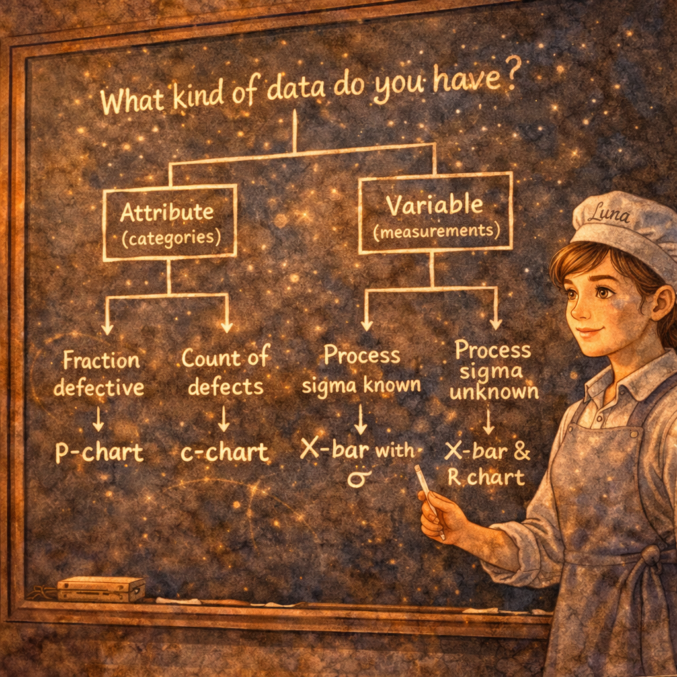
As dawn approached, Luna felt overwhelmed. Control charts, p-charts, c-charts, X-bar charts, R charts, Cpk... how would she know which tool to use?

Common Variation drew a simple decision tree on the chalkboard:

Question | Answer | Chart Type | Example
Is the data binary (pass/fail)? | Yes → Attribute | p-chart | % of cookies cracked
Counting defects per unit? | Yes → Attribute | c-chart | # of scratches per sheet
Measuring a continuous value? | Yes + sigma unknown | X-bar & R chart | Weight of bread loaves
Measuring + sigma known? | Yes + sigma known | X-bar chart (z method) | Temperature of oven
Is the process capable? | After in-control | Cpk calculation | Can we meet 250g +/- 10g?
Evaluating a batch/lot? | Incoming inspection | Acceptance Sampling | New flour shipment

🧠 Memorize This!
The quiz WILL ask you to choose the right chart for a scenario. Remember: (1) Attribute data → p-chart (proportion defective) or c-chart (count of defects). (2) Variable data → X-bar & R charts (sigma unknown) or X-bar with z-sigma (sigma known). (3) Process capability → Cpk. (4) Incoming lots → Acceptance sampling with AQL/LTPD.

Chapter Ten
The Sunrise — Luna's Quality System


As the first golden rays of sunrise crept through the bakery windows, Luna stepped back and looked at what she had built. On the wall, neatly posted beside her Pareto chart and fishbone diagram from Part One, were her new Night Watchers:

A p-chart tracking her daily defective cookie rate.
A c-chart counting irregularities in her fondant sheets.
X-bar and R charts monitoring bread loaf weight.
A Cpk analysis showing her bread process was capable (and getting better).
A sampling plan for inspecting incoming flour shipments.

The Night Watchers faded as the sun rose, but their scrolls remained. They would activate again tonight, and every night, watching over her process.

Common Variation: "We'll always be here, Luna. Every process has variation. Your job isn't to eliminate us — it's to understand us."
Assignable Variation: "And when I show up? You'll know. Because you're watching now."

Luna smiled, poured herself a cup of coffee, and unlocked the front door. The first customer of the day walked in, and Luna knew — with absolute confidence — that every croissant, every loaf, and every cookie was exactly as it should be.

Not perfect. But in control. And capable.

─── End of Story ───

─── Reference ───
Chapter 13 Quick-Reference Summary
Concept | What It Does | Key Formula / Rule | Interview Phrase
Common Variation | Natural, inherent process variation | Always present; cannot be eliminated | Random variation inherent in the process
Assignable Variation | Variation from identifiable causes | Investigate and eliminate the cause | Special-cause variation that signals a change
Control Chart | Monitors process stability over time | CL +/- 3 sigma = UCL/LCL | Visual tool to separate signal from noise
p-Chart | Tracks fraction defective (attribute) | sp = sqrt[p-bar(1-p-bar)/n] | Used for binary pass/fail quality data
c-Chart | Counts defects per unit (attribute) | sc = sqrt(c-bar) | Tracks defect count per inspection unit
X-bar & R Chart | Monitors mean and range (variable) | A2, D3, D4 factors from Exhibit 13.7 | Paired charts for process center and spread
Cpk | Measures process capability | min[(USL-mean)/3s, (mean-LSL)/3s] | Cpk >= 1.33 means reliably capable
Cp | Potential capability if centered | (USL-LSL) / 6 sigma | What capability COULD be if we re-center
AQL | Max acceptable defect rate (producer) | Defines 'good' quality level | Producer's acceptable quality level
LTPD | Consumer's rejection threshold | Defines 'bad' quality level | Lot tolerance percent defective
Alpha (α) | Producer's risk of rejecting good lot | Typically 5% | Type I error in acceptance sampling
Beta (β) | Consumer's risk of accepting bad lot | Typically 10% | Type II error in acceptance sampling
OC Curve | Shows acceptance probability vs defect rate | Steeper = better discrimination | Operating characteristic curve

