The Rhythm of the Roastery
A Story About Scheduling, Bottlenecks, & Finding the Beat

Covering Chapter 22: Workcenter Scheduling
& Chapter 22S: Theory of Constraints

An Experiential Learning Story for BCOR-440 / IE 425
Featuring interview-ready language you can use tomorrow
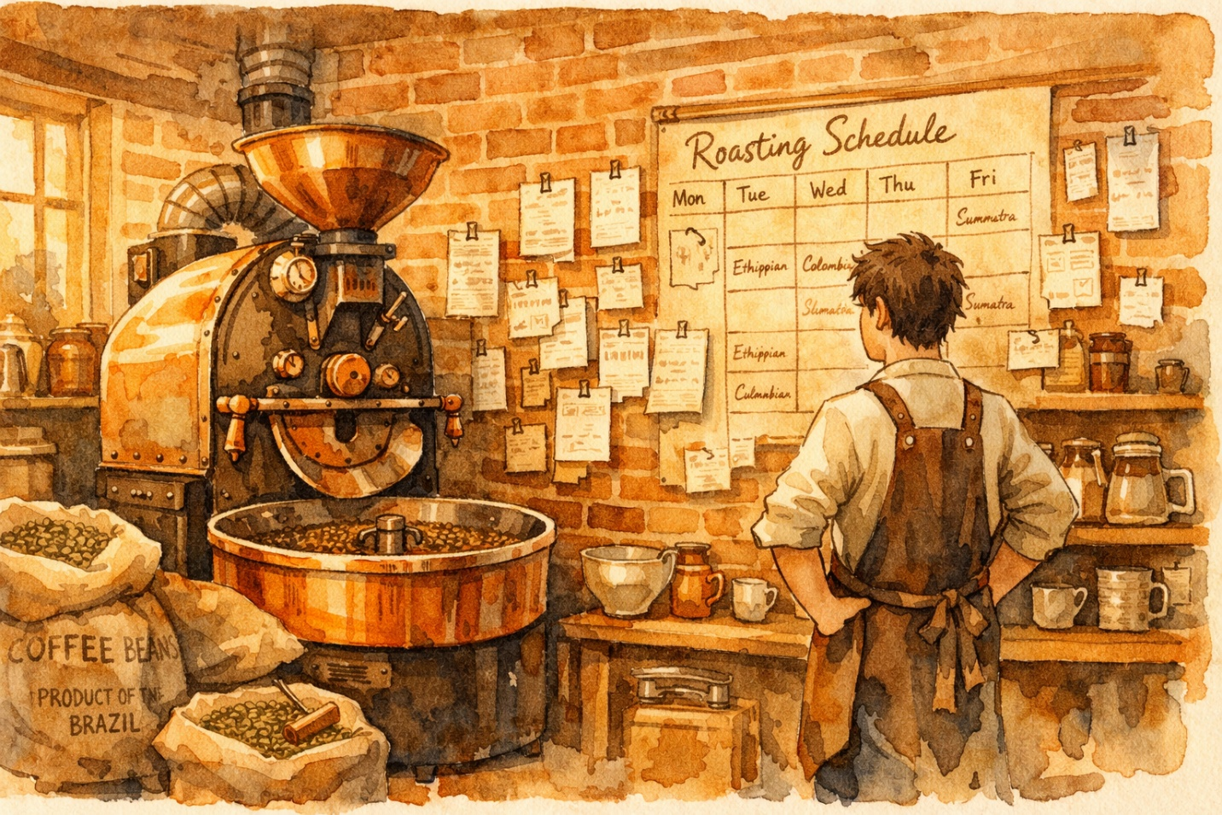
Meet the Characters
Marco | Owner of Copper Kettle Roastery. Former finance major who left a consulting internship to pursue his passion for specialty coffee. Determined, detail-oriented, but overwhelmed by his growing business.

Abuela Rosa | Marco’s grandmother. A retired operations manager from a textile factory in Colombia. She sees manufacturing problems everywhere — even in a coffee shop. Speaks in proverbs and always carries a notebook.

Priya | Marco’s business partner and head barista. Runs the café counter and manages the staff schedule. Practical, sharp, and the first to spot when customers are waiting too long.

Dev | The roaster. A mechanical engineering graduate who treats the roasting machine like a Formula 1 car. Obsessed with efficiency but sometimes forgets that not every station needs to run at full speed.

The Orders | Five custom roasting jobs that arrive on the busiest week of the year, each with different processing times, due dates, and demanding clients. They become the “characters” that teach priority rules.



Chapter One
The Monday Meltdown

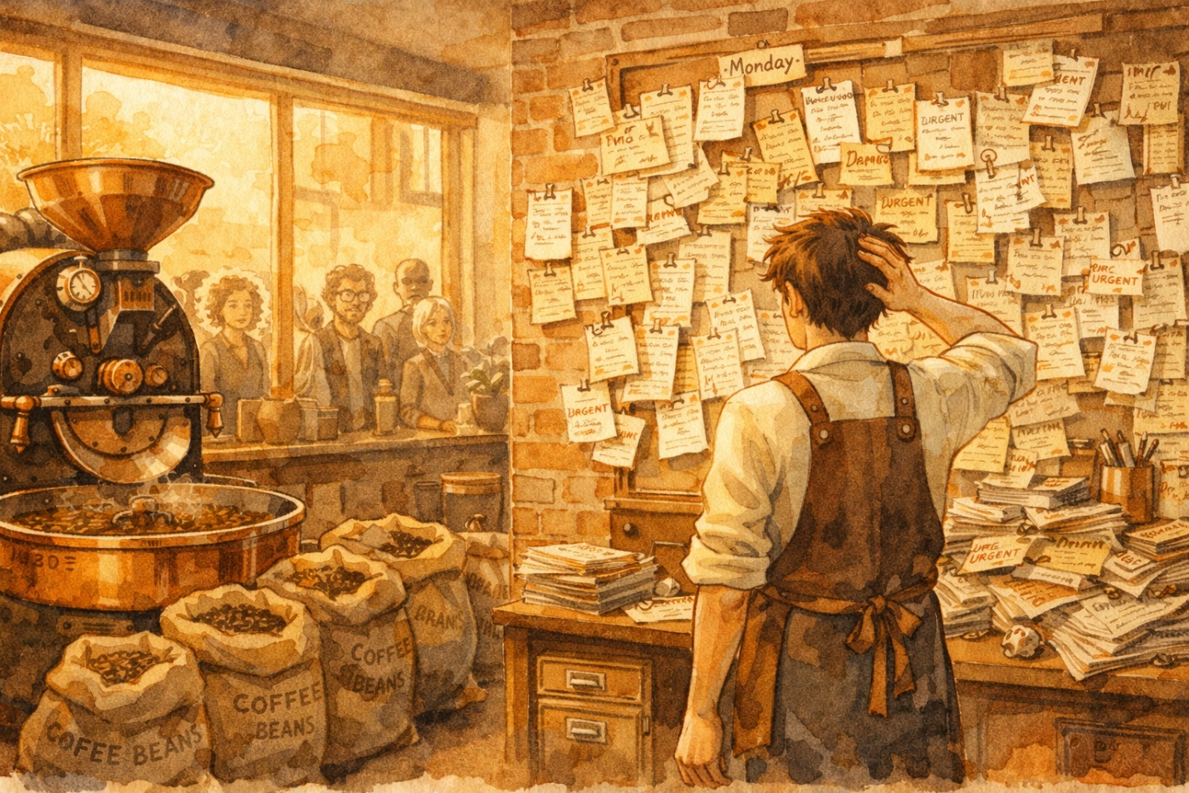
Copper Kettle Roastery smelled like possibility every morning — that deep, caramel-sweet scent of freshly roasted beans that made people stop on the sidewalk and breathe.
But on this particular Monday, Marco wasn’t breathing. He was drowning.

Five custom roasting orders had arrived over the weekend. A boutique hotel chain wanted 200 pounds of their house blend by Wednesday. A local restaurant needed a single-origin Ethiopian by Thursday. The university dining hall had placed a massive order due Friday. A specialty subscription box needed a small-batch experimental roast by Tuesday. And the weekend farmers’ market booth needed its usual stock by Saturday.

Marco: “I have five orders, three workstations, two employees, and exactly zero idea what to do first.”

The roastery was what operations people call a job shop — a facility where different products follow different paths through a set of workstations. Marco’s three stations were: the Roaster (Dev’s domain), the Grinder & Blending table, and the Packaging & Labeling area.
Unlike an assembly line where every product follows the same sequence, Marco’s orders bounced around. Some needed blending, some didn’t. Some were whole-bean, so they skipped the grinder entirely. It was organized chaos — emphasis on chaos.

📖 CONCEPT: Workcenter Scheduling
A workcenter is any area where productive resources are organized and work is completed. Workcenter scheduling involves deciding: (1) what jobs to run, (2) in what order, (3) when to start them, and (4) tracking their progress. The objectives include meeting due dates, minimizing lead time, minimizing setup time and cost, minimizing work-in-process (WIP) inventory, and maximizing machine utilization. The tricky part? You usually can’t optimize all of these at once.

📖 CONCEPT: Job Shop vs. Flow Shop vs. GT Cell
A job shop allows products to flow in any direction between departments — maximum flexibility, maximum scheduling complexity. A flow shop has all products following the same sequence (like an assembly line). A group technology (GT) cell falls in between — similar products are grouped and processed together. Marco’s roastery is a classic job shop.

🎯 INTERVIEW TIP
If an interviewer asks ‘What is workcenter scheduling?’ say: ‘It’s the process of allocating jobs to resources, sequencing them, dispatching them, and monitoring progress. The key challenge is balancing competing objectives like meeting due dates, minimizing WIP inventory, and maximizing resource utilization — because optimizing one often comes at the expense of another.’

Chapter Two
Abuela Rosa and the Five Rules


Abuela Rosa arrived Tuesday morning carrying a thermos and a lifetime of factory wisdom.

Abuela Rosa: “Marco, mi amor. You look like a man trying to juggle five balls with two hands. Let me show you something I learned in the textile mill.”

She pulled out five index cards and wrote Marco’s orders on each one:

Order | Client | Processing Time (hrs) | Due Date (day)
A | Subscription Box | 4 | Day 2 (Tue)
B | Hotel Blend | 8 | Day 3 (Wed)
C | Restaurant Ethiopian | 6 | Day 4 (Thu)
D | University Dining | 10 | Day 5 (Fri)
E | Farmers’ Market | 3 | Day 6 (Sat)

Abuela Rosa: “Now, mi amor, the question isn’t just ‘What do I do first?’ It’s ‘What rule do I use to decide?’ In operations, we call these priority rules.”

— Rule 1: First Come, First Served (FCFS) —
Abuela Rosa: “The simplest rule. Run jobs in the order they arrived. It feels fair, but fair and efficient aren’t always the same thing.”
Using FCFS, Marco would process: A → B → C → D → E, in the order the orders came in.

📖 CONCEPT: FCFS — First Come, First Served
Process jobs in the order they arrive. It’s intuitive and feels fair (think: a line at a bank), but it ignores job urgency and processing time. It rarely produces the best results for flow time or lateness, but customers perceive it as equitable.

— Rule 2: Shortest Operating Time (SOT) —
Abuela Rosa: “This one is my favorite. Always run the quickest job first. It minimizes the average time jobs spend waiting in your system.”
Using SOT, Marco would process: E (3 hrs) → A (4 hrs) → C (6 hrs) → B (8 hrs) → D (10 hrs).

Marco: “But wait — the University order is 10 hours. If I always run short jobs first, won’t the big order keep getting pushed back?”
Abuela Rosa: “Exactly! That’s the danger of SOT. Long jobs can be perpetually delayed. That’s why smart shops combine SOT with a lateness rule — a ‘longest-waiting’ override.”

📖 CONCEPT: SOT / SPT — Shortest Operating (Processing) Time
Run the job with the shortest processing time first. SOT is mathematically optimal for minimizing average flow time, average number of jobs in the system, and average lateness. However, it can perpetually delay long jobs in a dynamic environment. A common fix: combine SOT with a maximum-wait rule so that no job waits beyond a threshold.

🎯 INTERVIEW TIP
If asked ‘Which priority rule minimizes average flow time?’ the answer is SOT (Shortest Operating Time), also called SPT. But always add: ‘The downside is that long jobs can be perpetually delayed, so in practice it’s often combined with a lateness override.’ This shows you understand both the math and the real-world application.

— Rule 3: Earliest Due Date (EDD) —
Abuela Rosa: “When your customers care most about on-time delivery, you sort by due date. The job due soonest goes first.”
Using EDD: A (Day 2) → B (Day 3) → C (Day 4) → D (Day 5) → E (Day 6).

📖 CONCEPT: EDD — Earliest Due Date
Run the job with the earliest due date first. EDD minimizes the maximum lateness of any single job. It’s great when on-time delivery is the primary goal, but it ignores processing time entirely — a job due tomorrow that takes 20 hours could block everything.

— Rule 4: Slack Time Remaining (STR) —
Abuela Rosa: “This one is clever. Calculate how much cushion you have: time until the due date minus the processing time remaining. The job with the least cushion goes first.”
She wrote the formula on a napkin: STR = Time remaining before due date − Remaining processing time.

📖 CONCEPT: STR — Slack Time Remaining
STR = (Time remaining before due date) – (Remaining processing time). The job with the smallest slack goes first. A related variant, STR/OP, divides slack by the number of remaining operations, which is useful when jobs have different numbers of steps.

— Rule 5: Critical Ratio (CR) —
Abuela Rosa: “The critical ratio tells you how much trouble you’re in. If it’s less than 1, you’re behind schedule. If it’s exactly 1, you’re on track. Greater than 1? You have breathing room.”
CR = (Due date − Current date) ÷ (Number of work days remaining). Orders with the smallest CR are run first.

📖 CONCEPT: CR — Critical Ratio
CR = (Due date – Current date) / Work days remaining. CR < 1 means you’re behind schedule. CR = 1 means you’re exactly on track. CR > 1 means you have slack. The advantage of CR is that it’s dynamic — it can be recalculated every day as conditions change. The best priority rules are dynamic and based on slack.

🎯 INTERVIEW TIP
An interviewer might ask: ‘What characteristics should a good priority rule have?’ Answer: ‘A good priority rule should be dynamic — recalculated frequently to reflect changing conditions — and should be based on slack or urgency rather than static information. That’s why rules like Critical Ratio and STR tend to outperform simple FCFS in practice.’

Abuela Rosa: “There are also simpler rules people use without thinking: LCFS — last come, first served, which happens when the newest job lands on top of the pile. And Random — when the operator just picks whatever they feel like running.”
Marco: “That’s… basically what I’ve been doing.”
Abuela Rosa: “And that’s why you’re drowning, mi amor.”

Chapter Three
Loading the Roaster

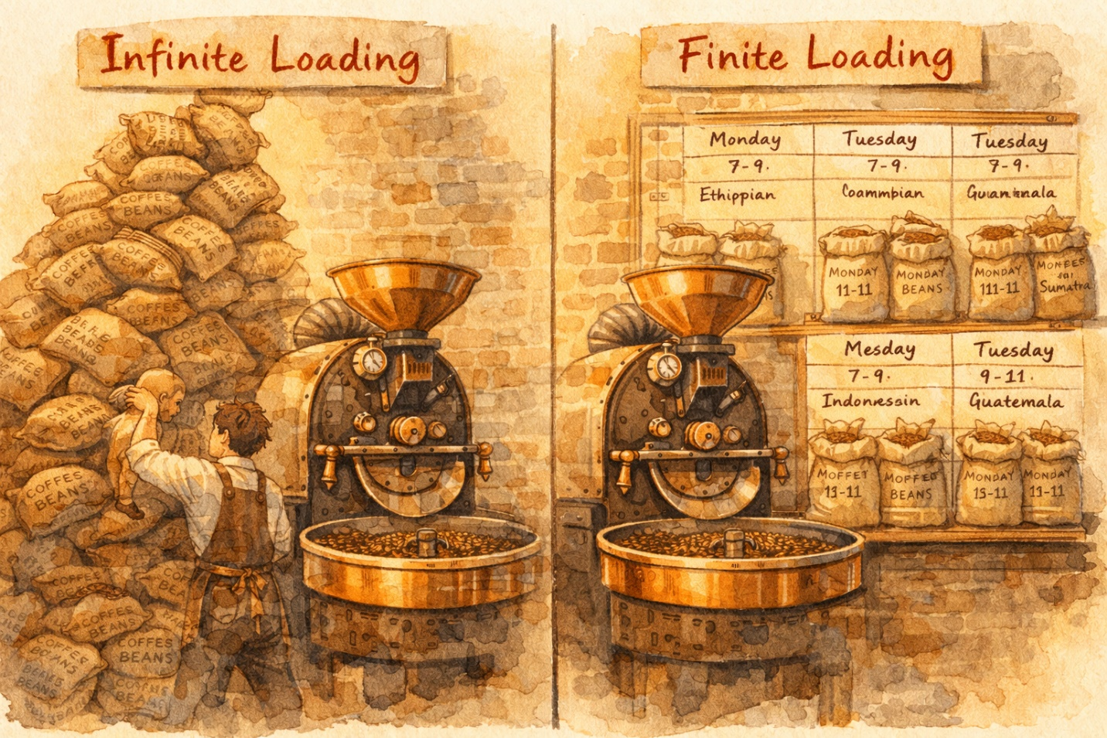
Dev was staring at the roasting machine, doing mental math.

Dev: “If I run the roaster for 12 hours straight, I can technically get through all five orders. But that assumes nothing goes wrong, no setups between batches, and that the grinder and packager keep up perfectly.”

Abuela Rosa shook her head.

Abuela Rosa: “There are two ways to think about loading work onto a machine. The first is infinite loading — you assign work based on what needs to be done, without worrying about whether the machine can actually handle it. MRP systems do this. The second is finite loading — you schedule each resource based on its actual setup and run times, so you know exactly what will happen at every moment.”

📖 CONCEPT: Infinite vs. Finite Loading
Infinite loading assigns work based on need, without considering capacity. It tells you what should be done. MRP systems typically use infinite loading. Finite loading schedules each resource using actual setup and run times, so you know exactly what will be done at every moment. Finite loading is more realistic but more complex to manage.

Abuela Rosa: “And there are two directions to schedule. Forward scheduling starts now and schedules everything into the future — it tells you the earliest an order can be done. Backward scheduling starts from the due date and works backward — it tells you when you must start to finish on time.”

📖 CONCEPT: Forward vs. Backward Scheduling
Forward scheduling takes an order and schedules operations forward in time from now, revealing the earliest completion date. Backward scheduling starts from the due date and schedules required operations in reverse, revealing when work must begin. MRP uses backward scheduling. Synchronous manufacturing uses forward scheduling to ensure feasibility.

🎯 INTERVIEW TIP
If asked about scheduling approaches, you can say: ‘Forward scheduling tells you the earliest you can finish. Backward scheduling tells you the latest you can start. In practice, forward scheduling gives you a feasible plan, while backward scheduling is what MRP systems use to calculate when to release orders.’

Chapter Four
The Two-Machine Tango

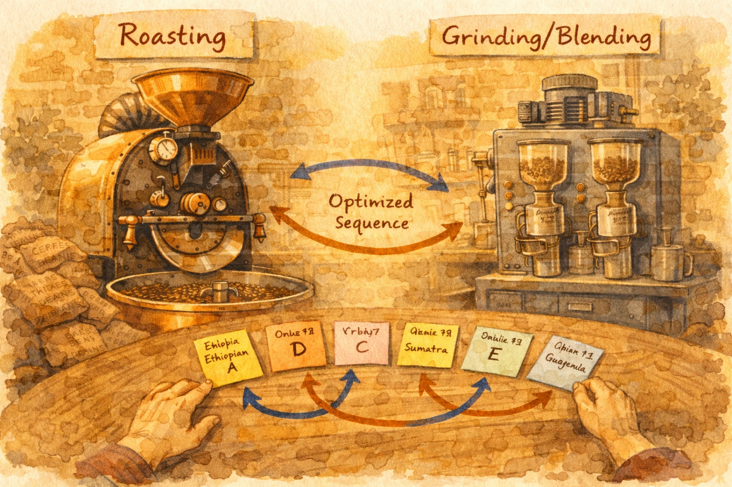
On Wednesday, Abuela Rosa noticed that all five orders needed to flow through two machines in the same sequence: first the Roaster, then the Grinder/Blender.

Abuela Rosa: “When every job must pass through two machines in the same order, there’s a beautiful trick called Johnson’s Rule. It gives you the optimal sequence — the one that minimizes the total time to finish all jobs.”

She laid out all five order cards and explained the steps:

Step 1: List the processing time for each job on each machine.
Step 2: Find the shortest processing time across all jobs and both machines.
Step 3: If the shortest time is on Machine 1, schedule that job first. If it’s on Machine 2, schedule it last.
Step 4: Remove that job from the list and repeat until all jobs are sequenced.

📖 CONCEPT: Johnson’s Rule
An algorithm for sequencing n jobs through two machines when all jobs follow the same order. It minimizes total completion time (makespan). The logic: put jobs with short Machine 1 times early (to get Machine 2 started quickly) and jobs with short Machine 2 times late (to keep Machine 2 busy at the end). For n jobs on 2 machines, Johnson’s Rule provides the provably optimal sequence.

🎯 INTERVIEW TIP
Johnson’s Rule is a classic interview topic. Be ready to walk through the steps: ‘List processing times on both machines. Find the shortest time. If it’s on Machine 1, schedule early; if Machine 2, schedule late. Remove and repeat. It minimizes makespan for two-machine flow problems.’

Marco: “What if I have more than two machines?”
Abuela Rosa: “Then it gets exponentially harder. For n jobs on m machines, there are (n!)^m possible schedules. With just 5 jobs and 3 machines, that’s over 1.7 million possibilities. At that point, you need computer simulation to evaluate different priority rules.”

📖 CONCEPT: n Jobs on m Machines
For n jobs on m machines, there are (n!)^m possible schedules. Even small workcenters produce enormous numbers of alternatives. Because of this combinatorial explosion, computer simulation is the only practical way to compare priority rules in complex shops. There is no single rule that works best in all situations.

Chapter Five
The Wall of Truth

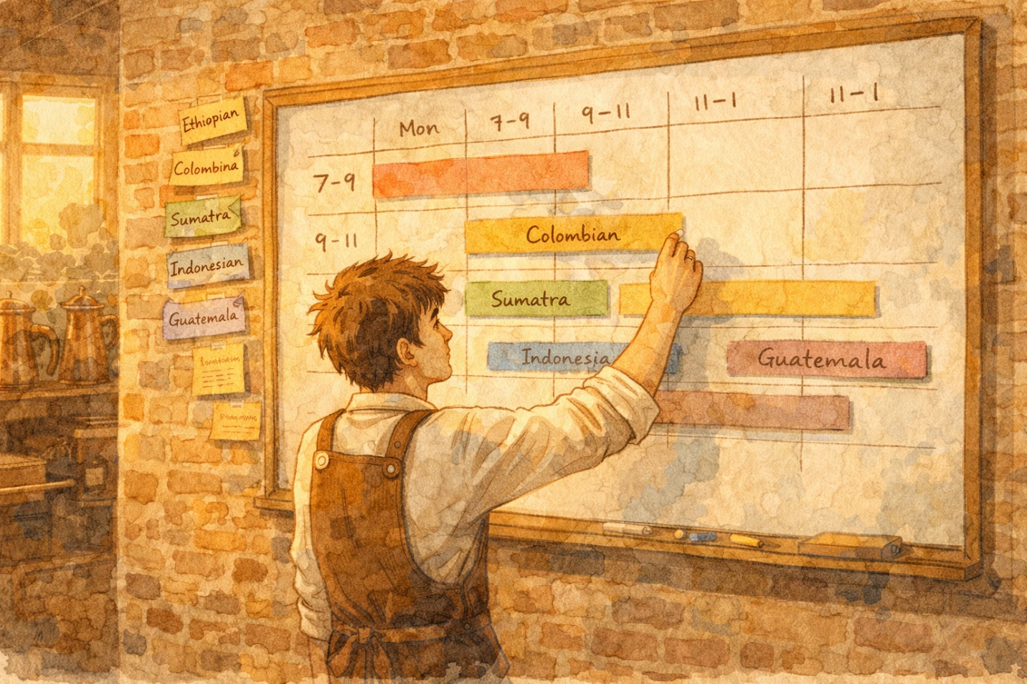
By Thursday, Marco had painted an entire wall with chalkboard paint. On it, he drew what Abuela Rosa called a Gantt chart — a visual timeline showing each job plotted against time.

Abuela Rosa: “This is your Wall of Truth. It shows you at a glance: which jobs are ahead, which are behind, and where your machines are idle. In a real factory, this is called shop-floor control — or production activity control.”

She explained the system: every morning, Dev would get a daily dispatch list — a document telling him which jobs to run, in what order, and how long each should take. Throughout the day, they’d update the Gantt chart to show actual progress versus planned.

📖 CONCEPT: Gantt Chart & Shop-Floor Control
A Gantt chart plots jobs against time, showing scheduled versus actual progress. Shop-floor control (also called production activity control) is the process of managing work flow on the manufacturing floor. Key tools include the daily dispatch list (what to run and in what order) and input/output control (ensuring planned input never exceeds planned output, preventing WIP buildup). Data integrity is crucial — inaccurate data ‘speeds up the mess.’

Dev: “What’s this ‘input/output control’ Abuela keeps talking about?”
Abuela Rosa: “Simple: the work going into a workcenter should never exceed what comes out. If you keep pouring orders in faster than the station can process them, you just build up a pile of work-in-process. That pile is not productive — it’s just trapped cash.”

📖 CONCEPT: Workflow = Cash Flow
The first principle of workcenter scheduling: there is a direct equivalence between workflow and cash flow. Work-in-process inventory is cash that’s trapped in the system. Smooth, continuous flow leads to efficient operations and minimum WIP. When flow is interrupted, WIP inventory grows and the process becomes less productive.

🎯 INTERVIEW TIP
A powerful interview statement: ‘I think of WIP inventory as trapped cash. One of the key principles of workcenter scheduling is that workflow equals cash flow — the faster work moves through the system, the faster you convert materials into revenue.’

Chapter Six
The Ten Commandments of Scheduling

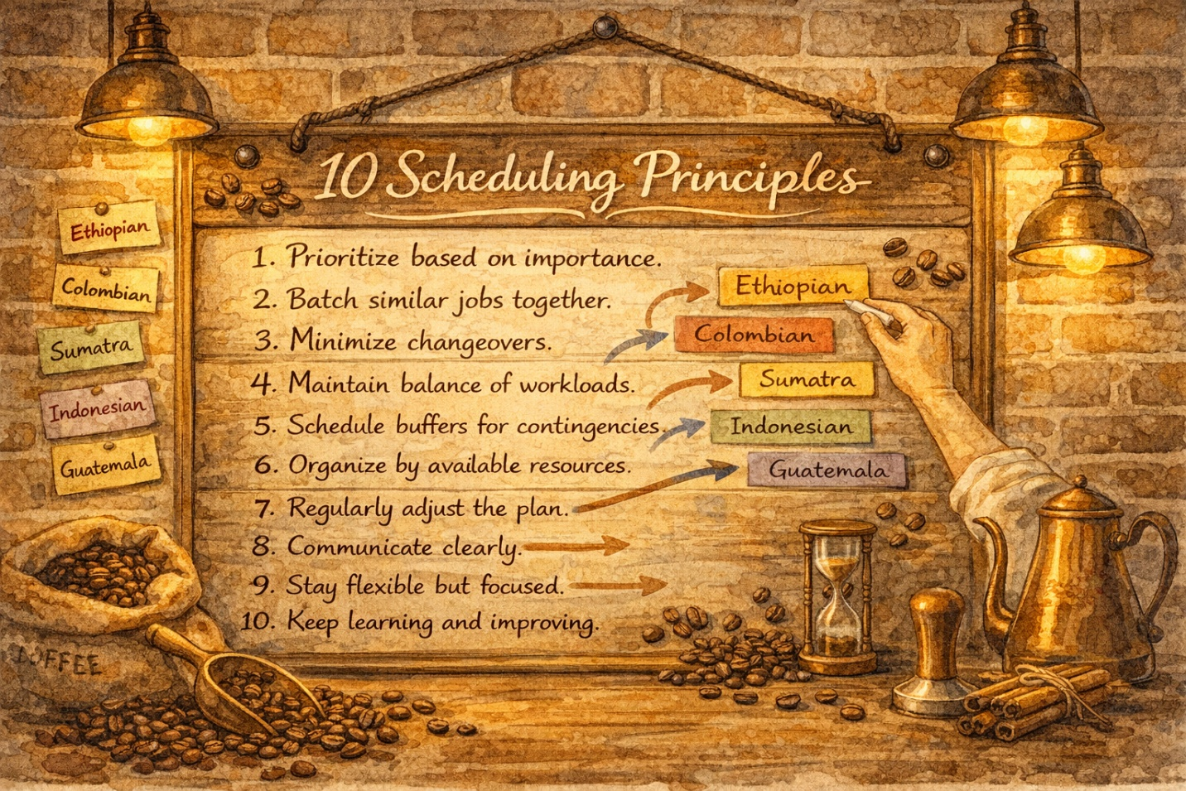
That evening, after the last order was packed, Abuela Rosa pulled out her notebook and read aloud ten principles she’d learned over decades in manufacturing:

1 | There is a direct equivalence between workflow and cash flow.

2 | The effectiveness of any job shop should be measured by speed of flow through the shop.

3 | Schedule jobs as a string, with process steps back-to-back.

4 | A job once started should not be interrupted.

5 | Speed of flow is most efficiently achieved by focusing on bottleneck workcenters and jobs.

6 | Reschedule every day.

7 | Obtain feedback each day on jobs that are not completed at each workcenter.

8 | Match workcenter input information to what the worker can actually do.

9 | When improving output, look for incompatibility between engineering design and process execution.

10 | Certainty of standards, routings, and so forth is not possible, but always work toward achieving it.

Marco: “Number 5 keeps coming up — bottlenecks. What exactly is a bottleneck?”
Abuela Rosa: “Patience, mi amor. That’s tomorrow’s lesson.”

Chapter Seven
The Slowest Dancer Sets the Tempo


Friday morning. Dev was running the roaster at full speed. The grinder was humming. But packaging? Priya was drowning in bags that weren’t labeled, orders that weren’t sealed, and a label printer that jammed every twenty minutes.

Dev: “I’m crushing it! I’ve roasted 200 pounds today!”
Priya: “And I’ve packaged 80. So 120 pounds of roasted beans are just… sitting there. On my table. Staring at me.”

Abuela Rosa walked over to the growing pile of unpackaged beans and smiled.

Abuela Rosa: “This, children, is what Eli Goldratt would call a bottleneck. Priya’s packaging station has less capacity than the demand placed on it. And an hour lost at a bottleneck is an hour lost for the entire system.”

📖 CONCEPT: Eli Goldratt’s Theory of Constraints (TOC)
Goldratt argued that manufacturers were not doing a good job scheduling and controlling resources. He developed a philosophy called Theory of Constraints (TOC) and software called Optimized Production Technology (OPT). The core insight: every system has at least one constraint (bottleneck), and the system’s output is limited by that constraint. Rather than trying to improve everything at once, focus on the constraint.

📖 CONCEPT: Key Definitions
Capacity: the available time for production. Bottleneck: a resource where capacity is less than the demand placed on it. Nonbottleneck: a resource where capacity is greater than demand. Capacity-Constrained Resource (CCR): a resource where capacity is close to demand — not quite a bottleneck, but dangerously close.

Marco: “So Dev running the roaster at 100% is actually a bad thing?”
Abuela Rosa: “Not bad — wasteful. Activating a resource is not the same as utilizing it. If Dev roasts faster than Priya can package, he’s just converting raw materials into work-in-process inventory. He’s busy, but he’s not productive.”

📖 CONCEPT: Utilization vs. Activation
Goldratt’s Rule 3: Utilization and activation of a resource are not the same. Running a nonbottleneck at 100% doesn’t increase throughput — it just builds WIP inventory. A nonbottleneck’s useful utilization is determined not by its own capacity, but by the constraint in the system.

🎯 INTERVIEW TIP
This is a killer interview insight: ‘An hour lost at a bottleneck is an hour lost for the entire system, but an hour saved at a nonbottleneck is a mirage. That’s Goldratt’s Rules 4 and 5 from Theory of Constraints, and it fundamentally changed how I think about resource utilization.’

Chapter Eight
The Five Steps to Freedom


Abuela Rosa: “Goldratt gave us a five-step recipe for dealing with any constraint. Let’s apply it right now, right here in this roastery.”

— Step 1: IDENTIFY the constraint —
They looked at each station’s capacity. The Roaster could handle 200 lbs/day. The Grinder could do 180 lbs/day. Packaging could only do 80 lbs/day. Packaging was clearly the bottleneck.

📖 CONCEPT: Step 1: IDENTIFY the constraint
Identify the system constraints. Which resource has less capacity than the demand placed on it?

— Step 2: EXPLOIT the constraint —
Make the bottleneck as productive as possible without spending money. They moved Priya’s lunch break to overlap with a label-printer maintenance window. They prepped all labels the night before. They eliminated the time Priya spent walking to the supply closet by moving supplies next to her station.

📖 CONCEPT: Step 2: EXPLOIT the constraint
Exploit: get the most out of the bottleneck. Don’t let it sit idle. Ensure it always has work, never processes defective items, and runs during breaks.

— Step 3: SUBORDINATE everything else —
Dev slowed down the roaster to match packaging’s capacity. Instead of roasting 200 lbs and creating a pile, he roasted 80 lbs and used his remaining time to help Priya label bags.

📖 CONCEPT: Step 3: SUBORDINATE everything else
Subordinate: everything else in the system should support the bottleneck’s pace. If a nonbottleneck produces faster than the bottleneck, it’s just building inventory.

— Step 4: ELEVATE the constraint —
They invested in a second label printer and trained Marco to run it during peak hours. Packaging capacity jumped to 140 lbs/day. Suddenly, packaging was no longer the bottleneck — now the Grinder was the tightest resource.

📖 CONCEPT: Step 4: ELEVATE the constraint
Elevate: if exploiting isn’t enough, invest to increase the bottleneck’s capacity. Buy equipment, add a shift, outsource — whatever it takes to raise capacity.

— Step 5: REPEAT (Don’t let inertia become the constraint) —
The team realized they needed to re-evaluate. With packaging solved, the grinder was now the constraint. The cycle begins again.

📖 CONCEPT: Step 5: REPEAT (Don’t let inertia become the constraint)
If the constraint has been broken, go back to Step 1. But don’t let inertia become the system constraint — the tendency to keep managing the old bottleneck after it’s moved.

🎯 INTERVIEW TIP
TOC’s five focusing steps are a must-know framework. In an interview, walk through them: ‘First, identify the constraint. Then exploit it — maximize output without spending money. Subordinate all other resources to the bottleneck’s pace. If that’s not enough, elevate — invest to increase capacity. Then repeat, because the constraint will shift.’

Chapter Nine
Drum, Buffer, Rope

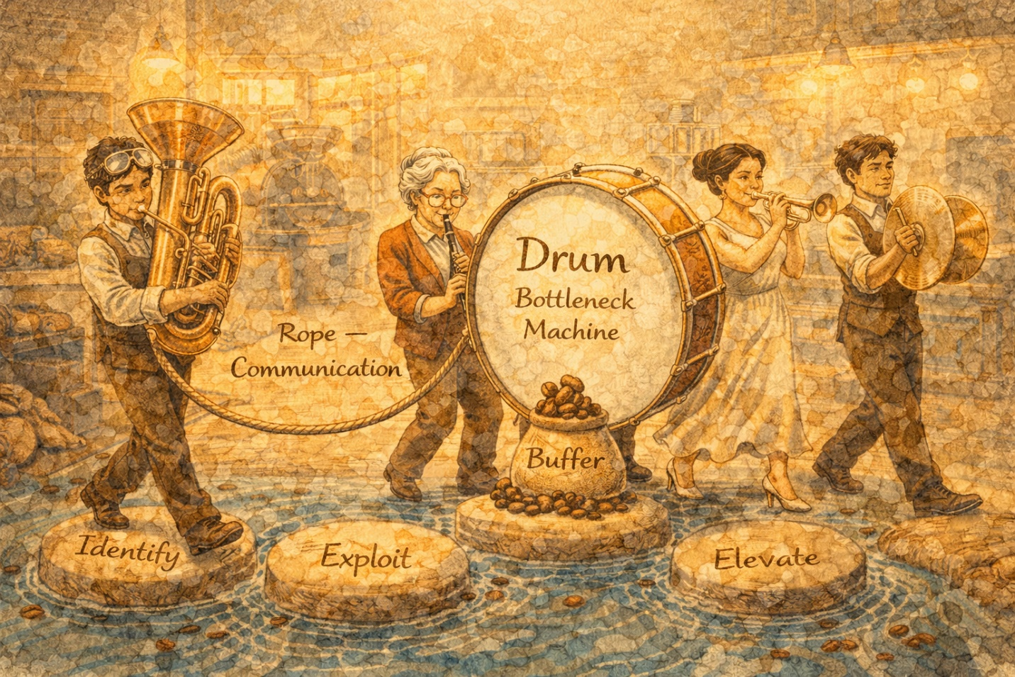
Abuela Rosa brought in a small drum from her car. An actual drum.

Abuela Rosa: “Every production system needs a heartbeat — something that sets the pace. Goldratt called it the drum. In your roastery, the bottleneck is the drum. It strikes the beat that the rest of the system uses to function.”

She set the drum next to the packaging station and tapped a steady rhythm.

Abuela Rosa: “Now, two things must happen. First, you keep a buffer of inventory in front of the bottleneck. Not too much — just enough so it never runs out of work. Second, you communicate upstream. The rope connects the bottleneck back to the first station, telling it: ‘Only send me what I can handle.’”

Dev: “So the rope is basically me checking with Priya before I start a new batch?”
Abuela Rosa: “Exactly. The rope prevents you from flooding her station with work she can’t process.”

📖 CONCEPT: Drum, Buffer, Rope (DBR)
Drum: The bottleneck (or the capacity-constrained resource, if no bottleneck exists) sets the pace for the entire system. Buffer: A small inventory bank kept in front of the bottleneck to ensure it never sits idle. Buffers are also placed at strategic points to protect throughput. Rope: Communication from the bottleneck back upstream, telling prior stations to only produce what the bottleneck needs. This prevents WIP from building up throughout the system.

🎯 INTERVIEW TIP
Drum-Buffer-Rope is an impressive framework to reference in interviews. Say: ‘In TOC, the bottleneck acts as the drum — it sets the pace for the whole system. You protect it with a buffer of inventory so it never starves, and you use a rope — upstream communication — to prevent overproduction at nonbottleneck stations.’

Chapter Ten
The Nine Rules & The Batch Size Trap

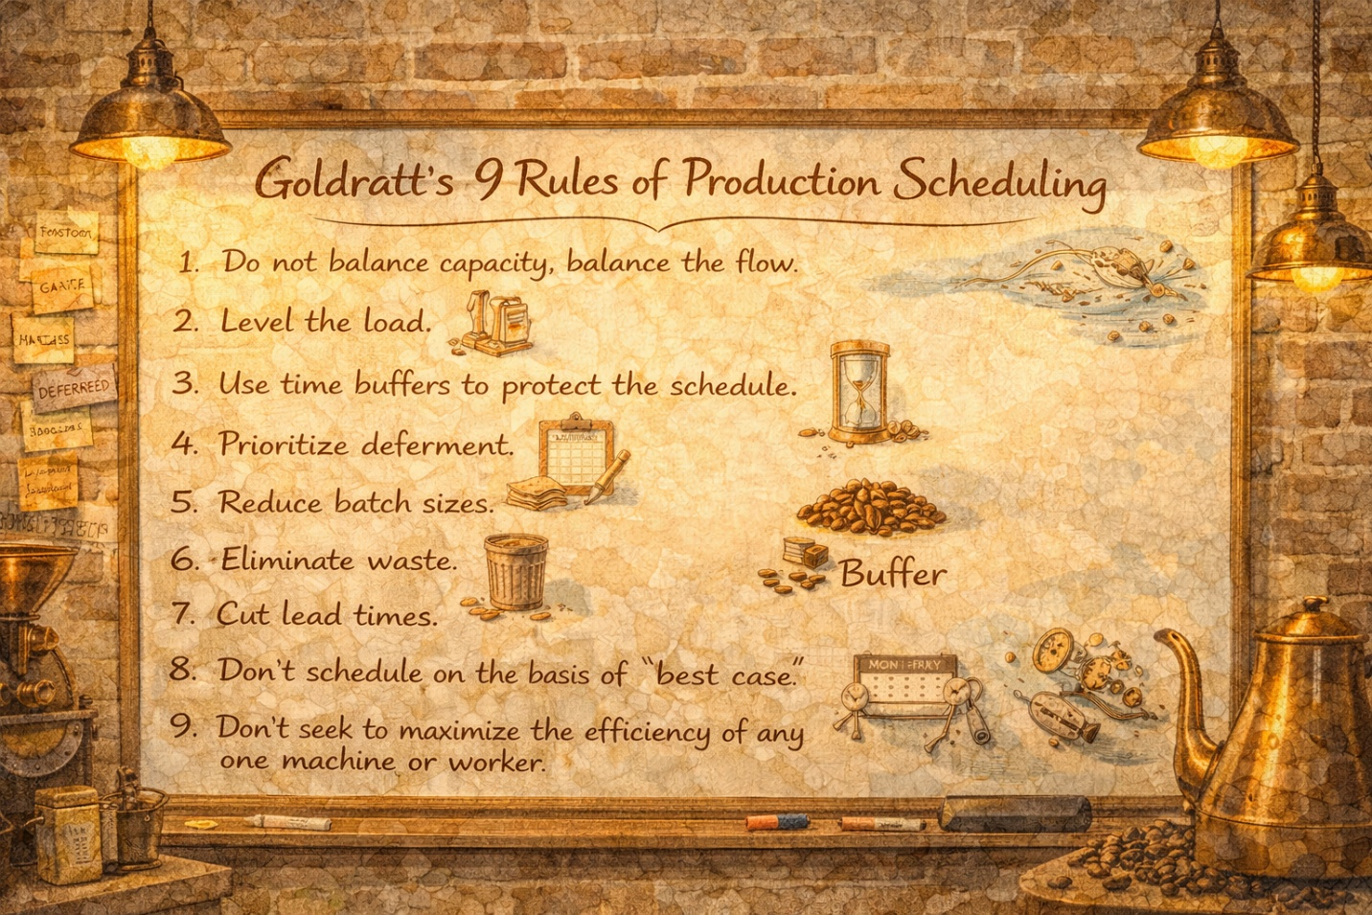
Saturday morning. The farmers’ market order was out the door. All five orders delivered. Marco, Dev, and Priya sat around a table while Abuela Rosa summarized everything she’d taught them.

Abuela Rosa: “Goldratt gave us nine rules for production scheduling. You’ve already lived most of them this week, but let me make sure they stick:”

1 | Do not balance capacity — balance the flow.

2 | A nonbottleneck’s utilization is determined by the system’s constraint, not its own potential.

3 | Utilization and activation of a resource are not the same.

4 | An hour lost at a bottleneck is an hour lost for the entire system.

5 | An hour saved at a nonbottleneck is a mirage.

6 | Bottlenecks govern both throughput and inventory in the system.

7 | The transfer batch may not, and many times should not, be equal to the process batch.

8 | A process batch should be variable both along its route and in time.

9 | Priorities can be set only by examining the system’s constraints, and lead time is a derivative of the schedule.

Marco: “Wait — Rule 7 says the transfer batch doesn’t have to equal the process batch. What does that mean?”

Abuela Rosa: “The process batch is how many you roast at once. The transfer batch is how many you move to the next station at a time. If Dev roasts 50 pounds, he doesn’t have to wait until all 50 are done to send some to Priya. He can transfer 10 pounds at a time, keeping her fed with work while he keeps roasting.”

📖 CONCEPT: Process Batch vs. Transfer Batch
Process batch: the total number of units processed in one setup at a station. Transfer batch: how many units are moved to the next station at a time. The transfer batch can (and often should) be smaller than the process batch. This keeps downstream stations working and reduces lead time. At a bottleneck, large process batches are preferred (fewer setups = more throughput). At nonbottlenecks, smaller batches are preferred (less WIP, more flexibility).

Dev’s eyes went wide.
Dev: “So that’s why batching caused so much trouble! When I roasted everything in one giant batch before sending anything downstream, Priya was idle for hours and then suddenly overwhelmed.”
Abuela Rosa: “Exactly. Batching can appear to improve efficiency, but it often leads to split lots, late deliveries, large WIP, and what operations people call the hockey stick phenomenon — where most output happens right before the deadline.”

Chapter Eleven
The Wandering Constraint

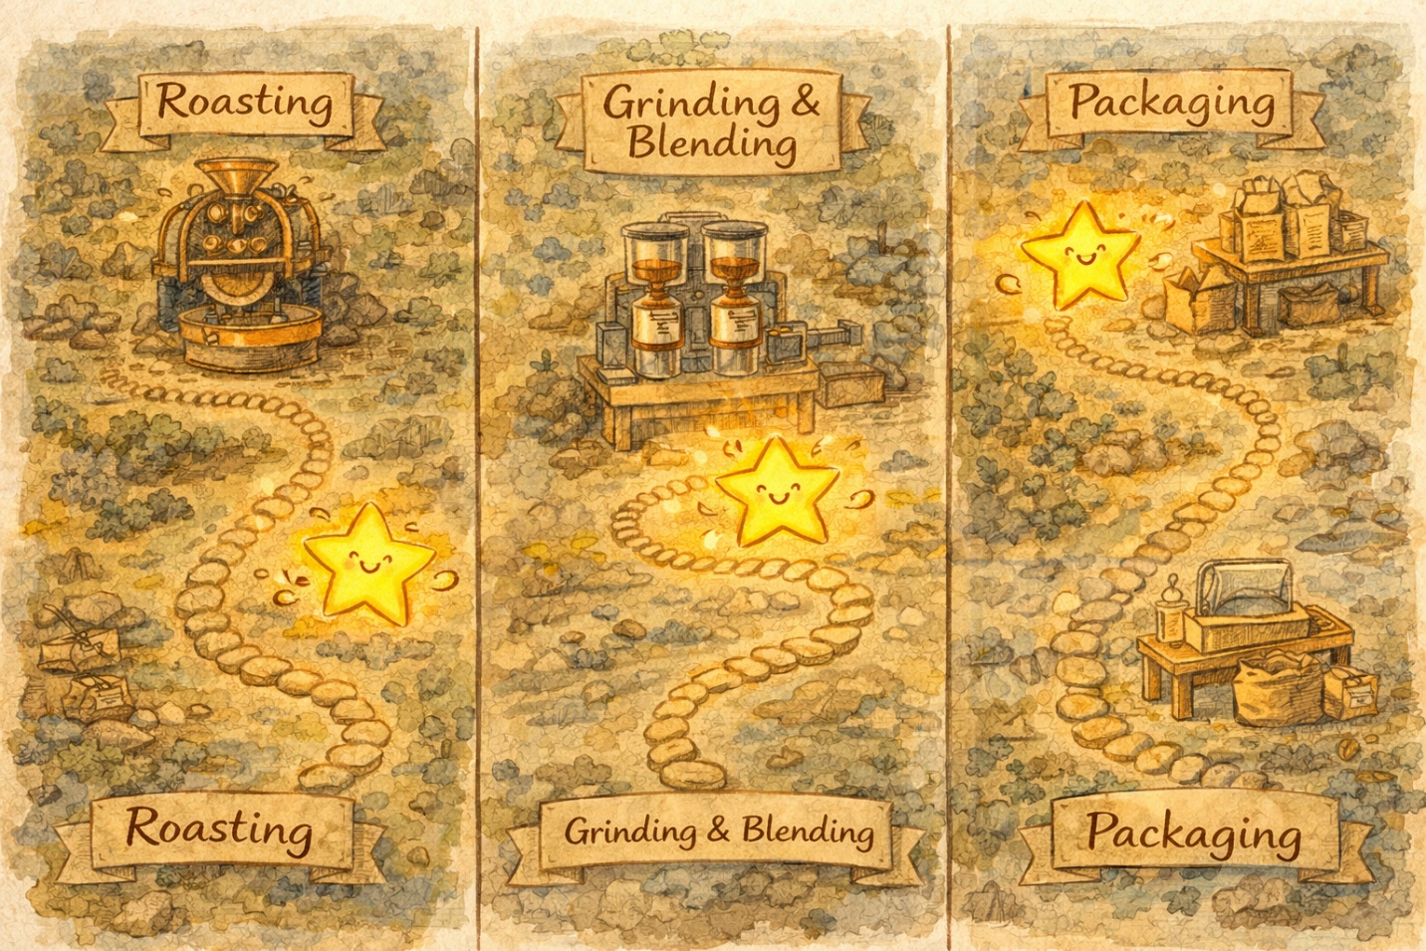
The following Monday, something strange happened. Packaging was running smoothly with its new printer. But the Grinder was overwhelmed — four different blend orders needed different grind settings, and each changeover took 30 minutes.

Priya: “Yesterday the bottleneck was me. Today it’s the grinder. Tomorrow it might be the roaster. It keeps moving!”

Abuela Rosa: “That’s called a moving bottleneck. It’s usually caused by batch sizes that are too large. A big batch on a machine with average excess capacity prevents other products from getting through, which starves downstream stations. From their perspective, that machine looks like a bottleneck — but days later it disappears and shows up somewhere else.”

📖 CONCEPT: Moving Bottlenecks
A moving bottleneck shifts from resource to resource over time. It’s typically caused by oversized batches. A large batch on a machine that normally has excess capacity can temporarily block other products, starving downstream operations. The ‘bottleneck’ then disappears when the batch finishes and reappears wherever the next oversized batch occurs. A nonbottleneck can become a bottleneck when scheduled with batches that are too large.

🎯 INTERVIEW TIP
If asked about moving bottlenecks: ‘A moving bottleneck is usually caused by batch sizes that are too large. When a nonbottleneck processes a huge batch, it temporarily starves downstream resources, making itself look like the constraint. The fix is to use smaller, more frequent batches — especially at nonbottleneck resources.’

Chapter Twelve
The Three Things That Actually Matter

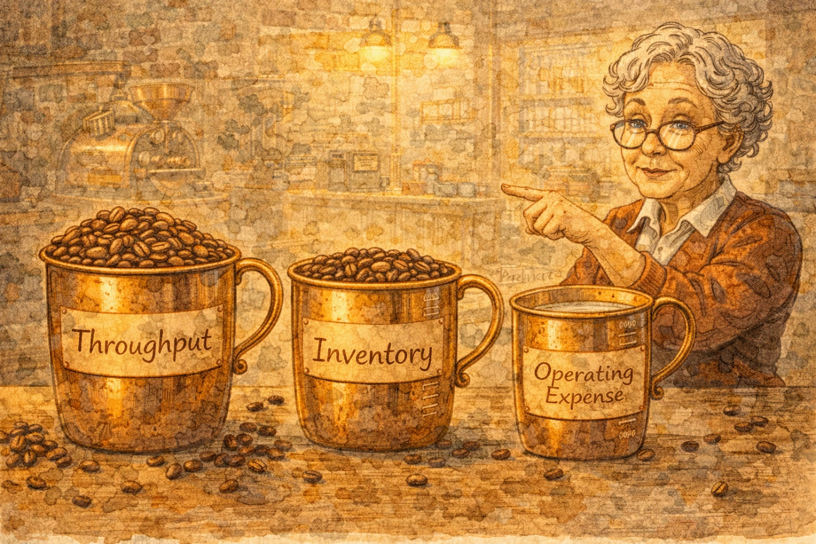
Abuela Rosa: “Traditional accounting measures the wrong things and rewards counterproductive behavior. Goldratt gave us three operational measurements that actually matter:”

📖 CONCEPT: Throughput, Inventory, and Operating Expense
Throughput: the actual rate of money generated through sales — not production, sales. Making products that sit in a warehouse is not throughput. Inventory: all the money invested in things intended to be sold — including raw materials, equipment, and buildings, but valued at purchase cost only (no value-added labor). Operating Expense: all the money spent to convert inventory into throughput — direct/indirect labor, materials used, depreciation, administrative costs. The goal: increase throughput while simultaneously reducing inventory and operating expense.

🎯 INTERVIEW TIP
This reframes the classic ‘productivity’ question. Say: ‘Under TOC, productivity is defined as all the actions that bring a company closer to its goals. The three operational measurements are throughput, inventory, and operating expense. The goal is to simultaneously increase throughput while reducing the other two — not to maximize machine utilization for its own sake.’

Chapter Thirteen
Priya’s Scheduling Puzzle


While Marco and Dev were focused on roasting operations, Priya was wrestling with a completely different kind of scheduling problem: people.

The Copper Kettle had expanded to include a café counter, open 7 days a week. Priya managed 7 part-time baristas, and she had three scheduling headaches: giving everyone two consecutive days off, staffing the right number of people each day, and adjusting staffing hour-by-hour during the day.

— Consecutive Days Off —
Priya: “Everyone wants weekends off, but our busiest days are Saturday and Sunday. I need to give each person two days off in a row while still meeting daily staffing requirements.”

Abuela Rosa taught her the algorithm: start with each day’s staffing requirement, identify the two consecutive days with the lowest combined requirement, assign those as the first employee’s days off, reduce the requirements for the remaining days, and repeat for each employee.

📖 CONCEPT: Scheduling Consecutive Days Off
Personnel scheduling in services involves three layers: assigning consecutive days off (weekly), scheduling daily work times, and scheduling hourly work times. The consecutive-days-off algorithm works by finding the pair of adjacent days with the lowest combined staffing need, assigning those as an employee’s days off, then reducing the requirement table and repeating.

— The First-Hour Principle —
Priya: “Even when I get the daily numbers right, some hours we’re overstaffed and other hours we’re slammed. How do I match staffing to demand that changes every hour?”

Abuela Rosa: “Use the first-hour principle. For the first hour of the day, assign exactly the number of workers needed. For each hour after that, only add workers if the current on-duty staff falls below the requirement. When workers finish their shift, only replace them if needed.”

📖 CONCEPT: First-Hour Principle for Hourly Scheduling
Services like restaurants and cafés face changing staffing requirements hour by hour. The first-hour principle works as follows: (1) For the first hour, assign workers equal to the requirement. (2) For each subsequent period, add only enough additional workers to meet the requirement. (3) When workers reach the end of their shifts, add replacements only if the remaining on-duty staff falls below the requirement. This produces lean staffing that tracks demand.

🎯 INTERVIEW TIP
Service scheduling is a common interview topic for retail, hospitality, and consulting roles. Say: ‘Service scheduling is challenging because demand is rarely smooth and customers expect immediate service. I’d use historical demand data to forecast hourly requirements, then apply the first-hour principle to build lean schedules that track demand while giving employees fair, consecutive days off.’

📖 CONCEPT: Service Execution System (SES)
Just as manufacturing uses shop-floor control, services use a Service Execution System (SES) — an information system that links, schedules, dispatches, tracks, monitors, and controls customer encounters with the service organization.

Chapter Fourteen
The Old Way vs. The New Way

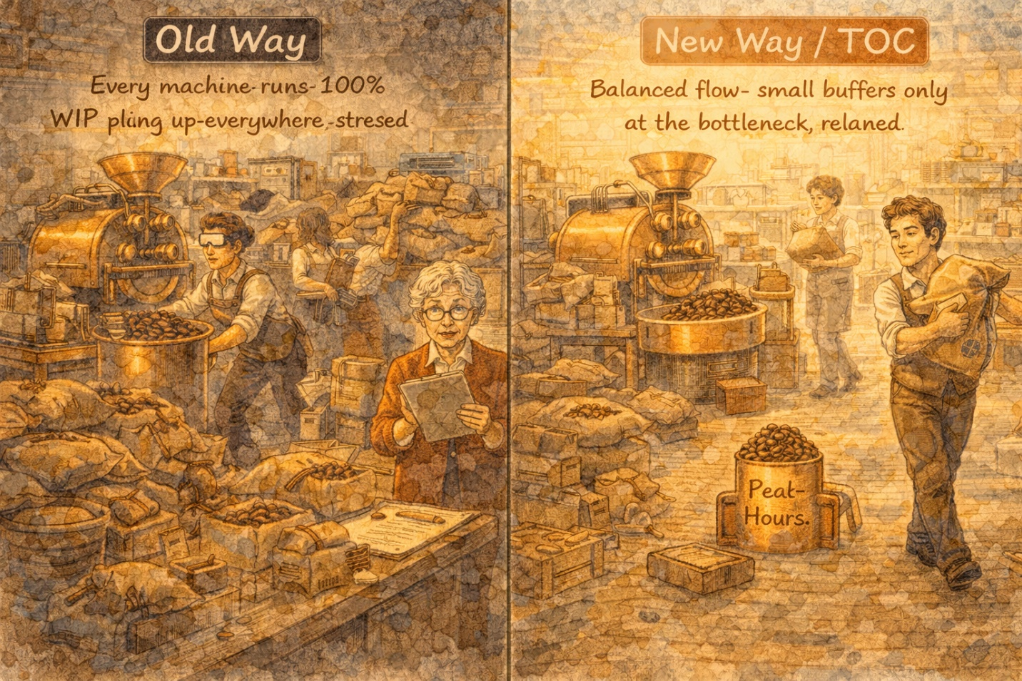
Marco: “So how is all this different from just using MRP or JIT?”

Abuela Rosa: “Great question. All three approaches try to manage production, but they think about it differently.”

📖 CONCEPT: Comparing MRP, JIT, and Synchronous Manufacturing (TOC)
MRP uses backward scheduling through a bill-of-materials explosion and generates capacity utilization profiles. Smoothing capacity is difficult. JIT uses kanban (pull) signals and seeks smooth, level production with minimal inventory. Lot sizes are ideally one. Synchronous Manufacturing (TOC) uses forward scheduling to ensure feasibility. Batch sizes vary based on whether the resource is a bottleneck or nonbottleneck. Quality control is placed specifically before bottlenecks. It’s flexible and focused on maximizing flow through the system while minimizing cost.

Abuela Rosa leaned back in her chair.
Abuela Rosa: “The biggest mindset shift is this: traditional approaches try to balance capacity — make every station equally loaded. TOC says that’s impossible and counterproductive. Instead, balance the flow. Let the bottleneck set the pace, and subordinate everything else to it.”

🎯 INTERVIEW TIP
If asked to compare MRP and TOC: ‘MRP uses backward scheduling and tries to balance capacity, which is difficult in practice. TOC uses forward scheduling, focuses on the bottleneck, and balances flow rather than capacity. The key difference is that TOC explicitly manages constraints while MRP treats all resources more equally.’

Chapter Fifteen
The Rhythm Found

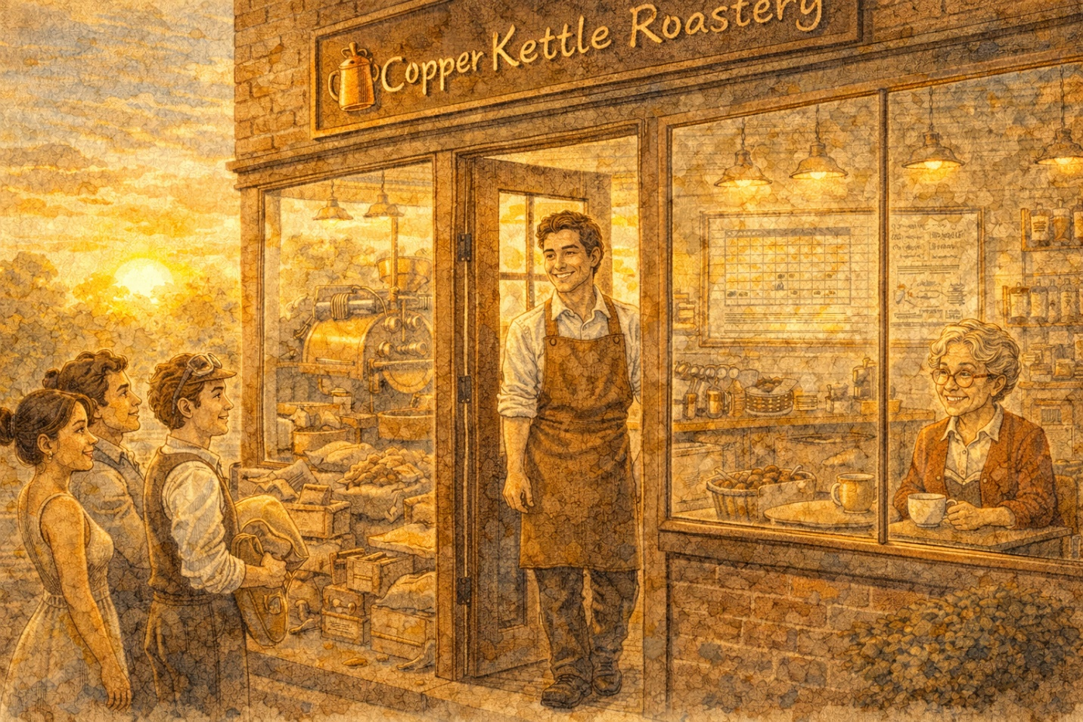
Six weeks later, Copper Kettle Roastery was a different place.

The Gantt chart on the Wall of Truth was updated every morning. Dev checked with Priya before starting each batch — the rope in action. A small, tidy buffer of roasted beans always sat in front of the packaging station, never too much, never empty. Priya’s hourly staffing schedule tracked customer demand like a heartbeat.

Marco stood at the counter, watching the morning rush flow like music.

Marco: “You know what changed? It’s not that we work harder. It’s that we found our rhythm. The roaster doesn’t set the pace — the constraint does. We don’t schedule by gut — we use rules. We don’t measure busyness — we measure flow.”

Abuela Rosa smiled from her corner table, sipping a perfect cortado.

Abuela Rosa: “You didn’t just learn scheduling, mi amor. You learned to see the system. And once you can see the system, you can improve it.”

The end — but the continuous improvement never stops.

📖 CONCEPT: Key Takeaways — Ch. 22 & Ch. 22S
Workcenter scheduling balances competing objectives: meeting due dates, minimizing lead time, minimizing WIP, and maximizing utilization. Priority rules (FCFS, SOT, EDD, STR, CR) help sequence jobs — the best rules are dynamic and based on slack. Johnson’s Rule optimally sequences jobs through two machines. Shop-floor control uses Gantt charts, dispatch lists, and input/output control. Theory of Constraints focuses on the system’s bottleneck using five focusing steps: Identify, Exploit, Subordinate, Elevate, Repeat. Drum-Buffer-Rope controls production flow. The goal: increase throughput while reducing inventory and operating expense. Service scheduling uses consecutive-days-off algorithms and the first-hour principle.

🎯 INTERVIEW TIP
The ultimate synthesis for any operations interview: ‘I believe the most important insight from operations management is that you should manage the system’s constraint, not optimize individual stations in isolation. Workflow equals cash flow. An hour lost at the bottleneck is an hour lost forever, but an hour saved at a nonbottleneck is a mirage. That’s the mindset I’d bring to any process improvement challenge.’

