🏪

Luna’s Bakery Goes Digital
An ERP & IoT Adventure
Chapter 17: The Internet of Things and ERP

BCOR440 / IE425 · Dr. Yaa
Operations & Supply Chain Management

Act One
The Chaos Before ERP
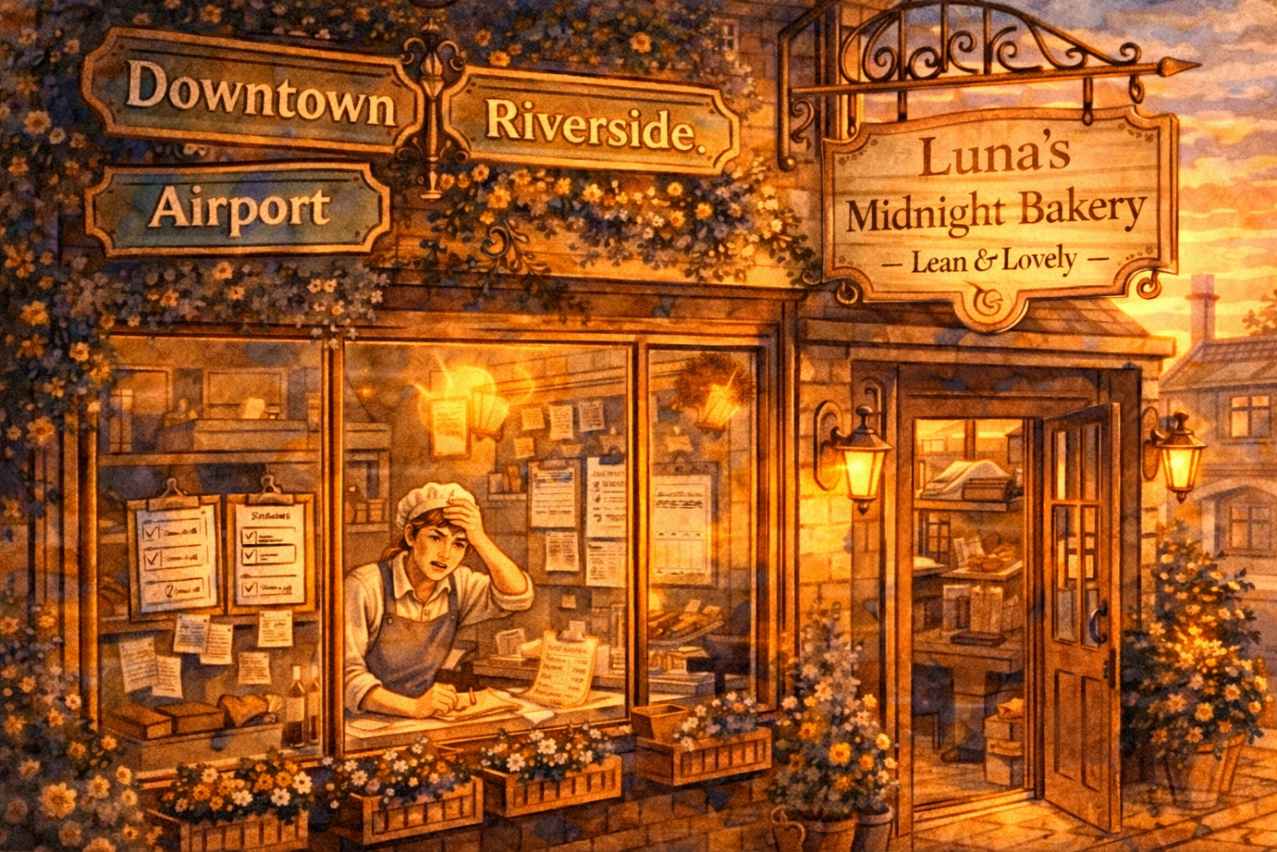

Luna’s Midnight Bakery had done something miraculous. What started as a single cozy shop on a cobblestone corner had become three thriving locations — Downtown, Riverside, and the new Airport Kiosk.
Business was booming. But behind the scenes? Things were falling apart.

Luna: “We sold 400 croissants yesterday, but I can’t tell you how many we actually made, how much flour we used, or whether we even made a profit. Every location keeps its own records. Nothing talks to anything else.”

Sound familiar? This is what happens when a growing company relies on disconnected systems — separate spreadsheets, separate software, separate versions of the truth.

Let’s look inside each department to see the chaos:

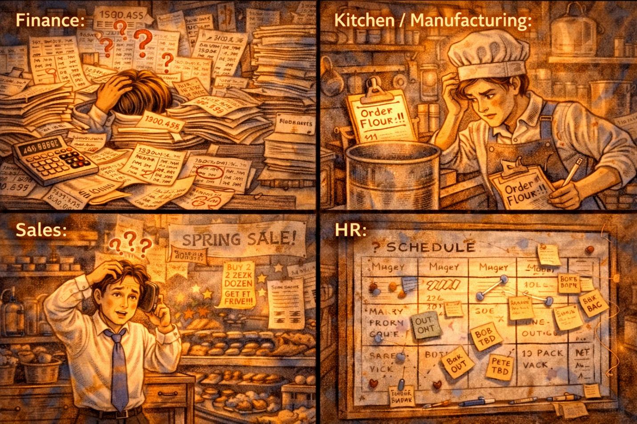

💰 Finance Department
Uses a desktop spreadsheet. Payroll data is re-entered by hand from HR’s separate system. Revenue numbers don’t match the sales team’s reports. Month-end closing takes 12 days.

🏭 Manufacturing & Logistics
Kitchen managers track inventory on paper clipboards. Flour runs out unexpectedly because nobody sees the Downtown location’s order until it’s too late. Delivery routes are planned by gut feel.

📊 Sales & Marketing
Uses a separate app to track customer orders. Forecasts demand by guessing. Ran a “Buy 5 Get 1 Free” promo but Finance didn’t know — so the revenue report looked like a disaster.

👥 Human Resources
Schedules are posted on a whiteboard at each location. When someone calls in sick, the manager texts Luna personally. Training records? “Somewhere in a binder.” Payroll is always late.

✨ CONCEPT SPOTLIGHT
The Core Problem: Data Silos
When each department uses its own separate system, data gets re-entered (causing errors), changes happen that other departments can’t see (no real-time updates), and there is no single version of the truth. ERP exists to solve exactly this problem.

One evening, after discovering that the Airport Kiosk had run out of sourdough for the third time this month, Luna sat down with her laptop and searched: “How do big companies manage all their departments together?”
And that’s when she found it.

✨ CONCEPT SPOTLIGHT
Enterprise Resource Planning (ERP)
A computer system that integrates application programs in accounting, sales, manufacturing, and other functions in a firm. This integration is accomplished through a database shared by all the application programs. For managers, it’s a comprehensive software approach to support decisions while planning and controlling the business.

Luna: “Wait — one system, one database, and every department sees the same information in real time? That’s literally what I’ve been wishing for!”

🎯 INTERVIEW TIP
“The fundamental advantage of ERP is that it integrates all business functions through a single shared database with real-time transaction processing. This eliminates data silos and ensures every department makes decisions from the same, current information.”

Act Two
One Brain for the Whole Bakery
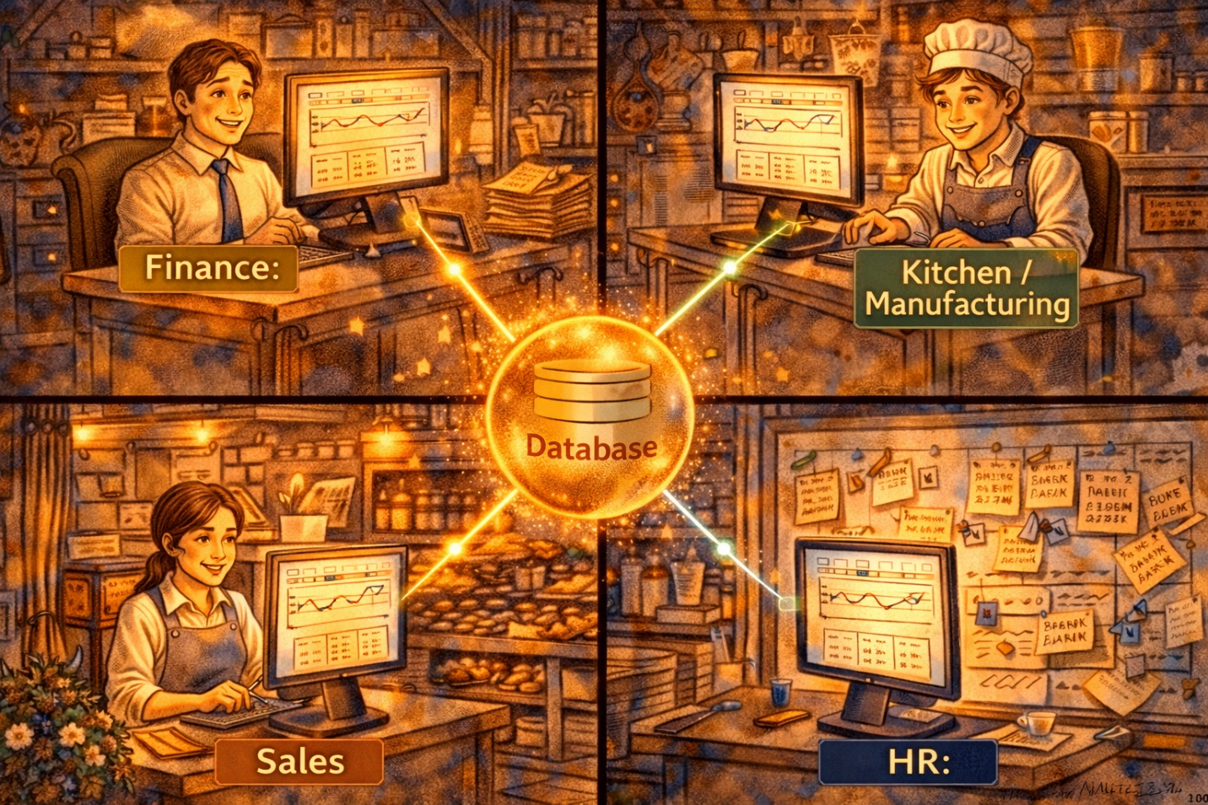
Luna learned that ERP systems are built from modules — each one handles a different business function, but they all connect to the same central database. There are four major module categories:

ERP Module | What It Does for Luna’s Bakery
💰 Finance | Automatic capture of accounting transactions at the source. No more re-entering data from HR’s spreadsheet!
🏭 Manufacturing & Logistics | The LARGEST and most complex module. Inventory tracking, production planning, vendor management — all coordinated across 3 locations.
📊 Sales & Marketing | Customer management, demand forecasting, promotions — and Finance sees every sale instantly. No more surprise promos.
👥 Human Resources | Manage, schedule, pay, hire, and train people. Payroll connects directly to Finance. No more whiteboards.

✨ CONCEPT SPOTLIGHT
Four Software Imperatives
What makes ERP software work: (1) Multifunctional in scope — covers all major areas. (2) Integrated — all modules share data seamlessly. (3) Modular in structure — add pieces as you grow. (4) Facilitates planning and control — not just record-keeping, but decision support.

An important surprise for Luna: an ERP system doesn’t have to come from a single vendor. You can mix and match modules. The largest ERP vendor in the world is SAP. Microsoft’s offering is called Microsoft Dynamics (better suited for smaller businesses).

✨ CONCEPT SPOTLIGHT
Transaction Processing
The posting and tracking of activities that document a business. In ERP, transactions update all modules in real time — the moment data is entered, every user sees the change. This eliminates reposting errors and ensures a common vision is instantly displayed.

Luna: “When a customer buys a dozen muffins at Riverside, the system instantly records the sale, reduces inventory, calculates revenue, updates tomorrow’s production target, and adjusts the flour order. All from ONE transaction!”

✨ CONCEPT SPOTLIGHT
Data Warehouse
A special program designed to automatically archive and process data for uses that are outside the basic ERP system applications. Think of it as the bakery’s ‘history library’ — storing years of data for deep analysis and custom queries.

🎯 INTERVIEW TIP
“In an ERP system, transactions are processed in real time through a shared database. This eliminates the reposting errors that plague organizations using disconnected systems. The key insight is that ERP provides integration — not just automation.”

Act Three
Smart Ovens & Talking Flour Bins
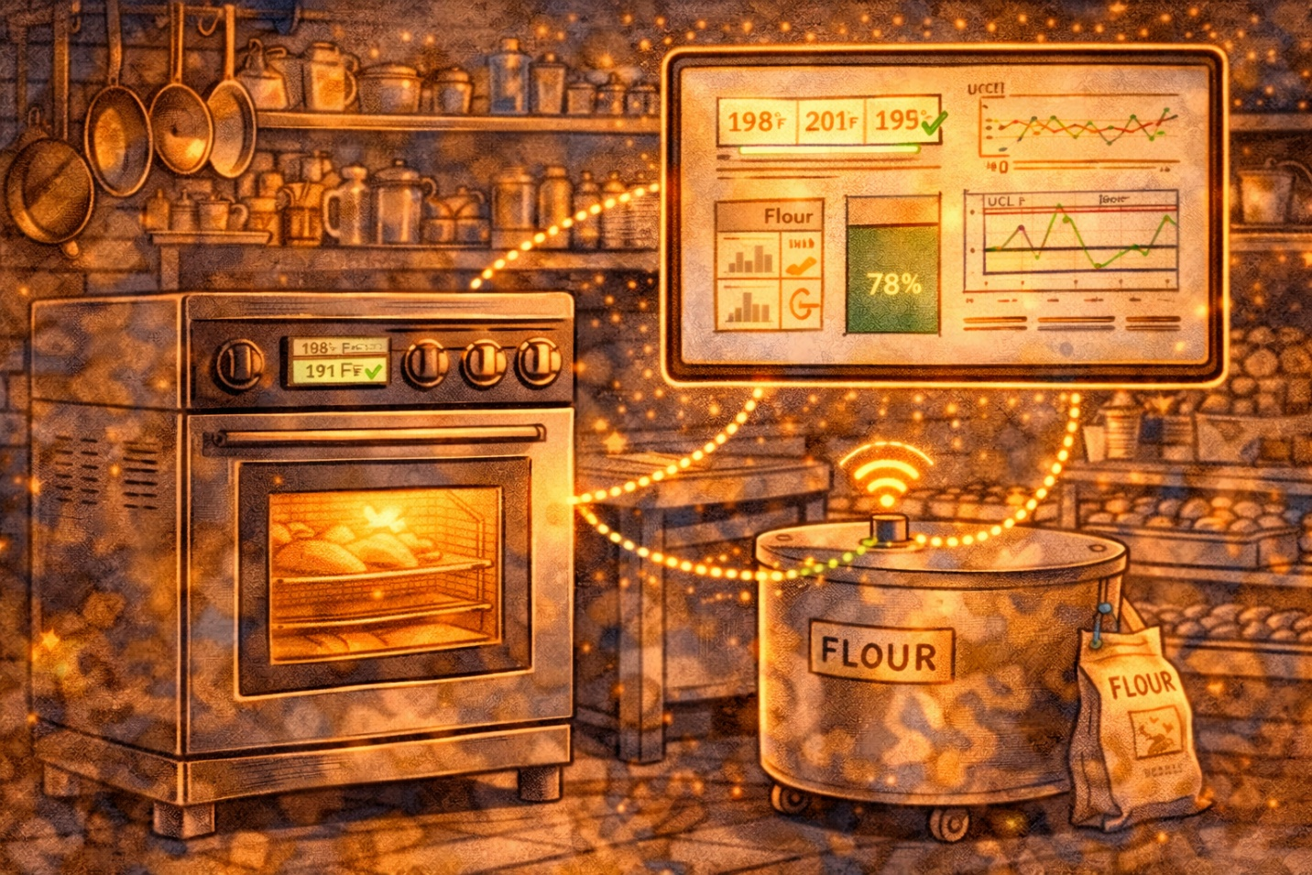

Luna’s ERP was transforming her business. But one morning, she walked into the Downtown kitchen to find 200 burnt baguettes. The oven had been running 15°F too hot all night, and nobody noticed.

Luna: “My ERP can track every sale, every ingredient, every employee... but it can’t tell me my oven is overheating? There has to be a way to connect my physical equipment to my digital system.”

There was. It’s called the Internet of Things.

✨ CONCEPT SPOTLIGHT
The Internet of Things (IoT)
IoT refers to the billions of devices connected to the Internet that are constantly collecting and storing data. Today, it’s possible to connect practically anything to the Internet. The integration of intelligent devices with ERP systems creates exciting opportunities for radically changing how business is done.

Luna started adding IoT sensors throughout her bakery:
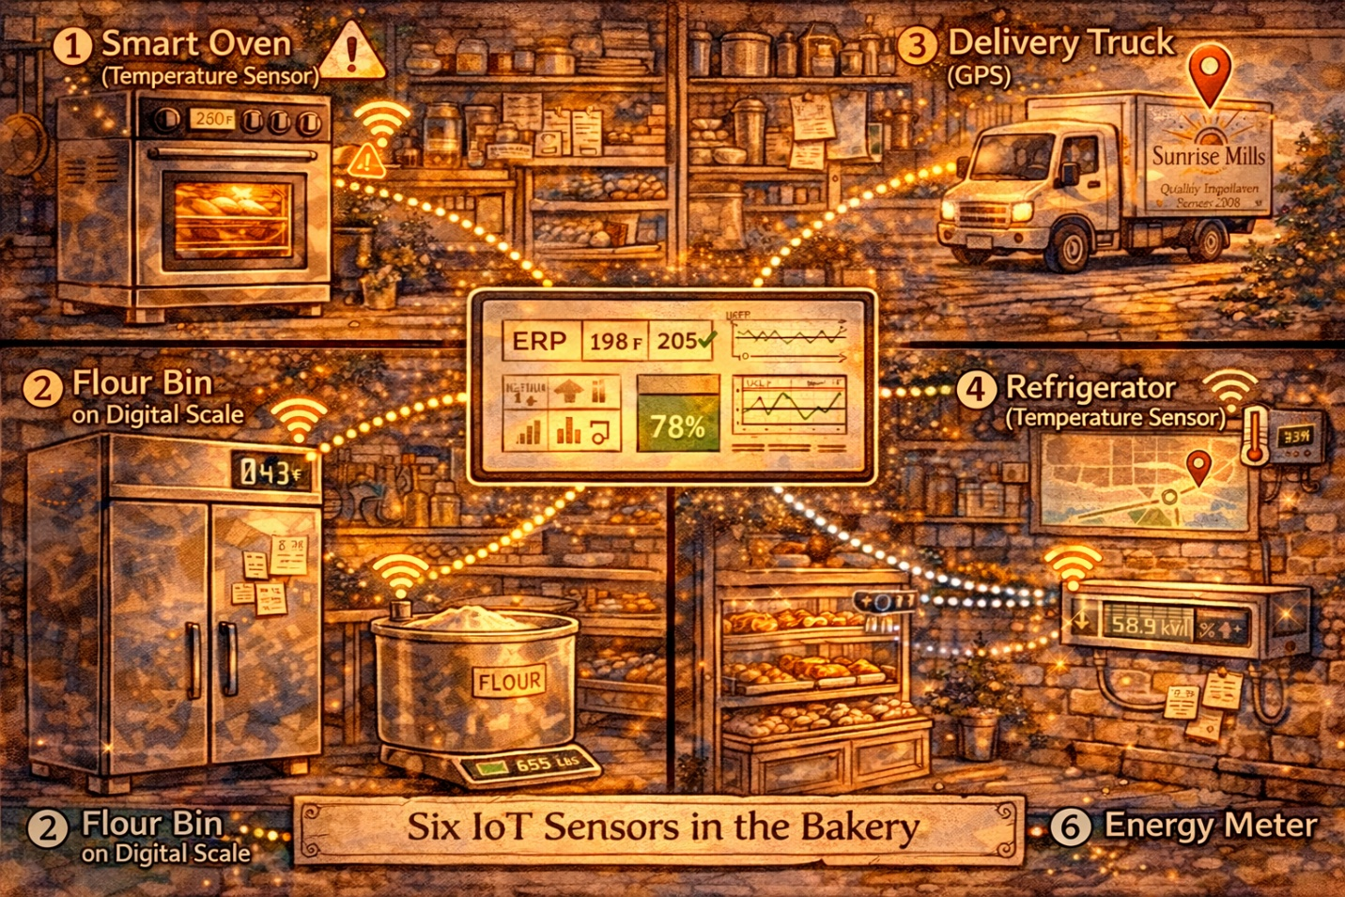
- 🌡️ Smart Ovens: Temperature alerts sent to ERP. Auto-adjusts if too hot or cold. Prevents entire batches from burning.
- ⚖️ Flour Bin Scales: Weight sensors track flour levels continuously. When below threshold, ERP auto-triggers a vendor reorder through VMI.
- 🚚 Delivery GPS Trackers: Real-time truck location feeds into ERP. Each location sees delivery ETAs. Customers can get updates.
- ❄️ Refrigerator Monitors: 24/7 temperature tracking. Instant alerts if temp rises above the safe zone. Prevents spoilage and waste.
- 📦 Shelf Sensors: Detect how many pastries remain on display. ERP auto-signals the kitchen to bake more when stock runs low.
- 🔌 Energy Meters: Track energy usage per oven, per shift. ERP identifies cost-saving opportunities and optimal scheduling.

🎯 INTERVIEW TIP
“IoT transforms operations by connecting physical assets to digital systems. When a floor sensor detects low inventory and automatically triggers a purchase order through the ERP, that’s the convergence of IoT and enterprise software — eliminating the lag between ‘something happened’ and ‘someone knows about it.’”

Act Four
The Supply Chain Command Center
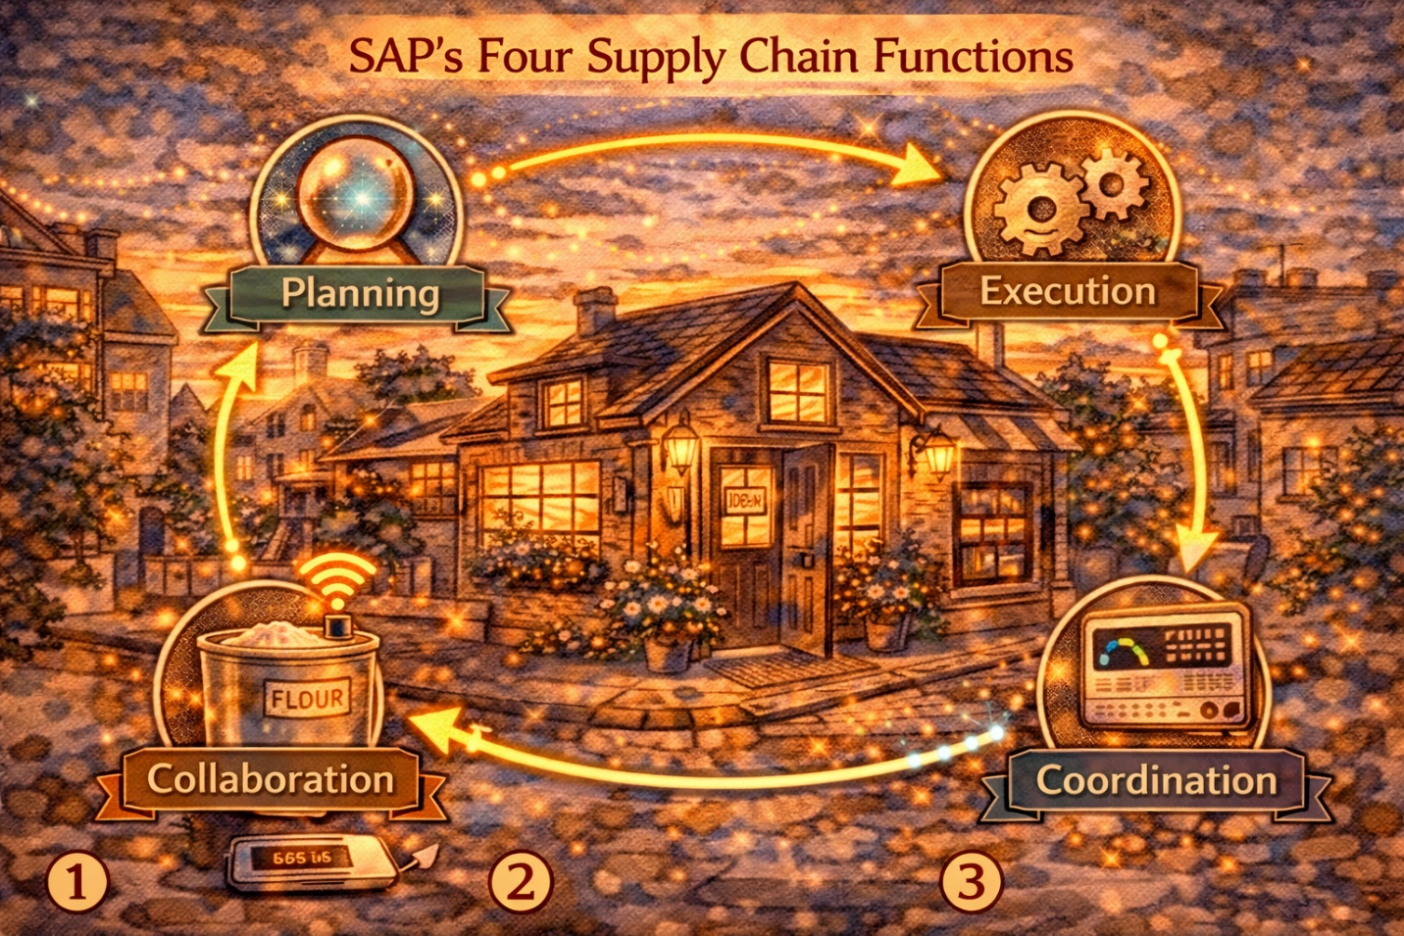
As Luna’s business grew, she realized ERP wasn’t just about internal departments. It was about managing her entire supply chain — from the wheat farmer to the customer’s hands.
She studied how SAP, the world’s largest ERP vendor, organizes its supply chain software into four main functions:

SAP Function | What It Does | Luna’s Bakery Example
Supply Chain Planning | Centralized overview of entire supply chain + demand/supply matching | Forecasts Airport Kiosk needs 150 croissants Mondays, only 80 Tuesdays
Supply Chain Execution | Materials management, collaborative manufacturing, fulfillment | Coordinates flour delivery with baking schedules — ingredients arrive just in time
Supply Chain Collaboration | VMI, enterprise portal, inventory collaboration hub | Luna’s flour supplier sees bin levels and auto-ships when low (VMI)
Supply Chain Coordination | Event monitoring, performance KPIs | Dashboard shows on-time delivery %, waste %, cost per croissant across all locations

✨ CONCEPT SPOTLIGHT
Vendor Managed Inventory (VMI)
A set of processes that enables vendor-driven inventory replenishment. Instead of Luna manually ordering flour, the supplier monitors her inventory through the ERP collaboration hub and automatically ships when levels drop. This reduces stockouts and frees Luna from manual ordering.

✨ CONCEPT SPOTLIGHT
Collaborative Manufacturing
The sharing of information with partners to coordinate production, enabling everyone to work together to increase visibility and responsiveness. Luna shares her production schedule with her chocolate supplier so they can time deliveries perfectly.

✨ CONCEPT SPOTLIGHT
Enterprise Portal
Gives users personalized access to a range of information, applications, and services supported by the system. Luna’s kitchen managers see production dashboards. Her accountant sees financial reports. Her delivery drivers see route schedules. Same system, different views.

Luna now understood the three major functional areas of her internal supply chain: Purchasing → Manufacturing → Sales & Distribution. Tight cooperation between these three is essential for effective manufacturing planning and control.

🎯 INTERVIEW TIP
“The three internal supply chain functions — Purchasing, Manufacturing, and Sales & Distribution — require tight cooperation, and ERP provides the infrastructure for that coordination. SAP organizes its supply chain software into four functions: planning, execution, collaboration, and coordination.”

Act Five
Luna’s Digital Transformation
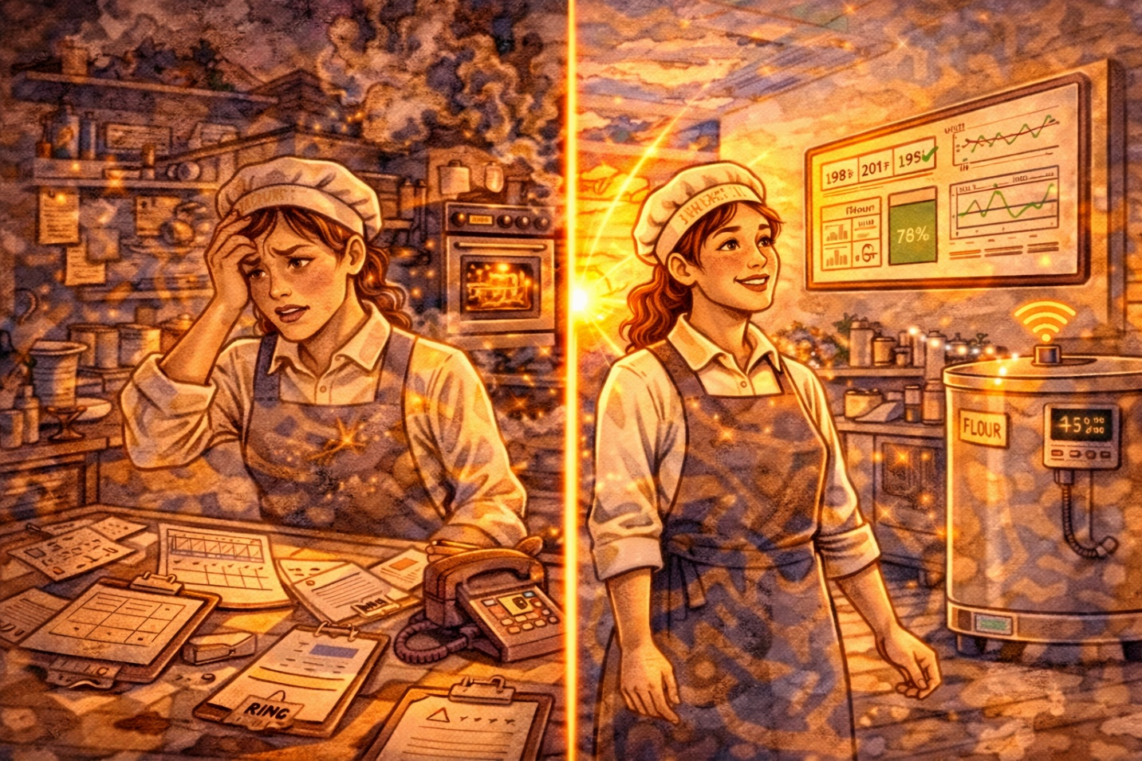
Six months after implementing ERP and IoT, Luna looked at her bakery and barely recognized it:

Area | ❌ Before ERP | ✅ After ERP + IoT
Inventory | Paper clipboards, surprise stockouts | Real-time bin sensors, VMI auto-reorder
Finance | 12-day month-end close, data re-entry | 2-day close, automatic transaction capture
Forecasting | Guessing based on “last year was busy” | Data-driven forecasting from sales history
Communication | Texting Luna for every problem | Enterprise portal with role-based dashboards
Quality | Burnt baguettes discovered next morning | IoT alerts the moment oven temp drifts
Suppliers | Phone calls and faxes | Collaborative manufacturing & SAP hub

Luna: “The biggest thing I learned? ERP isn’t just software — it’s a way of thinking. When every part of your business speaks the same language and sees the same data, you stop fighting fires and start making real decisions.”

🎯 INTERVIEW TIP
“In any supply chain role, understanding ERP is essential. I can speak to how ERP provides real-time integration through a shared database, eliminates data silos, and enables performance measurement across the entire enterprise. The convergence of IoT with ERP is creating even more opportunities for intelligent, responsive operations.”

Quick Reference: Key Terms for Quiz 2

Term | Definition / Key Fact
ERP | Integrates all business functions through a single shared database updated in real time
Transaction Processing | Posting and tracking of activities that document a business
Four ERP Modules | Finance, Manufacturing & Logistics, Sales & Marketing, Human Resources
Largest/Most Complex Module | Manufacturing and Logistics
SAP | Largest ERP vendor in the world
Microsoft Dynamics | Microsoft’s ERP offering, oriented toward smaller businesses
Data Warehouse | Special program to archive and process data beyond basic ERP applications
Four Software Imperatives | Multifunctional, Integrated, Modular, Facilitates Planning & Control
IoT | Billions of Internet-connected devices collecting and storing data
SAP Supply Chain (4 functions) | Planning, Execution, Collaboration, Coordination
VMI | Vendor Managed Inventory — vendor-driven replenishment
Collaborative Manufacturing | Sharing information with partners to coordinate production
Enterprise Portal | Personalized access to ERP information, apps, and services
SaaS | Delivering ERP services on demand over the Internet
3 Internal SC Areas | Purchasing, Manufacturing, Sales & Distribution
Single Vendor Required? | No — ERP modules can come from different vendors
ERP Implementation | NOT simple — requires significant configuration, training, and organizational change

BCOR440 / IE425 · Dr. Yaa · Operations & Supply Chain Management
Luna’s Bakery Goes Digital — Chapter 17: The Internet of Things and ERP

