Project Management Worksheet
ANSWER KEY with Explanations

Problem #1: CPM Basics
This problem tests your ability to: (1) draw a network diagram from a table, (2) find the critical path, and (3) calculate slack.
Key Concept: What is the Critical Path?
The critical path is the LONGEST path through the network. It determines the minimum project duration. Any delay on the critical path delays the entire project.
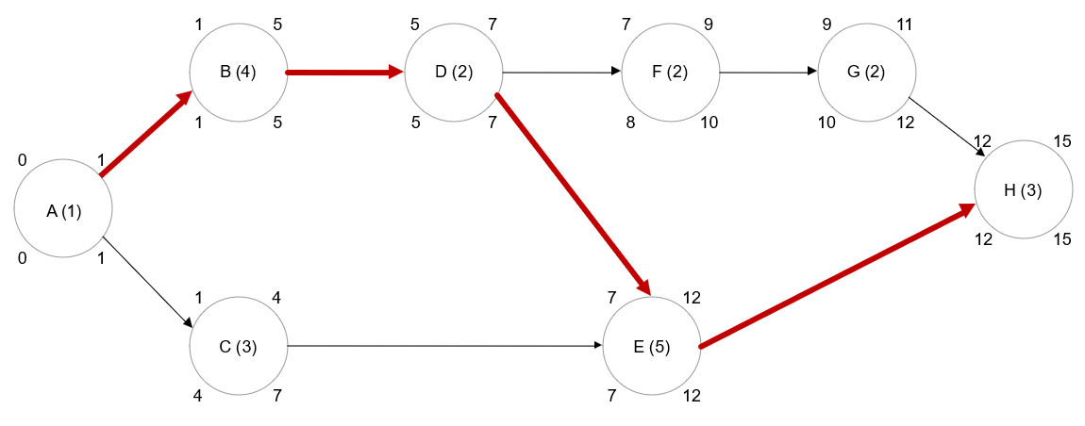

Answer: Critical Path
Critical Path: A → B → D → E → H
Project Duration: 15 weeks (1 + 4 + 2 + 5 + 3 = 15)

Forward & Backward Pass Table
How to Fill This Table
Forward Pass (ES/EF): Start at the beginning, work forward. ES = max of all predecessor EFs. EF = ES + Duration.
Backward Pass (LS/LF): Start at the end, work backward. LF = min of all successor LSs. LS = LF - Duration.

Activity | Duration | ES | EF | LS | LF | Slack
A | 1 | 0 | 1 | 0 | 1 | 0
B | 4 | 1 | 5 | 1 | 5 | 0
C | 3 | 1 | 4 | 4 | 7 | 3
D | 2 | 5 | 7 | 5 | 7 | 0
E | 5 | 7 | 12 | 7 | 12 | 0
F | 2 | 7 | 9 | 8 | 10 | 1
G | 2 | 9 | 11 | 10 | 12 | 1
H | 3 | 12 | 15 | 12 | 15 | 0

Reading the Table
Pink rows = Critical path activities (Slack = 0).
Green cells = Activities with slack (can be delayed without affecting project).
Slack = LS - ES = LF - EF.
Activities C, F, and G have slack of 3, 1, and 1 weeks respectively.

Problem #2: Three-Point Estimates (PERT)
This problem adds uncertainty! Instead of one time estimate, we have three: optimistic (a), most likely (m), and pessimistic (b).
The PERT Formulas You Need
Expected Time (ET) = (a + 4m + b) / 6 | Variance = [(b - a) / 6]² | These formulas assume a beta distribution, which gives more weight to the most likely estimate.
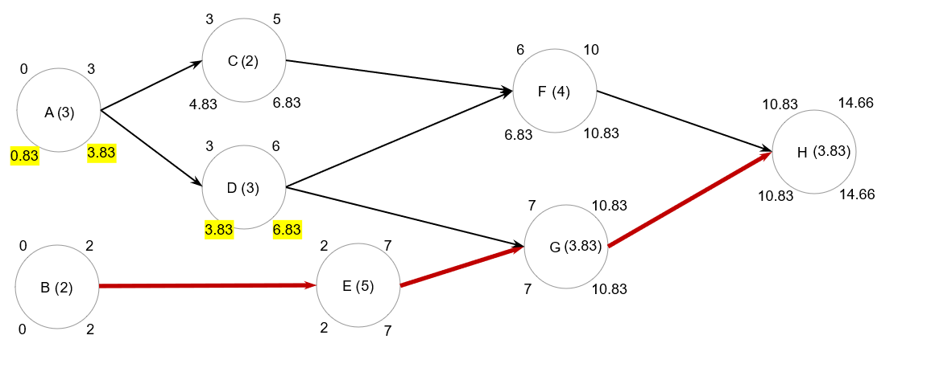

Calculated Expected Times & Variances
Activity | a | m | b | ET = (a+4m+b)/6 | Var = [(b-a)/6]² | Path?
A | 1 | 3 | 5 | 3.00 | 0.444
B | 1 | 2 | 3 | 2.00 | 0.111 | CP
C | 1 | 2 | 3 | 2.00 | 0.111
D | 2 | 3 | 4 | 3.00 | 0.111
E | 3 | 4 | 11 | 5.00 | 1.778 | CP
F | 3 | 4 | 5 | 4.00 | 0.111
G | 1 | 4 | 6 | 3.83 | 0.694 | CP
H | 2 | 4 | 5 | 3.83 | 0.250 | CP

Answers
Critical Path: B → E → G → H
Expected Project Duration: 14.66 days (2.00 + 5.00 + 3.83 + 3.83)
Project Variance: 2.833 (0.111 + 1.778 + 0.694 + 0.250) — sum of CP variances only!
Common Mistake Alert!
Only add variances for activities ON THE CRITICAL PATH. Don't add all variances — that's the #1 error students make on this type of problem.

Probability of Completing in 16 Days
Z = (Target - Expected) / √Variance = (16 - 14.66) / √2.833 = 1.34 / 1.683 = 0.79
Look up Z = 0.79 in a standard normal table, or use Excel:
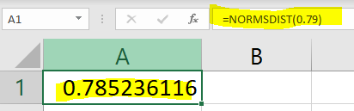
P(T < 16) = 78.52% chance of finishing within 16 days
What Does This Mean in Plain English?
There's about a 79% chance we'll finish on time (within 16 days). That means roughly a 21% chance we'll be late. Is that acceptable? Depends on the project! For a wedding, probably not. For an internal pilot project, maybe.

Problem #3: Project Crashing
Crashing = paying extra money to speed up the project. The key is figuring out WHICH activities to crash, and in what ORDER.
The Crashing Logic (This is What Matters!)
1. Only crash activities on the critical path (crashing non-critical activities won't shorten the project). 2. Crash the CHEAPEST critical path activity first. 3. After each crash, RE-CHECK if the critical path changed. 4. Stop when you've saved enough days or when all CP activities are fully crashed.
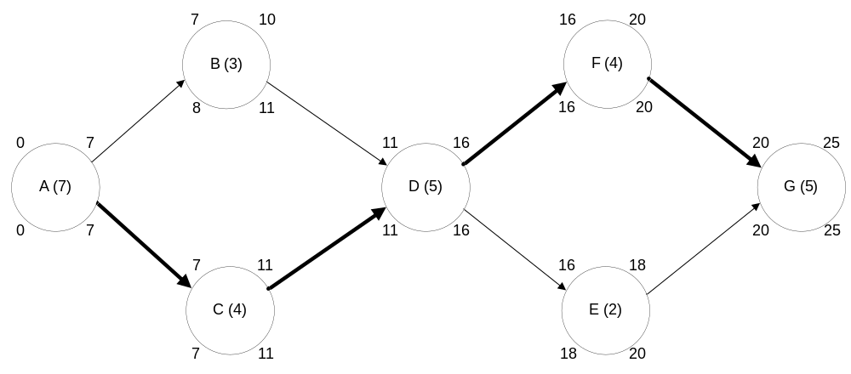

First: Calculate Cost Per Day to Crash
Cost/day = (Crash Cost - Normal Cost) / (Normal Time - Crash Time)
Activity | Normal Time | Crash Time | Normal Cost | Crash Cost | Days Saved | $/Day
A | 7 | 6 | $7,000 | $8,000 | 1 | $1,000
B | 3 | 2 | $5,000 | $7,000 | 1 | $2,000
C | 4 | 3 | $9,000 | $10,200 | 1 | $1,200
D | 5 | 4 | $3,000 | $4,500 | 1 | $1,500
E | 2 | 1 | $2,000 | $3,000 | 1 | $1,000
F | 4 | 2 | $4,000 | $7,000 | 2 | $1,500
G | 5 | 4 | $5,000 | $8,000 | 1 | $3,000
Pink rows = Critical path activities. Green cells = Best options to crash.
Initial Critical Path: A → C → D → F → G = 7 + 4 + 5 + 4 + 5 = 25 days

Crashing Steps (to save 4 days)
Step | Activity | Cost | Days | Why This Activity?
1 | A | $1,000 | 1 | Cheapest on CP ($1,000/day). E is also $1,000 but NOT on CP!
2 | C | $1,200 | 1 | Next cheapest on CP. A is now fully crashed.
3 | D | $1,500 | 1 | D and F both cost $1,500/day. Either works.
4 | F | $1,500 | 1 | Can't crash F by 2 days — would make another path critical!
 | TOTAL | $5,200 | 4 | New duration: 25 - 4 = 21 days

Why Can't We Crash F by 2 Days?
F can technically be crashed by 2 days (from 4 to 2). But after crashing it by 1 day, another path becomes critical. If we crashed it further, we'd need to crash activities on BOTH paths simultaneously — which would cost more. Always check for new critical paths after each crash!

The Big Picture on Crashing
Crashing is about making smart trade-offs. You're paying money to buy time. The question is always: Is the extra cost worth the time saved? In real projects, this could mean paying overtime, adding resources, or expediting deliveries.

